

Reading Policy

Written by: Victoria Amey

Date agreed by Governors: November 2022

Review date: November 2024

**Introduction**

At Mayespark Primary School, we are proud to offer a rich reading environment where imagination and creativity can be fuelled. Through using a range of reading strategies, we are able to bring a sense of wonder and enjoyment to our pupils which enables them to explore real-life issues, develop conversations and create a passion for learning.

This policy outlines the aims, organisation and management for the teaching and learning of Reading at Mayespark Primary School. Reading is an essential life skill which provides access to the experiences of people from different cultures and times. Children must acquire good reading skills in order to access the information that will support their development in all curriculum areas.

We whole-heartedly believe that reading is of vital importance to all children. It is our duty to teach the children how to read, to understand what they have read and to link it to their own lives and experiences. We do this by: -

* teaching the essential skills of reading
* promoting a culture of reading for learning.
* developing a life-long passion for reading.
* facilitating independent learning and progress across the curriculum.

We have a whole school approach to the teaching of reading. A wide variety of reading strategies are taught throughout all the classes which reflect the statutory requirements set out in the National Curriculum in England (2014) and in the Literacy and Communication and Language sections of the Statutory Framework for the Early Years Foundation Stage (2021). The following is an outline of progression for the teaching of reading.

|  |  |
| --- | --- |
| Year Group | Provision |
| Nursery | Begin learning RWI sounds twice a week in Spring Term. |
| Reception, Year 1, Year 2 and any key stage 2 children on the programme. | Daily RWI lessons |
| Arch | Daily jolly phonics programme |
| Year 2 | Daily adapted Destination Reader lessons once completed RWI programme. |
| Year 3, Year 4, Year 5, Year 6 | Daily Destination Reader lessons or Reading Plus if needed. |

**Early Reading**

As soon as the children come into Nursery they begin their reading journey by being given the opportunity to familiarise themselves with books. Children learn how to hold a book the right way, how to turn pages, how to explore pictures and listen to a range of stories, rhymes, poems and songs. They will have opportunities to role play stories, develop vocabulary and build sentences orally through planned talk experiences.

Initial letters and sounds are introduced in the Spring term for those children who are ready. Teachers use ‘fred talk’ (saying sounds using pure sounds) with the children, with the expectation that children will begin to orally blend and segment the words.

**Reception to Year 2**

At Mayespark Primary School, we use the synthetic phonics programme ‘Read Write Inc’. Read Write Inc is a method of learning centred around letter sounds and phonics. Using Read Write Inc the children learn to read effortlessly so that they can put all their energy into comprehending what they read.

When using Read Write Inc to read the children will:

* Learn 44 sounds and the corresponding letter/letter groups using simple picture prompts.
* Learn to read using Fred Talk.
* Read lively stories featuring words they have learnt to sound out.
* Show that they comprehend stories by answering questions.

Pupils are taught to work effectively with a partner to explain and consolidate what they are learning. This provides the teacher with opportunities to assess learning and to pick up on difficulties, such as children’s poor articulation, or problems with blending or alphabetical code knowledge.

Children are grouped homogeneously, according to their progress in reading rather than writing. This is because it is known that pupils’ progress in writing will lag behind progress in reading, especially for those whose motor skills are less well developed. Our aim is for children to work through and complete the phonics programme as early as possible. The sooner they complete it, the sooner they will be able to choose books to read at their own interest and comprehension level.

**RWI provision**

|  |  |  |
| --- | --- | --- |
|  | Frequency | Home reading books |
| Nursery | Spring Term – x2 sounds per week | X2 weekly library books |
| Reception | Daily 30 mins lessons | X2 weekly library books  X1 words sparks books until on RWI books  Depending on their phonic knowledge – either a sound blending book, ditty, RWI book and /or book bag book x1 weekly. |
| Year 1 | Daily x2 30 min sessions | X2 weekly library books  Depending on their phonic knowledge – either a sound blending book, ditty, RWI book and /or book bag book x1 weekly. |
| Year 2 | Daily x 2 30 mins sessions | X2 weekly library books  Depending on their phonic knowledge – either a sound blending book, ditty, RWI book and/or book bag book x1 weekly.  Once RWI is completed, either x1 gold. White or a lime banded book. |
| Key Stage 2 | Daily 40 mins sessions | Depending on their phonic knowledge – either a sound blending book, ditty, RWI book, book bag book x1 weekly. |

Appendix 1

**Year 2 to Year 6**

In order to support children to develop their reading skills through a smooth transition from Read Write Inc we follow Destination Reader across KS2. Children who have completed RWI in Year 2 will begin to be taught elements of Destination Reader.

Destination Reader:

* Provides a systematic approach to the teaching of reading across KS2.
* Enables children to develop key strategies which deepen their understanding of texts.
* Develops children’s motivation to read broadly for pleasure and purpose.
* Increases children’s ability to lead their learning through the acquisition of key learning behaviours.
* Places children at the centre of a formative approach to assessment in reading.

The program covers seven key skills identified within the National Curriculum to support the reading and understanding of a wider range of texts. These are:

* Predicting
* Making connections
* Asking questions
* Evaluating
* Inferring
* Summarising
* Clarifying

Whilst children read their book with their partner they are encouraged to stop and have discussions using sentence stems that are specifically taught.

**Reading Plus**

Children who have completed the Read Write Inc programme in Key Stage 2 and need to practise their fluency and comprehension skills before fully starting Destination Reader will follow the reading plus programme during the independent reading session of Destination Reader.

Reading Plus is an adaptive reading intervention program designed to improve reading comprehension and speed up literacy acquisition. This program assesses a child’s reading proficiency and places them on a personalised program. Children select books from an online library and the program will black out the text to keep the child reading consistently at their pace. There are comprehension questions at the end. Reading is monitored ensuring they are on a personalised path to success.

**Jolly Phonics**

Jolly Phonics is a multi-sensory and child centred approach to teaching reading through synthetic phonics with actions for each 42 letter sounds. This is an approach that is taught to SEND children and children who are unable to access Read Write Inc.

**Individual Reading**

Children from Reception to Year 6 read individually with their class teacher and school adults. Children have access to RWI books or a banded book which they change regularly depending on their year group. Every child will read with the teacher on a one to one basis at least once in every three weeks. These sessions include assessing decoding skills as well as checking understanding by asking comprehension questions. Buddy readers in Year 3 to Year 6 support EYFS and key Stage 1 children with individual reading.

The book bands progress as follows:

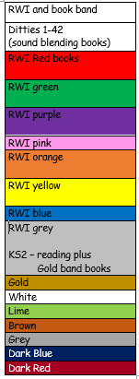

**Read Aloud**

Throughout school, story time is implemented into the daily timetable to promote the love of reading. This is where teachers and support staff read regularly to the children modelling the use of intonation and expression to bring characters to life and expose the children to a wide range of literature such as stories, poetry and information texts. This helps to foster a love of reading, extend children’s vocabulary and comprehension, and supports their writing.

**Reading for pleasure**

Teachers promote reading for pleasure in their classrooms by having an attractive and inviting reading area with age-appropriate texts that pupils can access at all times. (Appendix 2 for guidance). In EYFS children have access to the book corner during independent learning. In Key Stage 1 and 2 children select books to go home each week from the book corner and have the opportunity to read independently at times during the day. In addition, reading areas have been created in the corridors. Children are encouraged to see books as enjoyable and as a source of knowledge and made to believe there is no place where books are not allowed. Additional ‘Read with Me’ sessions in classrooms with parents allow children to enjoy reading further.

**Developing reading at home**

At Mayespark Primary School we value the importance of parental partnership in order to provide the best education for their child. We have clear expectations regarding home reading which are communicated to parents and embedded early on in EYFS. (Appendix 3 and 4). Parents are encouraged to provide written feedback on their child’s reading via a home reading record book each day. Parents are encouraged to read with their child even when they are ‘independent readers’ so that they can support their child to read with fluency and intonation, recognise punctuation, help decode any difficult words, discuss texts and ensure understanding of new vocabulary. Guidance on supporting their child can be found within the home reading record.

**Library**

We do not have a school library as we want to encourage children to visit their local public library. Each class visits the Goodmayes Public Library once every four weeks. Children are taught key skills to help them select a book according to genre, theme or authors. They are taught how to respect the learning environment of a library and encouraged to use the community library outside of school hours. Homework tasks are planned in order for children to use library for research during evenings and the holidays.

Additional reading resources are ordered termly from the Redbridge Central Library; teachers place orders based on topics being taught and requests made by children via the reading ambassadors.

**Planning**

Reading is a fundamental part of English and lessons are planned around and based on a quality text. Texts are mapped out across the school to link with topics where appropriate and to ensure coverage of a range of genres, themes, fiction, non-fiction, poetry, authors, classical texts, school values and British values.

Medium term planning

Each year group has a good quality text at the heart of their medium-term planning (Appendix 5). Children are encouraged to respond to the text in a philosophical manner. The teacher models the reading process to the whole class as an expert reader.

Learning intentions are pre-planned and sessions are characterised by explicit teaching of specific reading strategies, oral response from children and high levels of collaboration. During lessons in other curriculum areas, such as science and history, opportunities are provided for additional reading so that skills learnt in English lessons are applied in different contexts. Teachers plan these opportunities using differentiated reading material where appropriate.

Destination Reader

Teachers complete a termly overview when planning for Destination Reader which shows the strategies being taught that term and the lesson objectives to ensure progression (Appendix 6). A weekly plan is completed to include the teacher model and talk partner questions

**Targets**

Children have individual targets for Reading which are changed at least half termly. Children in EYFS have targets based on the EYFS framework. In Key stage 1 teachers set a target based on the requirements of the National Curriculum for the child. In Key stage 2 the children are more involved in setting their own target. In discussions with the teacher children decide which key reading strategy they need to practise more based on their Destination Reader lessons. All targets are shared with parents via the child’s home reading record.

**Homework**

We recognise the importance of making links between home and school and encourage parental involvement with the learning of reading. Homework provides opportunities for children:

• to practise their word reading

• develop their comprehension skills

• responding to comprehension style questions.

In addition to reading daily children from Year 1 to Year 6 will receive differentiated comprehensions as part of their homework. Children in Key Stage 2 have access to Reading Plus at home where they are encouraged to read a variety of online texts and answer the questions. Year 2 have access to Reading Plus in the summer term.

**Assessment**

Teachers listen to children once every three weeks to make formative assessments throughout the academic year.

Progress is partially monitored through half termly tracking of reading bands and recorded on the book band tracker (Appendix 7). This is regularly monitored by the class teacher, English lead and SLT to ensure progress is being made.

Reading Assessment in EYFS

* On-going assessment of reading behaviours during the session or day.
* Teachers in EYFS listen to a child read once every three weeks. The teacher keeps a running record every time a child reads. Comments are made about a child’s reading predominately based on their target they have been set.
* On-going assessment against the Early Learning Goals.
* RWI Phonic assessments approximately every eight weeks.
* End of EYFS profile.

Key Stage One

* Ongoing assessments during lessons and individual reading sessions.
* Phonic assessments approximately every eight weeks where needed.
* Year 2 PIRA tests Autumn Term, SATs paper Spring term.
* Formative assessment. Teachers listen to children read individually and make informed judgements based on their responses. Targets are set, monitored and updated according to individual needs of children.
* Year 1 phonics screening test.
* End of KS1 SATS assessments in Year 2.

Key Stage Two

* Ongoing assessments during lessons and individual reading sessions.
* Further assessments are made using written responses during Destination Reader lessons. Evidence is recorded in Destination Reader books.
* Teachers listen to children read individually once every three weeks and make informed judgements based on their responses.
* Targets are set, monitored and updated according to individual needs of children.
* PIRA reading assessments are carried out at the end of each term in Year 3 to Year 5, which are used to inform teacher assessments and inform planning.
* Practise SATs papers are used in Year 6.
* End of KS2 SATS assessments in Year 6

Moderation

Teachers are involved in moderation of Reading in the following ways:

* With colleagues in school during year group meetings
* With colleagues in school during professional development meetings.
* External moderation by local authority moderators for Year 2 and Year 6 as part of a four year cycle.

**Monitoring**

Monitoring is ongoing and is undertaken in various ways

* Leaders observe lessons usually with a focus that is a whole school priority or is an individual teacher’s area for development.
* Learning walks undertaken by leaders.
* Regular scrutiny of Destination Reader, RWI lessons and English planning and outcomes in books.
* Monitoring of pupil performance during pupil progress meetings.
* Monitoring of the reading environment.
* Timely feedback and appropriate support are provided to maintain the quality of teaching and learning all across the school.
* Analysis of various data including pupil surveys.
* Ongoing adherence to policy and procedures of the school.

**Appendices**

Appendix 1

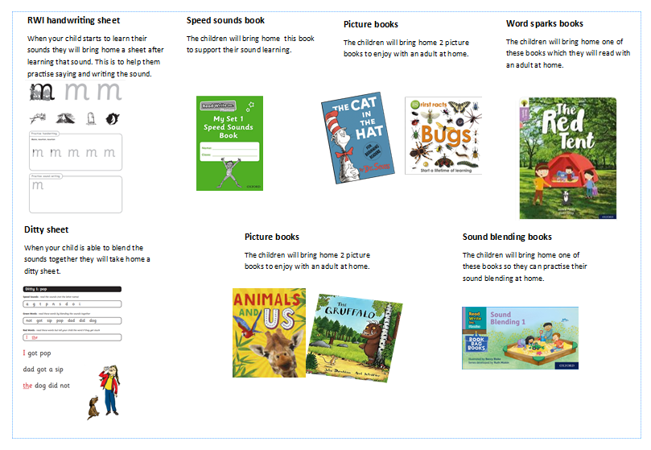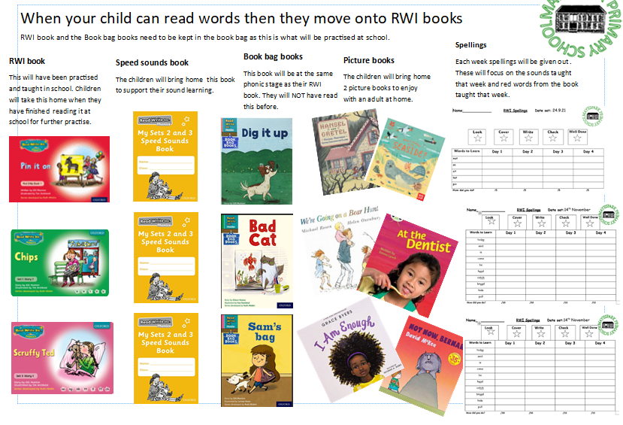

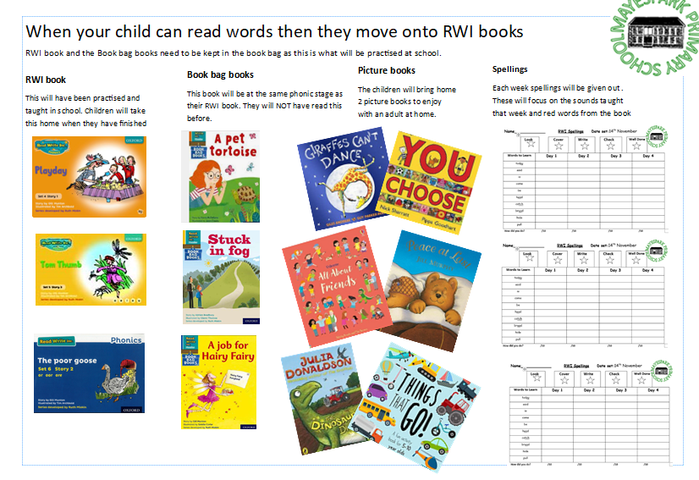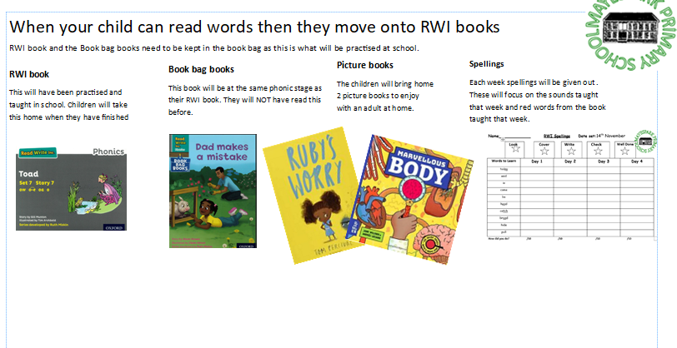

Appendix 2

|  |  |  |
| --- | --- | --- |
| Reading corner guidance. | Tick if completed | What needs doing. |
| Book corner is eye catching and appealing to children. |  |  |
| Range of books  Fiction – Themed e.g. animal stories, fairy tales, books by same author  non-fiction  poetry  graphic novels  banded books  topic books  dictionary/thesaurus (couple only) |  |  |
|  |  |
|  |  |
|  |  |
|  |  |
|  |  |
|  |  |
| Books easily accessible for browsing. |  |  |
| Banded books in labelled baskets. |  |  |
| Themed e.g. author, topic display |  |  |
| Books have a good quantity of books but not over crowed. |  |  |
| Books in good condition. |  |  |
| Book reviews, recommendations, open questions appropriate for age group available for children to complete. |  |  |
| Previous year’s text displayed /available. |  |  |

RWI Guidance

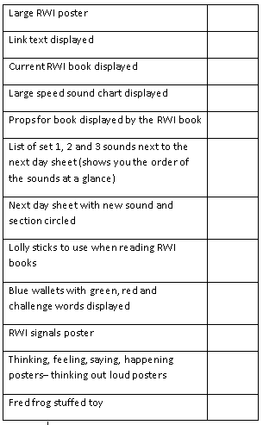

|  |  |  |
| --- | --- | --- |
| Destination Reading wall guidance |  | Tick |
| Heading to board | Reading wall |  |
| Book front cover displayed | Washing line – add books that have been taught throughout the year in both English sessions and DR sessions. |  |
| Author information | Picture of the author and key facts. |  |
| Other books they have written | display pictures of the front covers of other books they have written. |  |
| Stems | Display the stem being taught that week. If doing a combination of all stems have all the stems visible near the front of class so they can be referred to easily in DR sessions and other lessons too. |  |
| Vocabulary | Section for current vocabulary that is written up clearly and good size so it can be seen from back of class. Add a picture to vocabulary if needed. |  |
| Clarifying tool | Displayed near reading wall or on reading wall. This should be A3 size. They were enlarged last term. |  |

**Appendix 3**

**Expectations for reading**

**Arch**

**Teachers**

* Children to be heard daily by a school adult and at last once a week by the class teacher.
* Home reading records to be checked daily and incentives given.
* Children to have their books changed daily and given a book of their choice from the reading corner.
* When listening to a child read the teacher is to fill in the running record in the reading folder and comments based on their target to be made.
* The home reading record is completed by the adult or teacher and a brief comment made.
* Every child should be given a reading target that should be changed once the child has achieved that target. There may be times when you need to change a target if the child is struggling.
* Targets need to be written I the home reading record.

**Parents**

* Parents are expected to hear their child read their RWI book and RWI book bag book daily 6 days a week for at least 15mins.
* Parents are to date and sign the reading record each day.
* If a parent doesn’t sign the home reading record consistently or for at least three days a letter will be sent home and if there is still no improvement a member of SLT will contact the parent. When a letter is sent home a note of this is made in the child’s home reading record and on the reading phone call tracker.
* Encourage children to re- read books for fluency, comprehension and enjoyment.

**EYFS**

**Teachers**

* Children to be heard to read **at least** once every week by a school adult and at least once every three weeks by the class teacher.
* Home reading records to be checked daily and incentives given.
* Children to have books changed at least once a week and given two books of their choice from the book corner, a sound blending book, a ditty, a RWI book and a RWI book bag book (when ready).
* When listening to a child read the teacher is to fill in the running record in the reading folder and comments should be made. Questioning should mainly be towards the target the child has been set. The home reading record is stamped to indicate that the teacher has read with the child and a brief comment maybe made.
* When the child is ready for RWI books they should have a copy of either the sound blending book, ditty, RWI book taught that week and the corresponding book bag book to take home each week
* Every child should be given a reading target that should be changed once the child has achieved that target or at least once every half term. There may be times when you need to change a target if the child is struggling. You may also need to select targets from other year groups if needed.
* Targets need to be written in the home reading record by the teacher.

**Parents**

* Parents are expected to hear their child read their RWI book and RWI book bag book daily 6 days a week for at least 15mins.
* Parents are to date and sign the reading record each day.
* If a parent doesn’t sign the home reading record consistently or for at least three days a letter will be sent home and if there is still no improvement a member of SLT will contact the parent. When a letter is sent home a note of this is made in the child’s home reading record and on the reading phone call tracker.
* Encourage children to re- read books for fluency, comprehension and enjoyment.

**Year 1 and Year 2 Teachers**

* Children to be heard to read **at least** once every week by a school adult and at least once every three weeks by the class teacher.
* Home reading records to be checked daily and incentives given.
* Children to have books changed at least once a week and given a banded book (if they are off RWI), two books of their choice from the book corner, RWI book and RWI book bag book.
* When listening to a child read the teacher is to fill in the running record in the reading folder and comments should be made. Questioning should mainly be towards the target the child has been set. The home reading record is stamped and a brief comment can be made.
* If the child is on a book band this should be recorded on the running record and if they are on the RWI programme the RWI book should be read.
* Every child should be given a reading target that should be changed once the child has achieved that target or at least once every half term. There may be times when you need to change a target if the child is struggling. You may also need to select targets from other year groups if needed.
* Targets need to be written in the home reading record by the teacher.

**Parents**

* Parents are expected to hear their child read their RWI book, RWI book bag book or banded book daily, 6 days a week for at least 15mins.
* Parents are to date and sign the home reading record each day.
* If a parent doesn’t sign the home reading record consistently or for at least three days a letter will be sent home and if there is still no improvement a member of SLT will contact the parent. When a letter is sent home a note of this is made in the child’s home reading record and on the reading phone call tracker.
* Encourage children to re- read books for fluency, comprehension and enjoyment.

**Year 3 and Year 4 Teachers**

* Children to be heard to read their banded book **at least** once every three weeks by the class teacher or RWI book if still on the programme.
* Children to change their books when they are ready but the class teacher to monitor this so that a child isn’t on the same book for too long. RWI books will be sent home by the RWI teacher.
* Home reading records to be checked daily and incentives given.
* When listening to a child read the teacher ‘s questioning should mainly be towards the target the child has been set. The home reading record is stamped and a brief comment maybe made.
* Children can become ‘independent readers ‘when they are on brown band and can write a comment in their home reading book each day. Children need to make comments based on the DR strategies and parents are expected to still sign the home record once a week.
* Every child should be given a reading target that should be changed once the child has achieved that target or at least once every half term. There may be times when you need to change a target if the child is struggling. You may also need to select targets from other year groups if needed.
* Targets need to be written in the home reading record by the child.

**Parents**

* Children to read at home their banded book at least six times a week for 20- 30minutes a day.
* Once the child is an ‘independent reader’ they can record in their reading record themselves. However, the parent is to sign the home reading record once a week.
* If a parent doesn’t sign the home reading record consistently or for at least three days a letter will be sent home and if there is still no improvement a member of SLT will contact the parent. When a letter is sent home a note of this is made in the child’s home reading record and on the reading phone call tracker.

**Year 5 and Year 6 Teachers**

* Children to be heard to read their banded book **at least** once every three weeks by the class teacher or RWI book if still on the programme.
* Children to change their books when they are ready but the class teacher to monitor this so that a child isn’t on the same book for too long. Non-banded books can be read only when first checked by a teacher and after every two banded books have been read. RWI books will be sent home by the RWI teacher.
* Home reading records to be checked daily and incentives given.
* When listening to a child read the teacher ‘s questioning should mainly be towards the target the child has been set. The home reading record is stamped and a brief comment maybe made.
* Children can become ‘independent readers ‘when they are on brown band and can write a comment in their home reading book each day. Children need to make comments based on the DR strategies and parents are expected to still sign the home record once a week.
* Every child should be given a reading target that should be changed once the child has achieved that target or at least once every half term. There may be times when you need to change a target if the child is struggling. You may also need to select targets from other year groups if needed.
* Targets need to be written in the home reading record by the child.

**Parents**

* Children to read their banded book at home at least six times a week for 30minutes a day.
* Once the child is an ‘independent reader’ they can record in their home reading record themselves. However, the parent is to sign the home reading record once a week.
* If a parent doesn’t sign the home reading record consistently or for at least three days a letter will be sent home and if there is still no improvement a member of SLT will contact the parent. When a letter is sent home a note of this is made in the child’s home reading record and on the reading phone call tracker.

**Appendix 4**

**Home Reading Expectations**

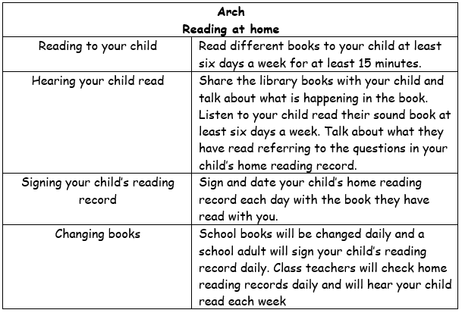 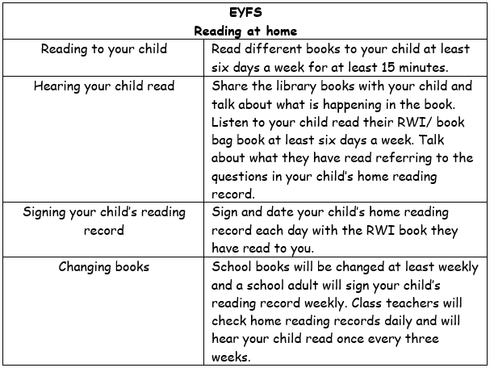

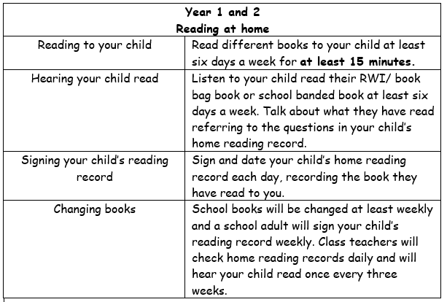 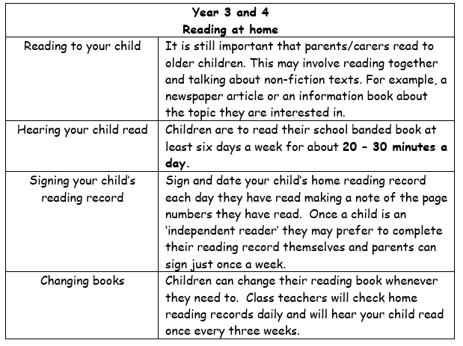

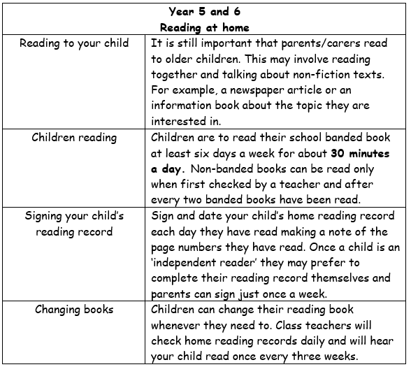

**Appendix 5**

Core English texts

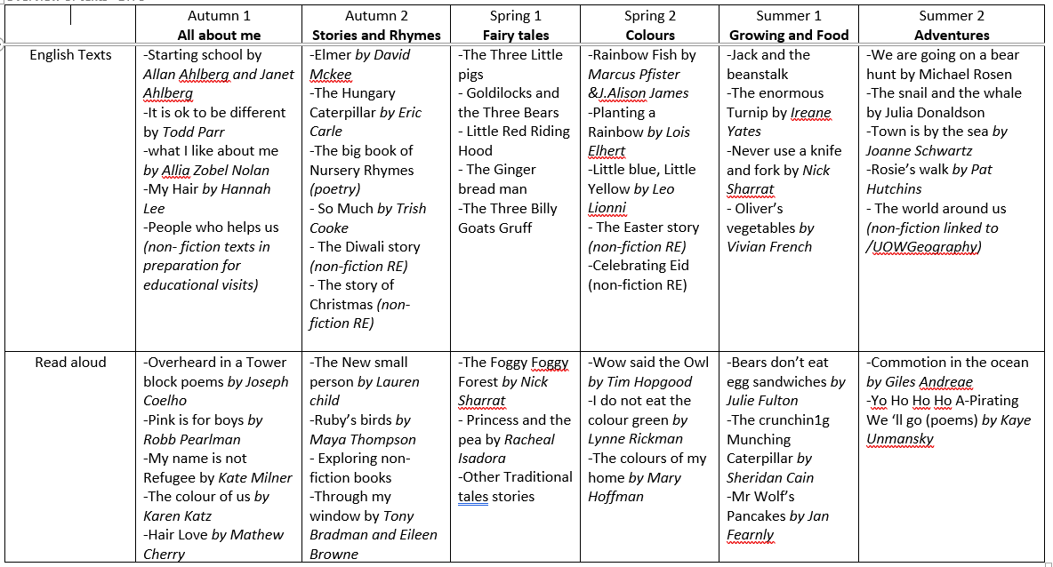

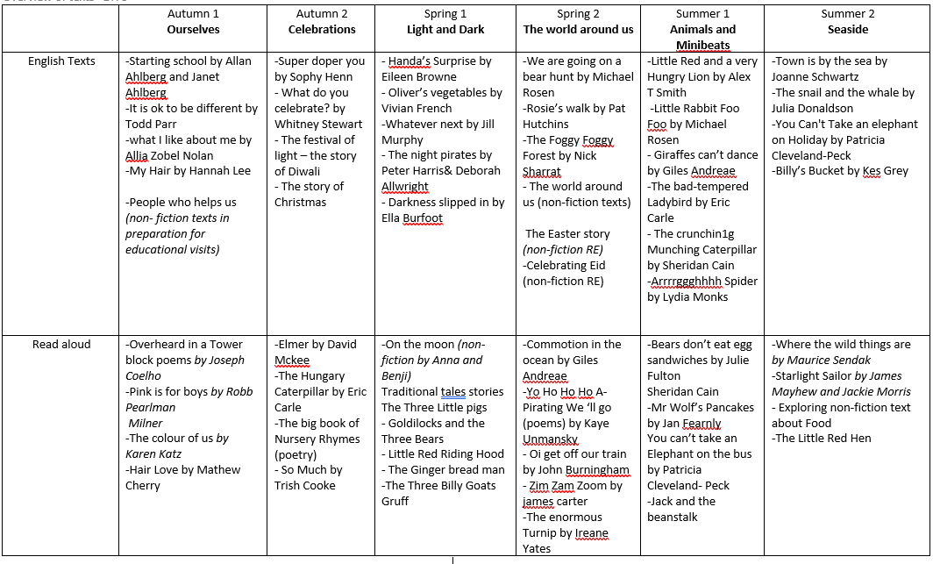

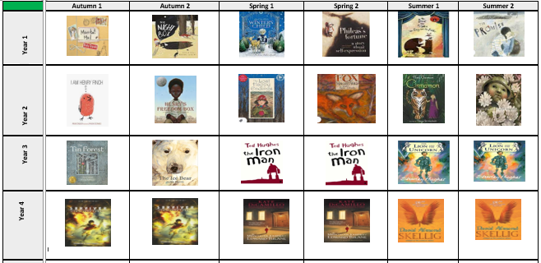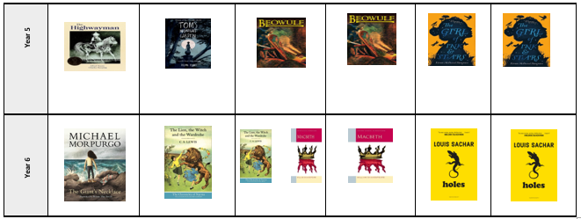

**Appendix 6**

Daily planning of English lessons

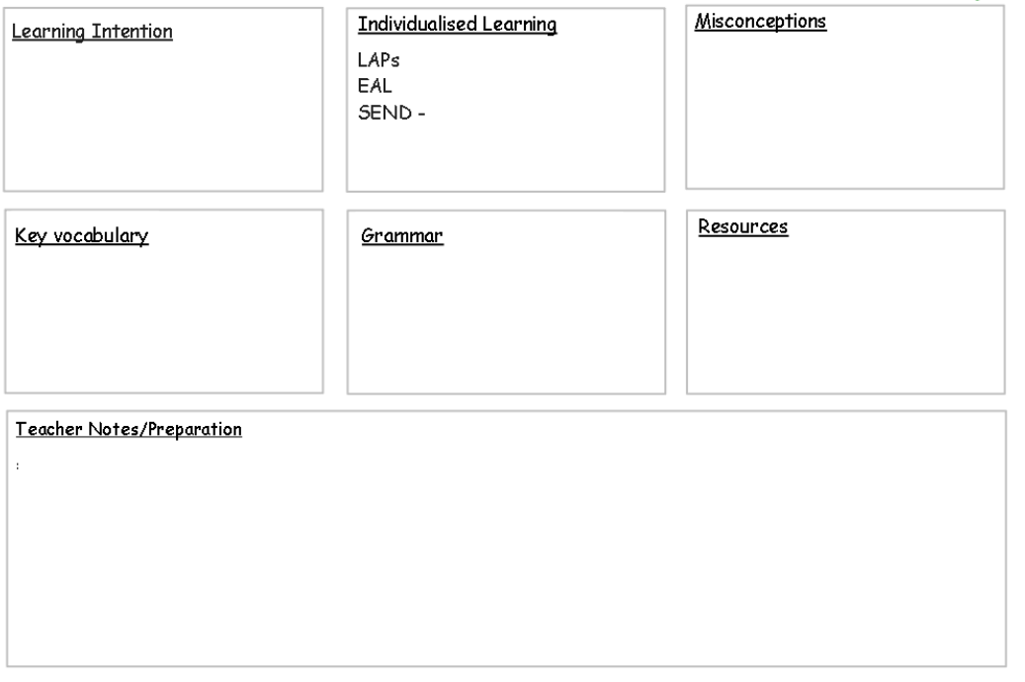

Termly planning for Destination reader

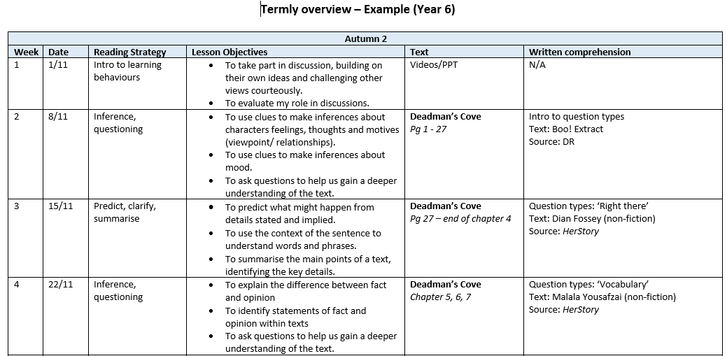

Weekly planning for Destination Reader

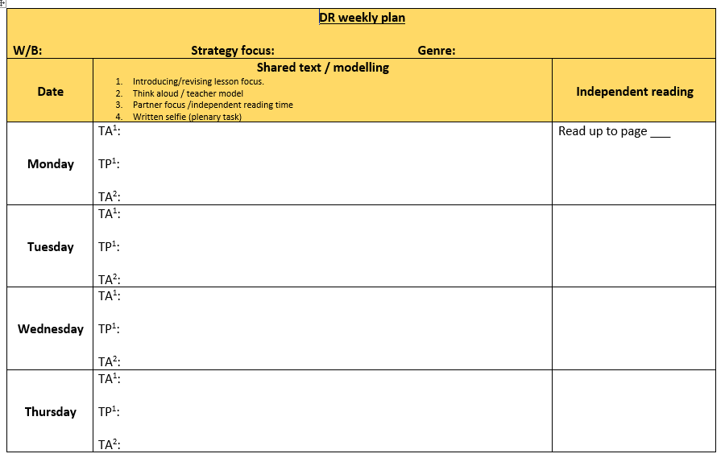

**Appendix 7**