Contents
Our school vision | Page 2/3
Introduction | Page 3
People you need to know | Page 4
Organisation | Page 5
Attendance and illness | Page 5
Uniform for nursery children | Page 6
Food and snacks | Page 7
Induction | Page 7/8
Teaching and learning in nursery | Page 9/10
An example of a typical nursery day | Page 11
Progress | Page 12
Home learning | Page 13
Getting ready for nursery | Page 14

Our School Vision
Mayespark is a school where all staff work together to ensure that every child is inspired to achieve their best.
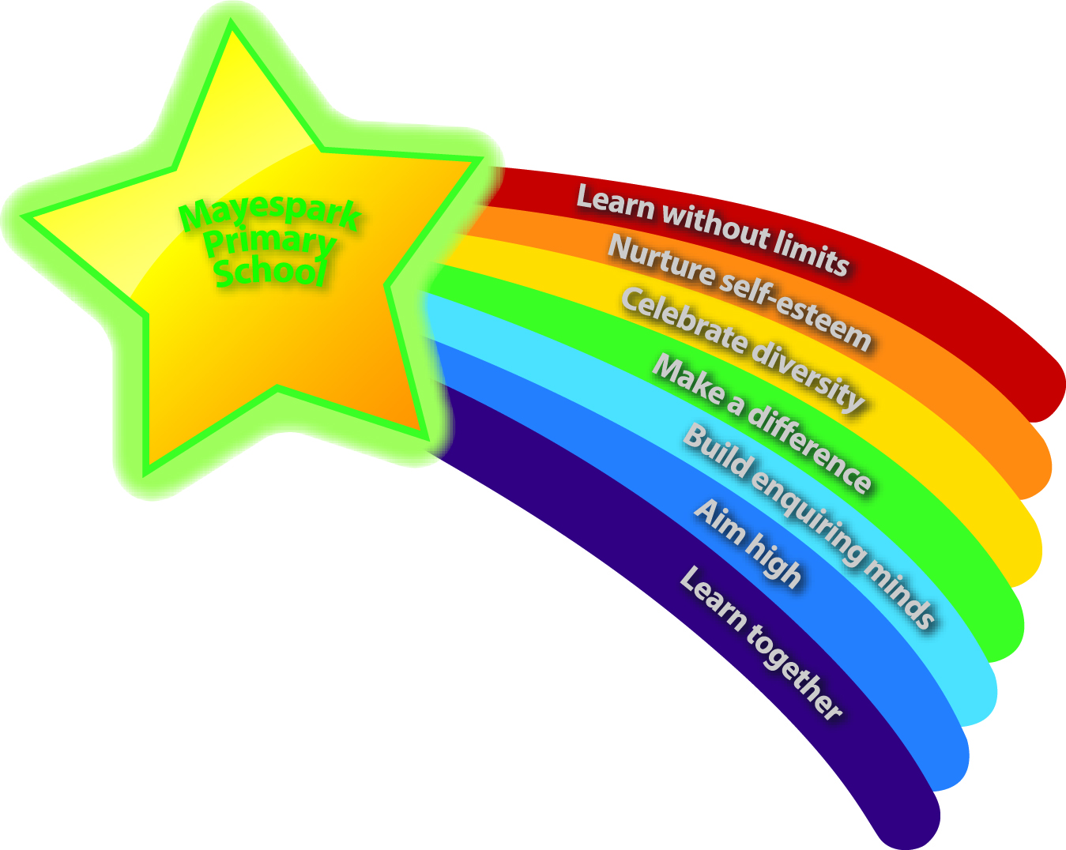

Children look forward to coming to school and take pride in their learning environment
Children develop enquiring minds and are provided with memorable educational experiences
Children achieve high standards through an exciting and stimulating curriculum
Children develop high self-esteem and confidence and become self-motivated independent learners
Children have positive attitudes, good behaviour and an understanding of what is right and wrong
Children learn within a safe, supportive, inclusive and caring environment
Children learn to respect each other’s religious and cultural values and celebrate the diversity of our community
Children believe and understand how they can make a difference in the world

Introduction

Welcome to Mayespark Primary School. We believe that the key to a good start and a successful, happy school career is a good trusting relationship between our staff and our families. With this in mind, we aim to give you as much information about us as possible and to provide you with opportunities to tell us about your children, before term starts in September.
Along with this booklet, you will also receive a school prospectus. You can also access information including uniform, attendance, behaviour policies and much more on our website at www.mayesparkprimaryschool.org.uk
We hope you find this information useful and would appreciate any feedback on this booklet and the induction process.

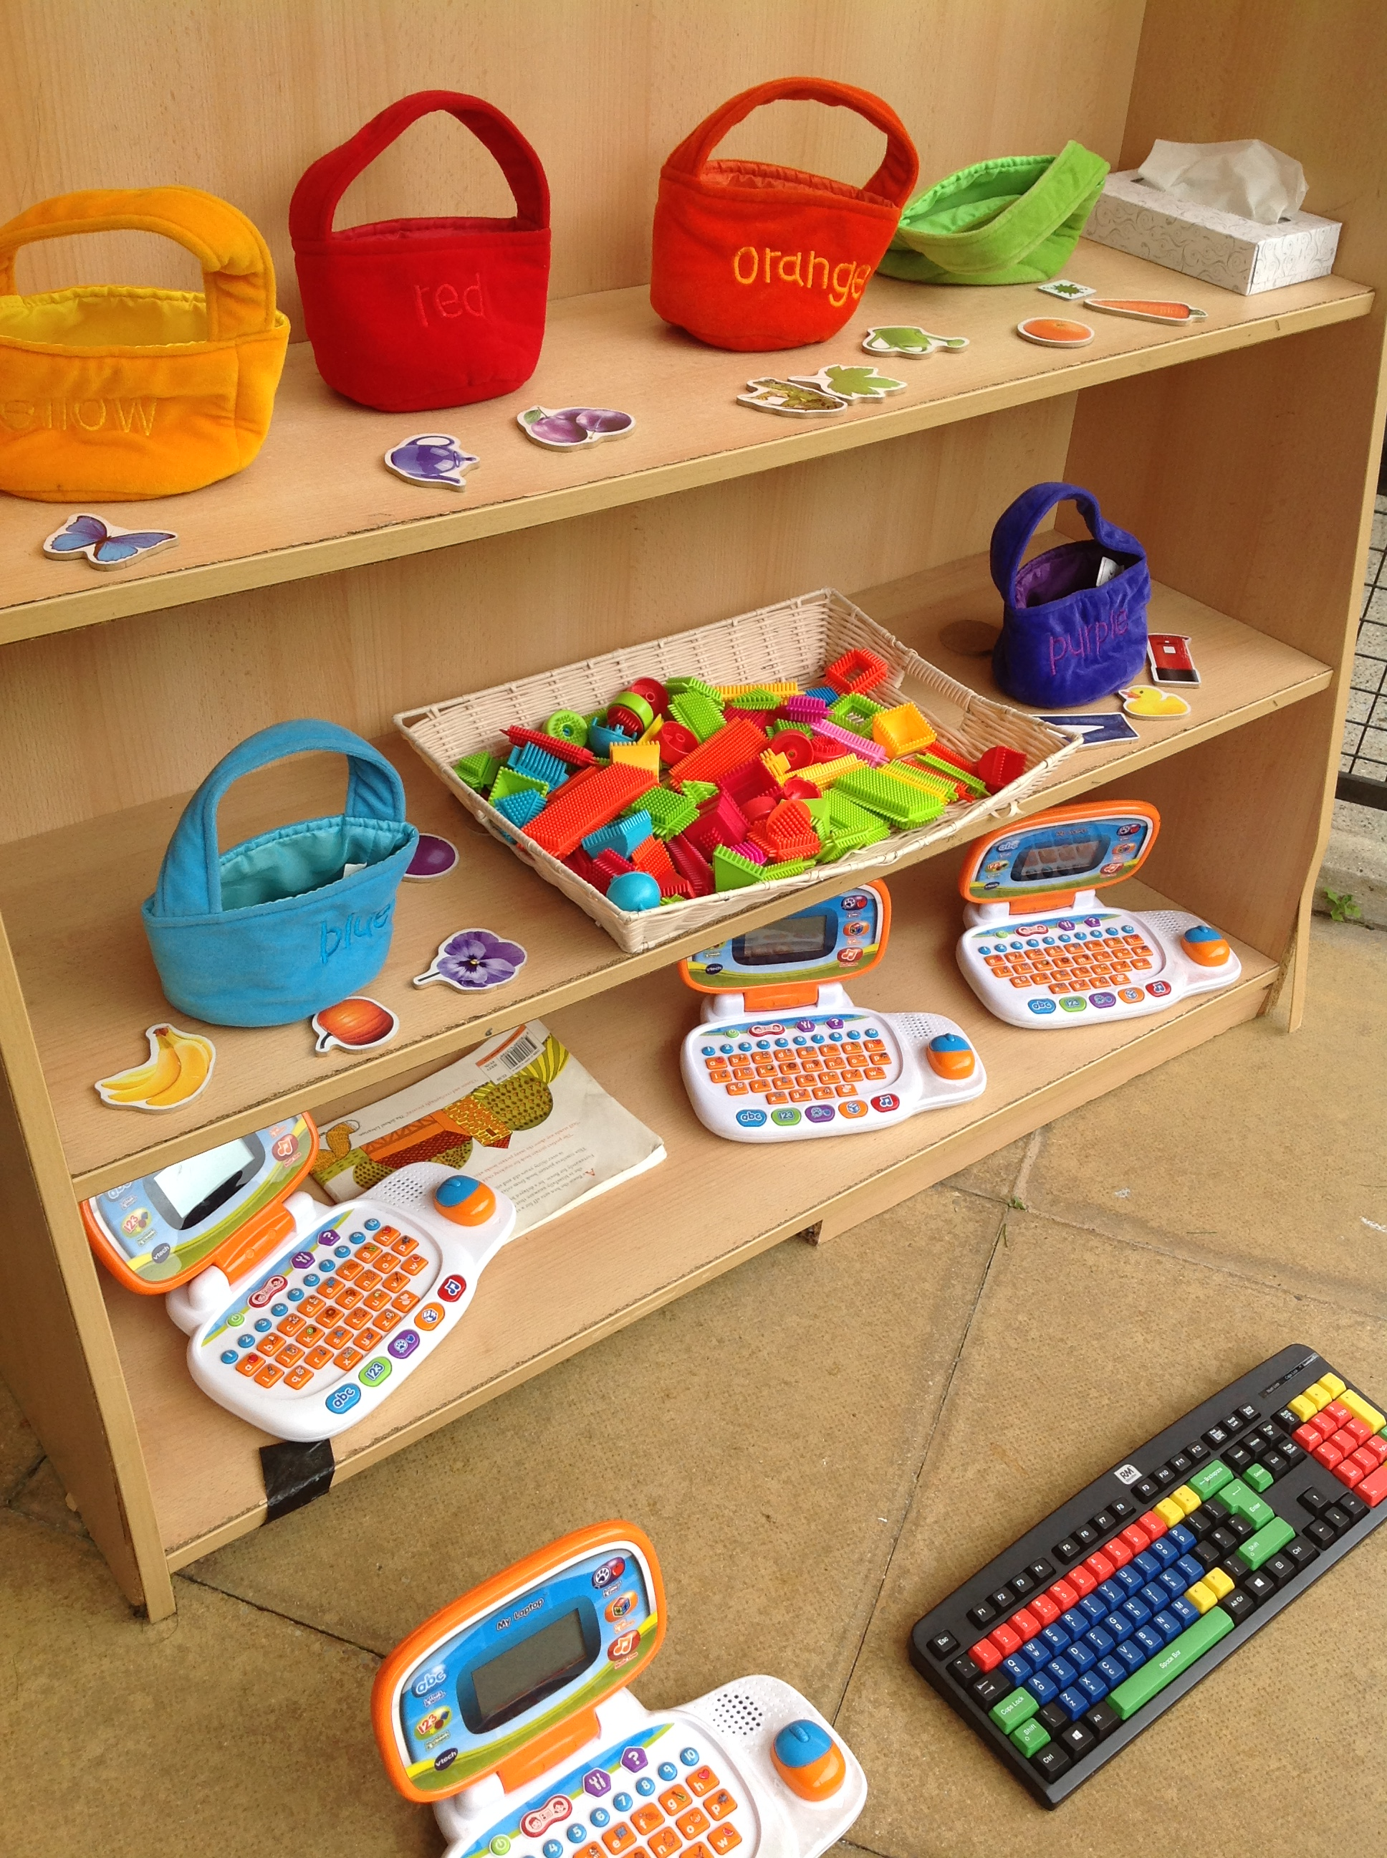
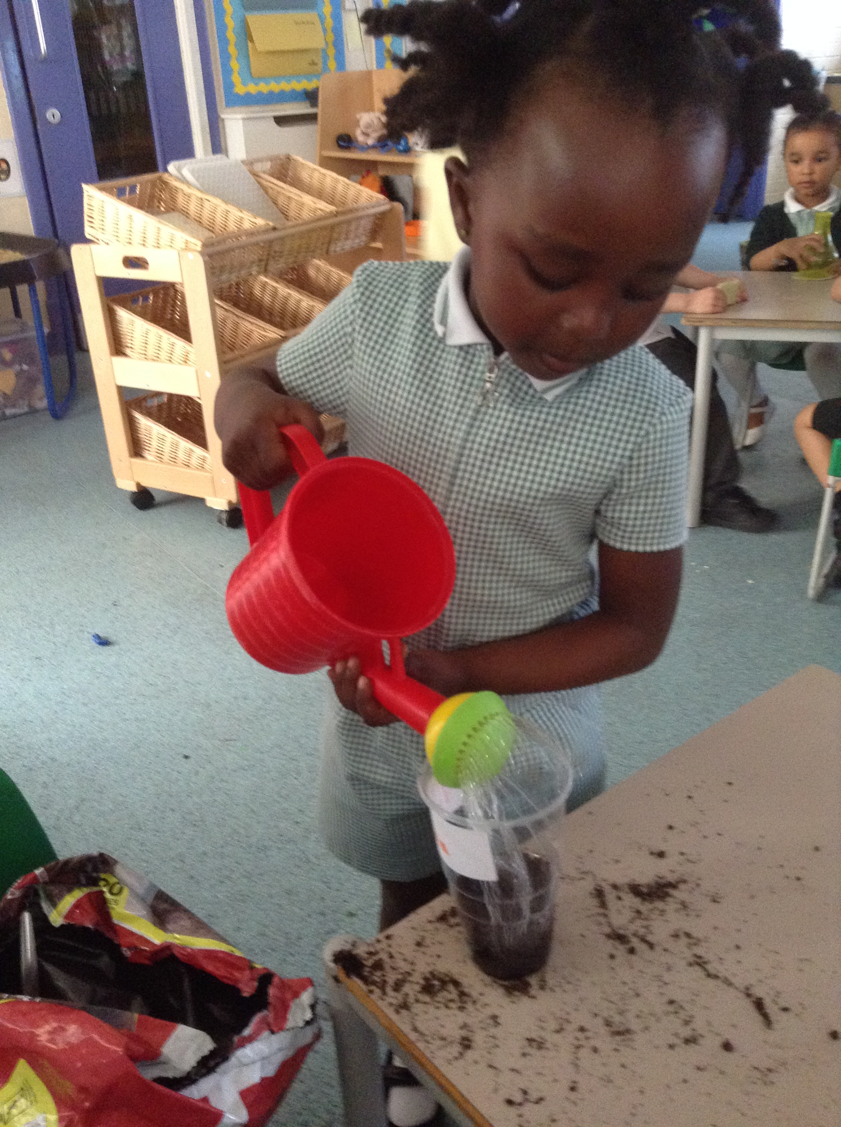

Nursery Class Teacher
Mrs Shamim
PPA Teacher
The class teacher is entitled to half a day each week for planning, preparation and assessment (PPA). The nursery nurse will remain within the nursery during these sessions along with the PPA teacher.

Senior Leaders

Ms Davies
Headteacher
Mrs Jones
Deputy Headteacher
Mr Radmore  Assistant Headteacher | Mrs Ige  Assistant Headteacher

School contact number: 0208 599 2263
School email: admin.mayespark@redbridge.gov.uk
Organisation
From September 2023, in addition to offering one morning nursery class and one afternoon nursery class, with up to 26 children in each. We will also be offering all day session, subject to 30 hour code, which would be from 8.45am to 11.50am and 12.30pm to 3.30pm. If you wish for your child to attend over the lunch break (11.50am to 12.30pm) we would require a fee of currently £4.20 per day, payable in advance at the start of each term. This would cost approximately £252 per term (12 weeks), depending on the amount of school days. You will also need to provide a packed lunch for your child. Please note the fee may increase or decrease slightly each term dependent on the number of all day places taken.
The morning nursery class starts at 8:45am and ends at 11:50am. The afternoon nursery starts at 12:30pm and ends at 3:30pm, children who attend all day will start from 8:45am and finish at 3:30pm. All classes have the same class teacher and nursery nurse. The nursery has a large learning space, both indoors and outdoors and the children and staff may move between the two environments to take part in different activities. We call our outdoor area the ‘Learning Garden.’

Nursery classes starting in September 2023 will stay in the same class until the end of the school year in July 2024. All the children in nursery will celebrate their 4th birthday between 1st September 2023 and 31st August 2024. In September 2024 they will move to Reception. Applications for Reception places, at Mayespark or other Redbridge schools, must be made by mid-December to the London Borough of Redbridge. Your child will not automatically be given a place in our Reception classes.
The teacher will welcome children and parents at the start of each session. Parents and carers enter straight into the nursery classroom to support their child to put their belongings away. This is a good time to pass on any messages or ask quick questions to the staff. The teacher will dismiss children from the nursery door at the end of each session and will be available for a brief discussion after the last child has been collected. The teacher is always happy to make appointments for meetings should this be more convenient. Any urgent messages can be either emailed or sent via the school’s office during school hours.
Attendance and Illness
It is vital to your child’s development and progress that they come to nursery every day. However, if your child is ill (not including coughs and colds), you should keep him or her at home and inform the office, 02085992263, before 9:00am. In the case of sickness or diarrhoea, children must be kept at home for at least 24 hours after they have been unwell.
The school is not allowed to authorise absence for holidays, birthdays or special events during term time. Our attendance team and Educational Welfare Officer keep a close eye on attendance and lateness and will contact families whose attendance is poor and your child’s place will be at risk.
It is important that we develop the correct habits of attendance at school while your child attends nursery and poor attendance is not acceptable at Mayespark.
Uniform for Nursery Children

Boys | Girls
- Plain grey trousers or shorts  - White polo top or shirt  - Green jumper (preferably with MPS logo)  - Black shoes or trainers (plain and with black laces)  - Black, grey or white socks  - Green, black or white hair accessories in school colours  - MPS bookbag | - Plain grey trousers, shorts, skirt, pinafore or shalwar kameez  - White polo top or shirt  - Green and white checked dress (can be worn with plain white trousers)  - Green cardigan or jumper (preferably with MPS logo)  - Black shoes or trainers (plain and with black laces)  - Black, grey or white socks or tights (no leggings)  - Plain black or white religious head wear  - Green, black or white hair accessories  - MPS bookbag
Not included in our school uniform:
- Leggings
- Nail polish
- Jewellery (small stud earrings are permitted)
- Open toed sandals, heeled shoes or high boots
- Any item of clothing with logos, slogans or patterns (excluding MPS logo)

Please remember to clearly label all items with your child’s full name. There are up to 52 children in the nursery who are a similar size, wearing similar uniform, so items are easily mixed up and can be difficult to trace if lost. Lost property is stored in the back playground in a storage bench. Please also remember that children play outside every day. In cold weather they need hats, scarves and gloves and in hot weather they need sunhats and sun cream (please apply this before children come to school).
Children in nursery take part in a range of physical play activities outside their allocated PE lessons, so please make sure they are wearing sensible shoes. Open toed sandals and flip-flops are dangerous and are not permissible. Please expect your child to get dirty! The nursery curriculum is filled with physical and creative activities involving lots of digging, painting, model making and climbing. Products we use are bought from reputable educational suppliers. Any stains from these products can usually be removed from clothing by soaking before washing. School uniform can be purchased online via a secure website called Brigade: www.brigadeuniformdirect.uk.com using credit or debit cards, or in person from Rupens Schoolwear: 98-100 Meads Lane, Ilford, Essex IG3 8QN, 0208 590 3734. Our office staff are happy to help if you need it.

Food and Snacks
Fruit is provided daily in school through the Government Fruit Scheme, please do not send in any other snacks. We ask that parents provide a reusable water bottle, children are free to drink water whenever they want to.
Cooking activities are sometimes planned to support learning in various areas of the curriculum. We always consider the dietary needs of our children and plan to use ingredients suitable for all.
You will be asked about your child’s diet and eating habits on your Induction Day and any information you give us will be recorded on your child’s entry profile.
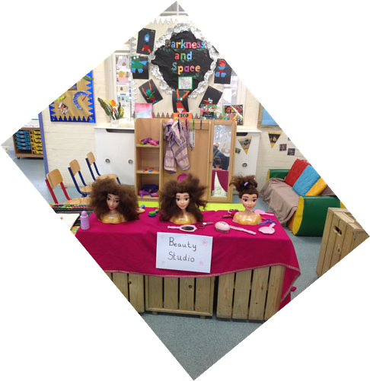
Many children like to share treats when it is their birthday. You are welcome to send in individual sweets, chocolate bars or cakes for this special occasion, which will be given out at the end of the session to take home. Please note that we do not have the facilities or the time to cut up large birthday cakes. Mayespark is a nut free school. Please do not send in any items that contain traces of nuts.
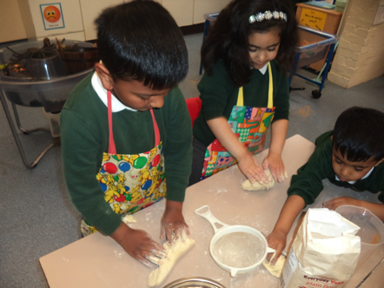

Induction
Starting full time school is a big milestone, which can be very exciting and also a little worrying. We believe that a positive, trusting relationship between parents/carers and staff is essential to children’s wellbeing, happiness and progress. We have put a great deal of thought into organising the induction and settling period so that parents and children are well prepared for starting school and have the best possible start. The process is outlined below:
Friday 16th June 2023  9:00 am | New Parents’ Meeting  Key staff will present information about Mayespark School and how our nursery classes work. You will be given an induction pack, including parents’ handbook, school prospectus, and details of your child’s class and start date. You will need to complete a Parent Declaration form for your Early Years provision. There will be opportunities to ask questions.
September 2023  Wednesday 6th  Thursday 7th  Friday 8th  Monday 11th  Tuesday 12th  Wednesday 13th  Thursday 14th  Friday 15th | Home visits  The Nursery class teacher and nursery nurse would like to meet you and your child in your family home. This helps to bridge the gap between home and school which ensures a smooth transition.
September 2023  Monday 18th  Tuesday 19th | Stay and play sessions  All parents/carers are expected to bring their children to explore their new class. Parents/carers will have a discussion with the class teacher or nursery nurse about their child’s experience, needs and interests. You will be given a day, which we require you to attend. During your visit you can see our Learning Garden and you may stay and play for as long as you wish. Parents should report to the school office and wait to be escorted to their child’s class.
Date |  | Start days for Summer born and Spring children | AM nursery | PM nursery
Wednesday 20th September 2023 |  | Summer and Spring born children day 1 | 8:50- 9:50am | 12:30 - 1:30pm
Thursday 21st September 2023 |  | Summer and Spring born children day 2 | 8:50 - 10:50am | 12:30 - 2:30pm
Friday 22nd September 2023 |  | Summer and Spring born children day 3 | 8:50 - 11:50pm | 12:30 - 3:30pm
Date |  | Start days for Autumn born children | AM nursery | PM nursery
Monday 25th September 2023 |  | Autumn born children day 1 | 8:50 - 9:50am | 12:30 - 1:30pm
Tuesday 26th September 2023 |  | Autumn born children day 2 | 8:50 - 10:50am | 12:30 - 2:30pm
Wednesday 27th September 2023 |  | Autumn born children day 3 | 8:50 - 11:50pm | 12:30 - 3:30pm

Teaching and Learning in Nursery
We believe that children learn best when they feel relaxed and confident and are having fun. Our nursery and Learning Garden are set up to enable children to learn in a variety of ways. Sometimes children’s learning is lead directly by an adult in a planned focus activity; the adult may work with the whole class, a small group or individual children on activities planned to meet specific learning intentions.
Sometimes children will be working independently, within areas set up to develop different skills e.g. practising writing at the writing table, investigating magnets at the discovery table, sharing tools and equipment at the making table or exploring adult roles (making dinner or looking after a baby etc) in the role play area. Adults may model the skills they wish to see children develop in their free play, or ask challenging questions to help children extend their ideas.
For large parts of the day, we operate a child-initiated learning system, where children can decide whether they wish to play in their classroom or outside in the Learning Garden. The classroom and Learning Garden are set up to promote learning in all areas of the curriculum.
Indoor and outdoor activities include:
maths areas, writing areas, discovery areas, book corners, role play areas, computer stands, sand and water trays, play-dough tables, creative areas, small world areas, large physical play (climbing frame, bikes and balancing equipment), small physical play (hoops, bean bags, bats and balls) and construction areas.
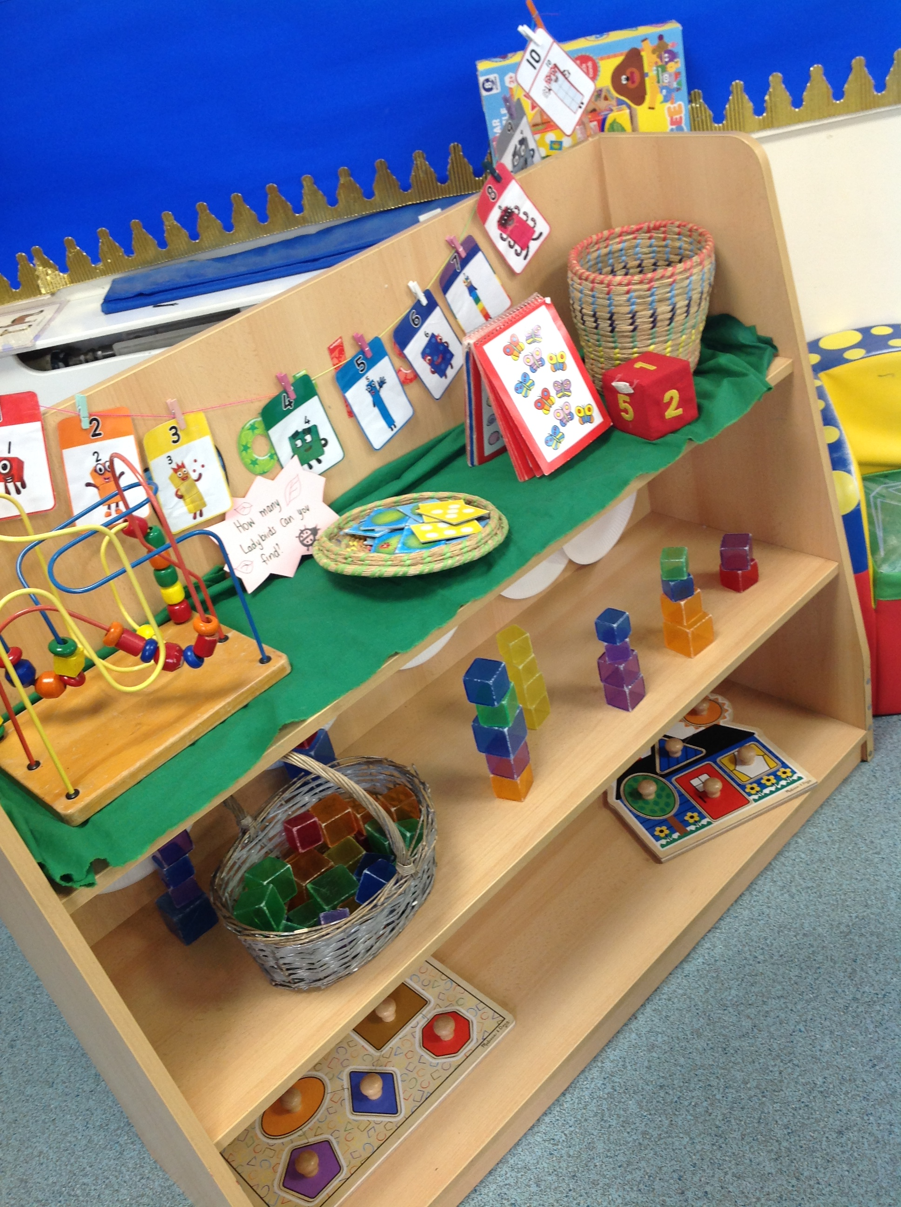
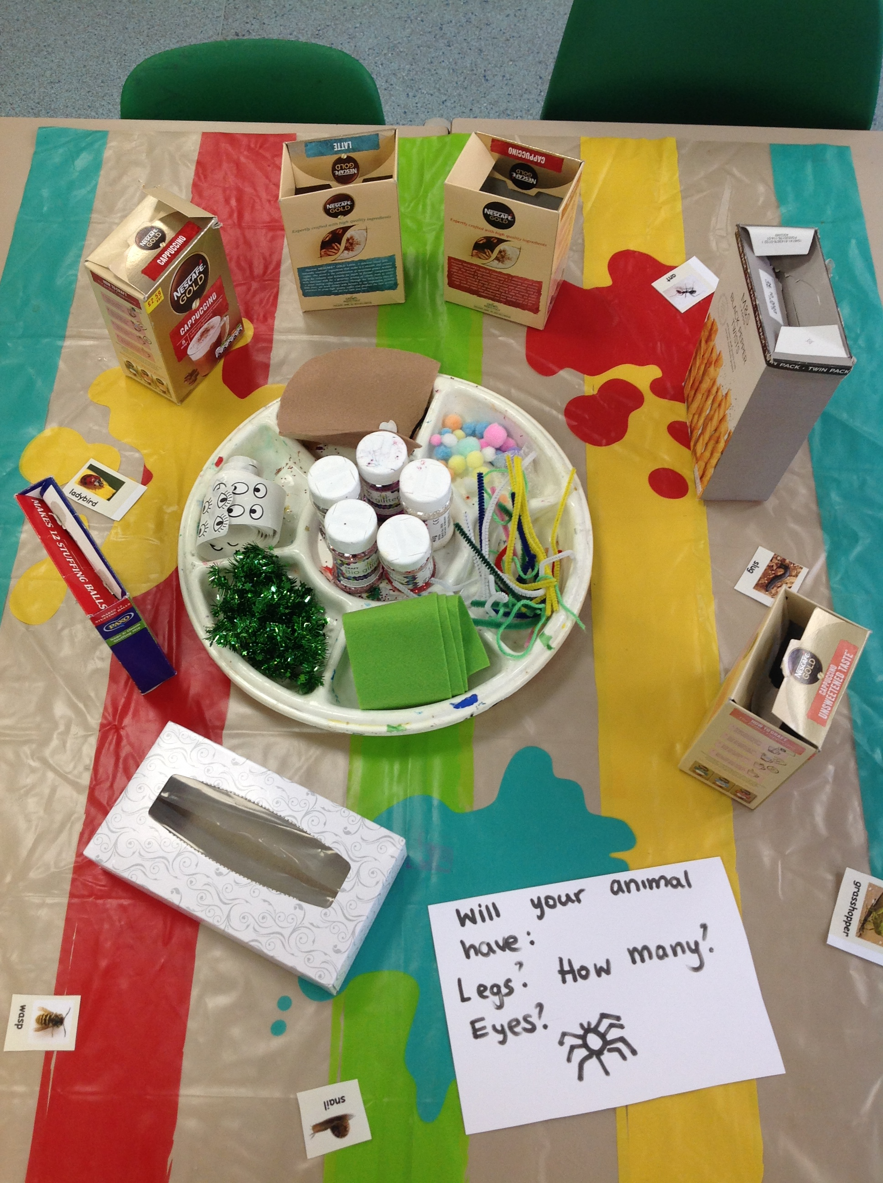
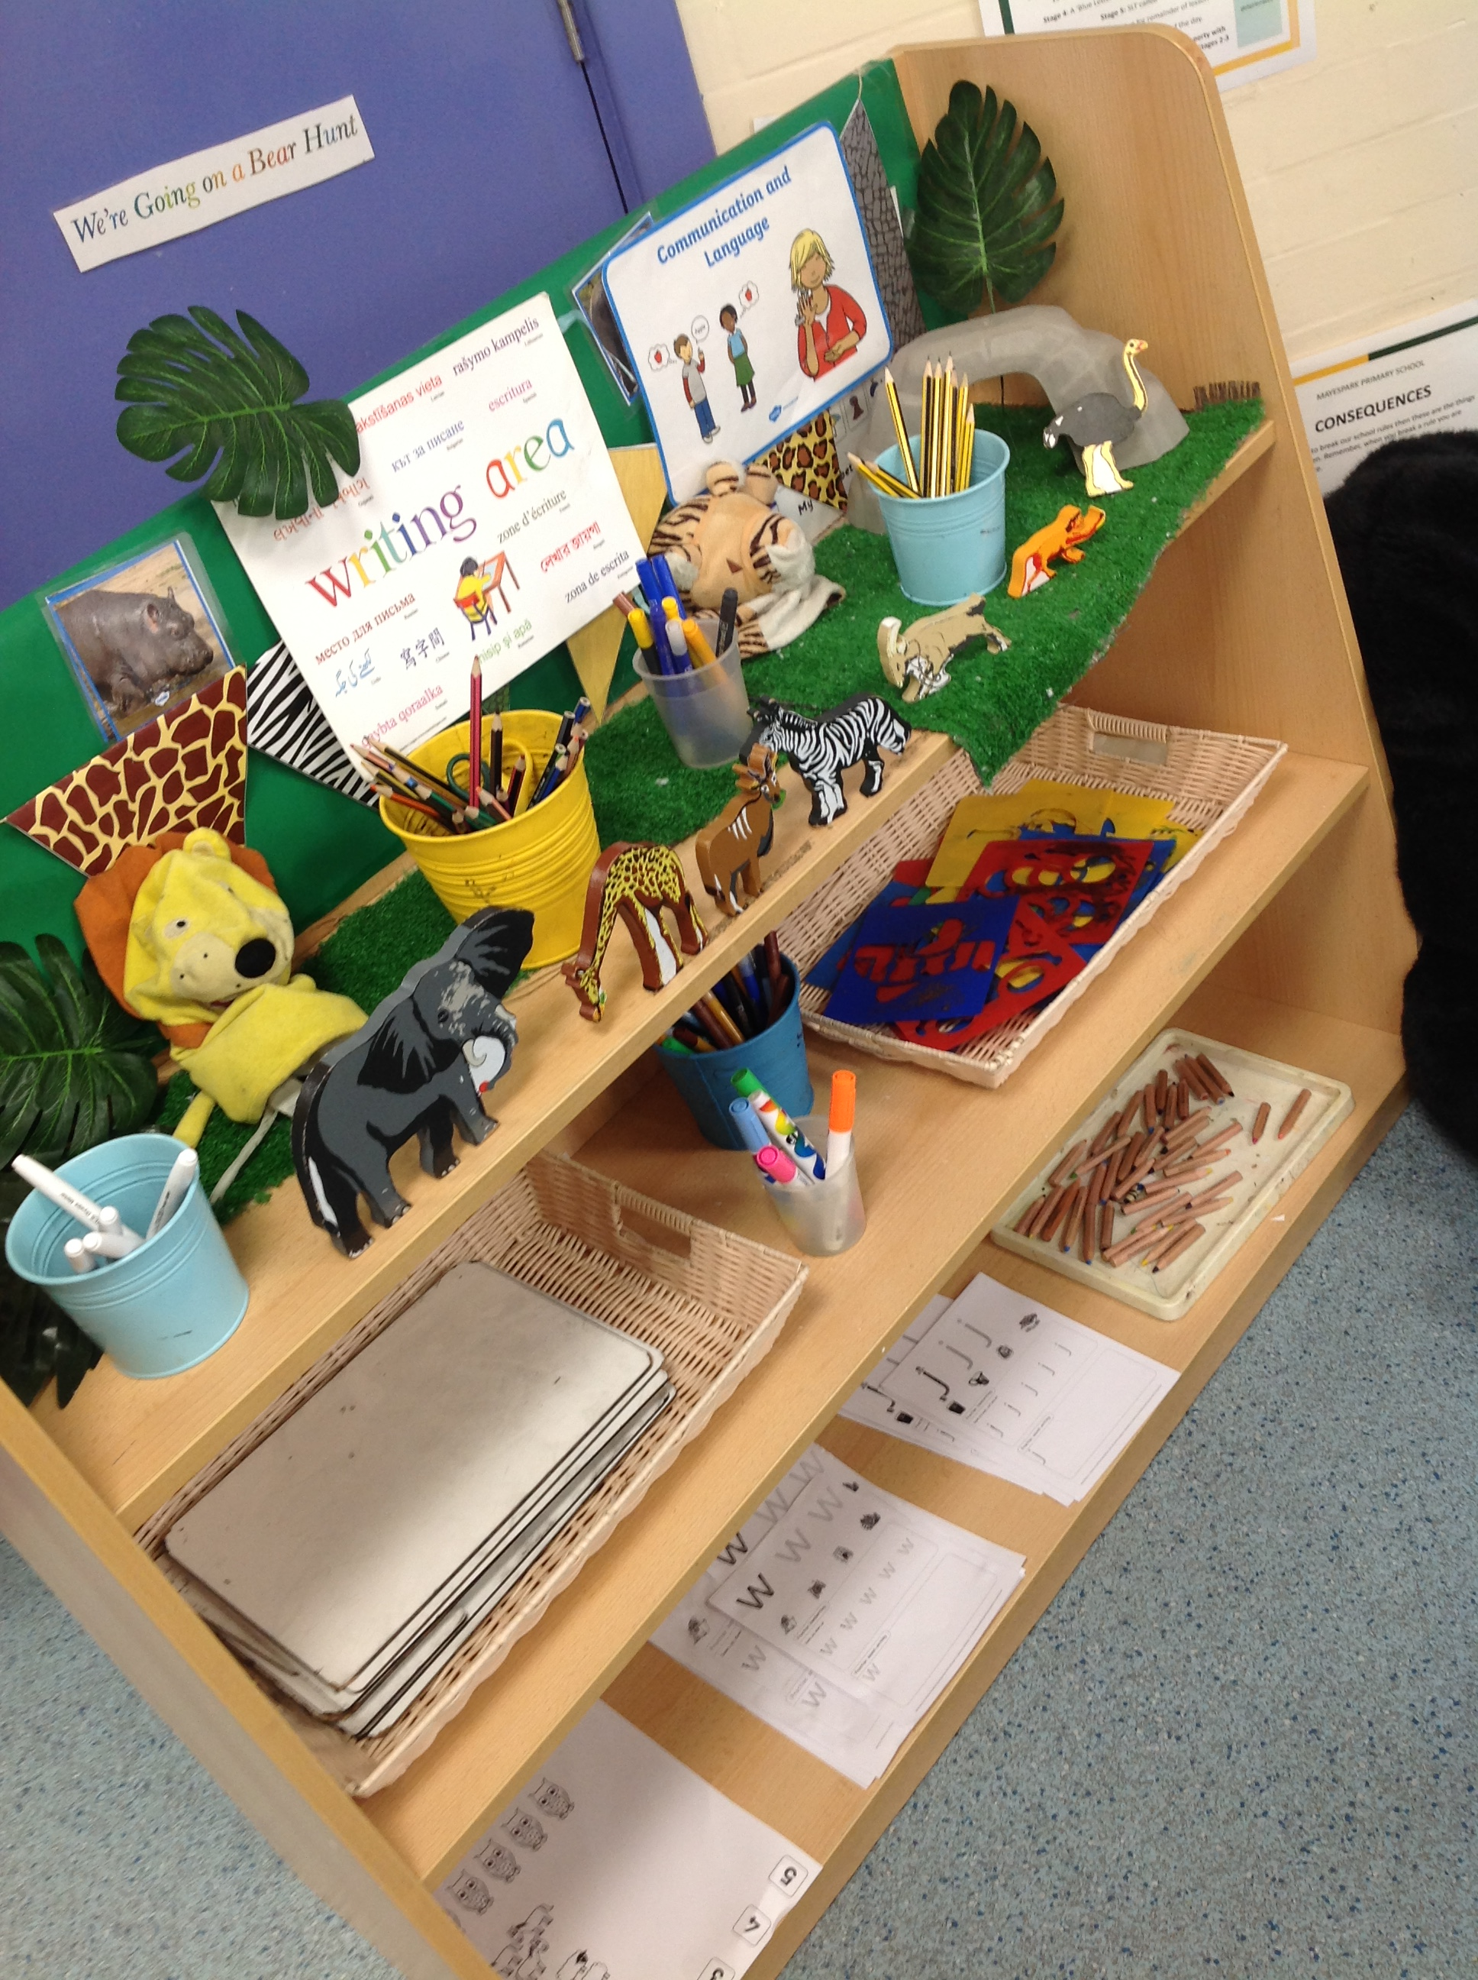
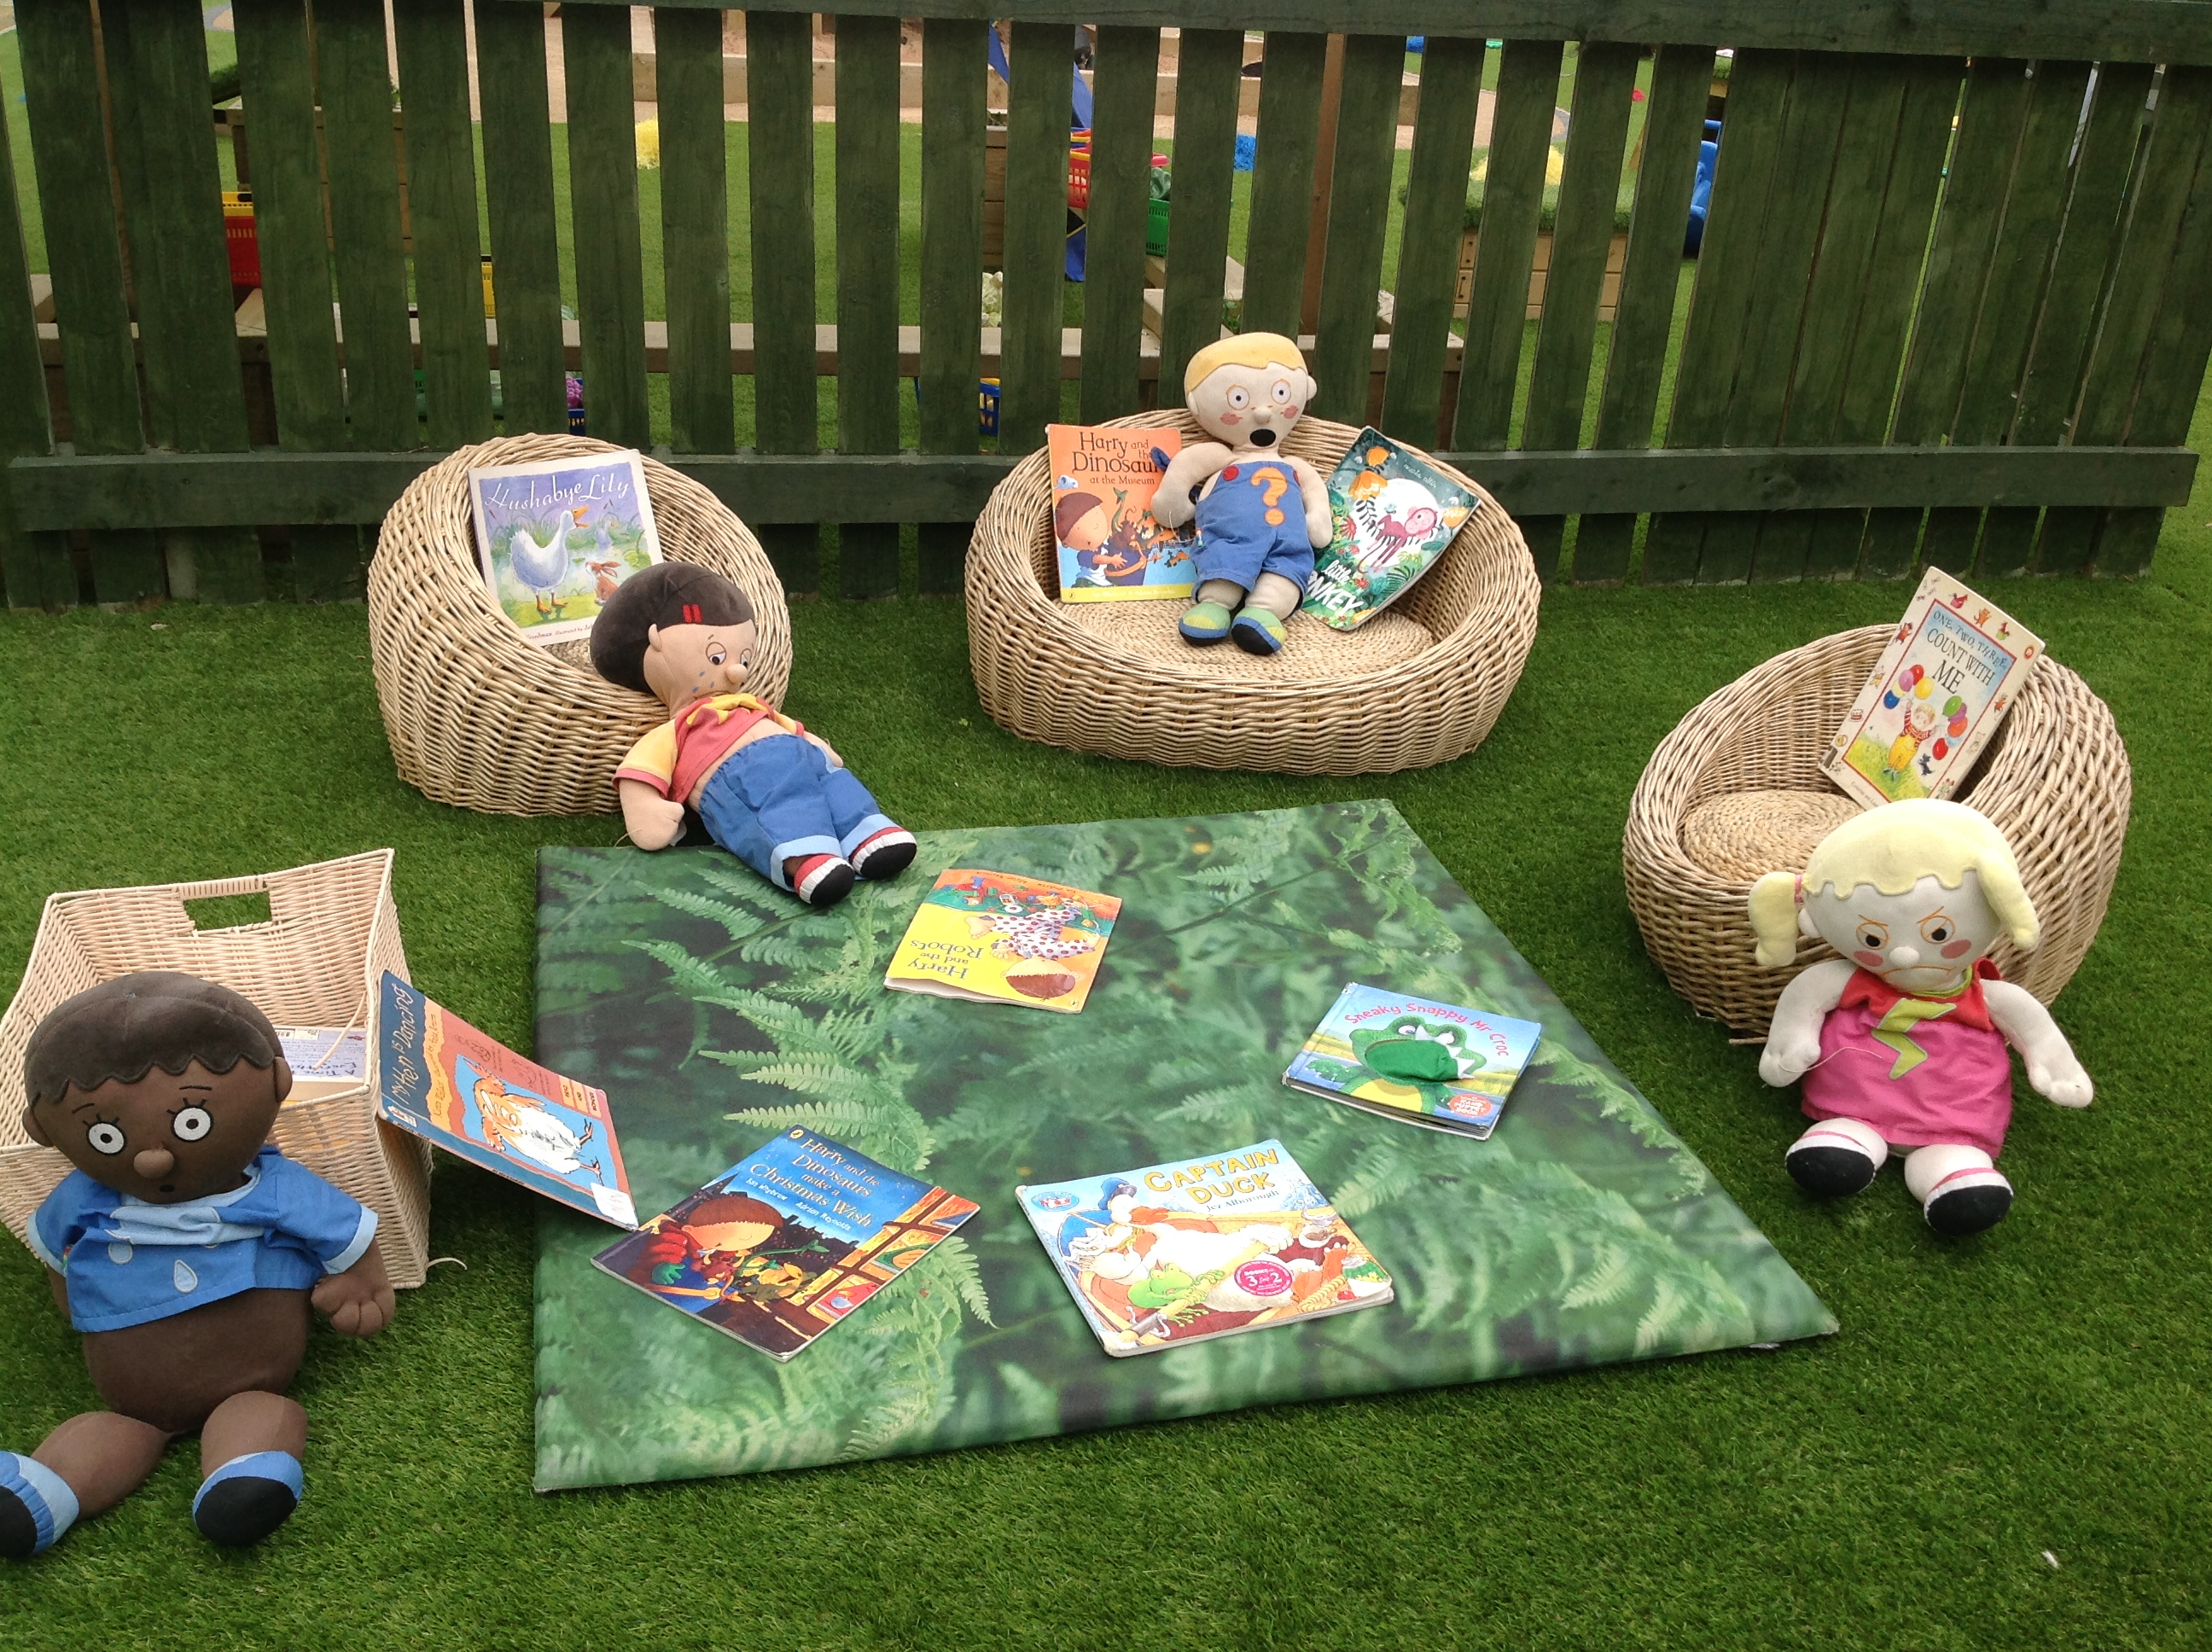
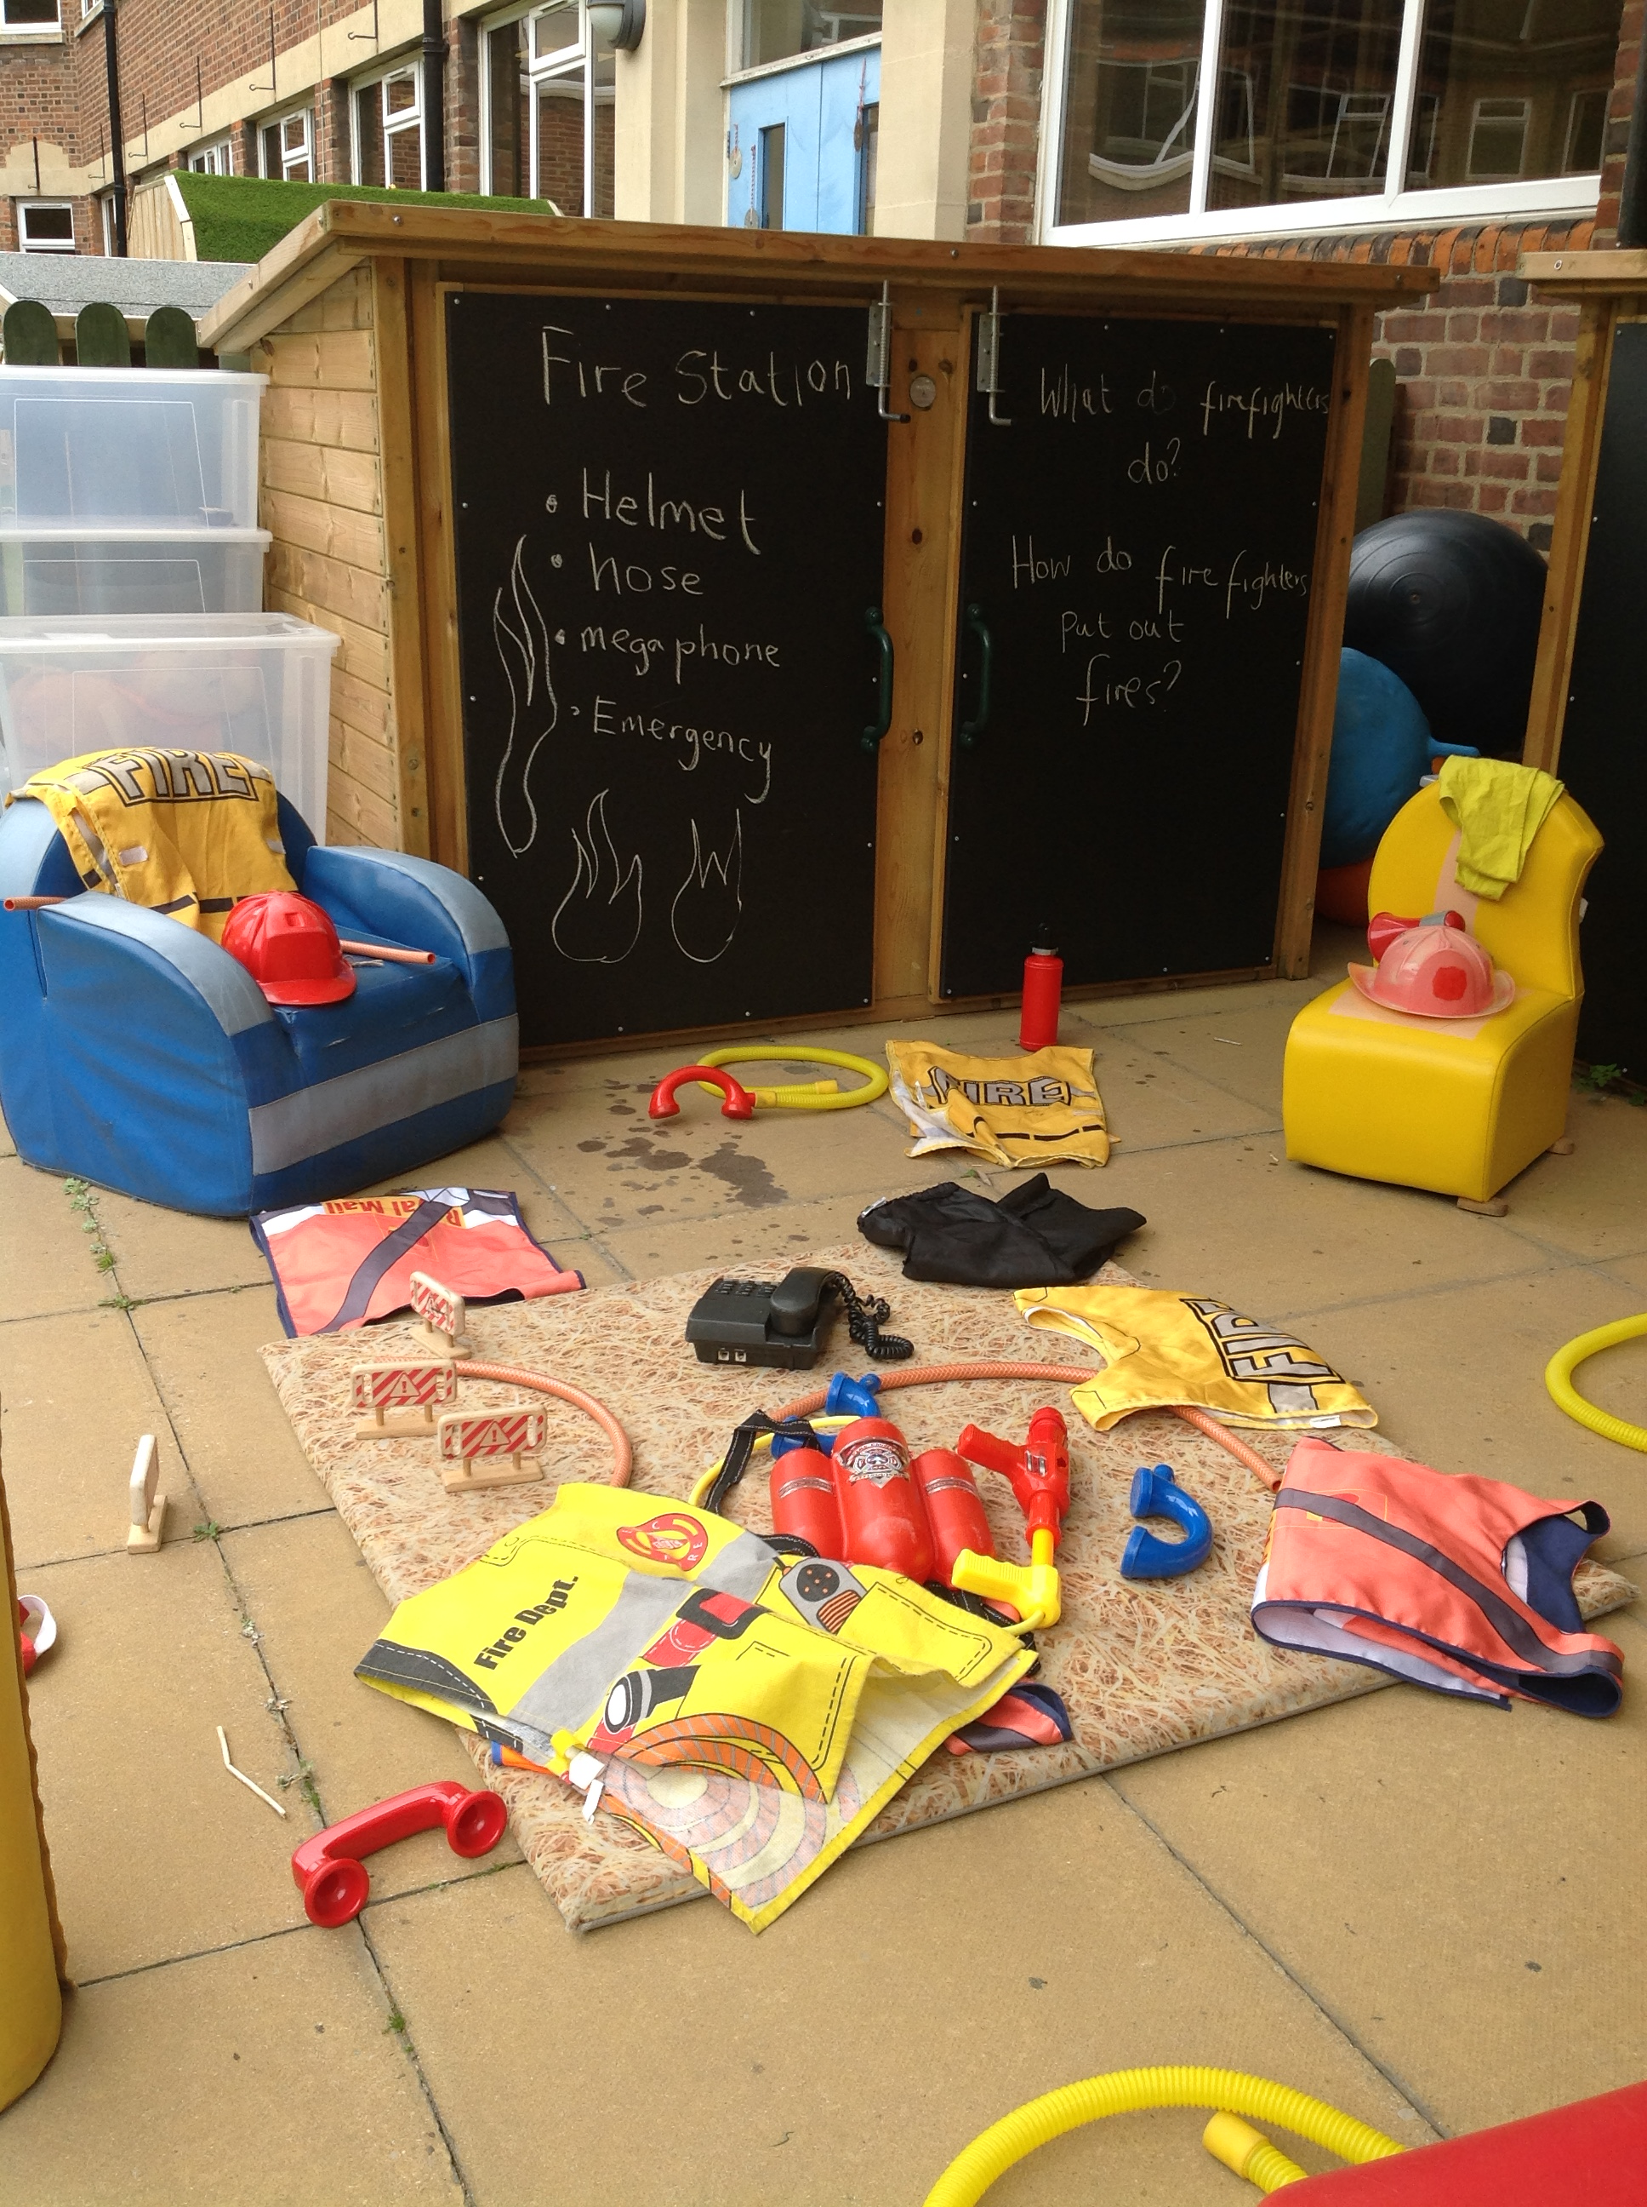

Our activities are planned around topics that change every half term and they vary from year to year.
Some of our topics are:

- All about me
- Stories and Rhymes
- Fairy tales
- Colours
- Growing and Food
- Adventures
Our curriculum is carefully planned using the most recent government guidelines, this is called the statutory framework for the early years foundation stage. In the early years curriculum there are seven areas of learning including three prime areas and four specific areas, through which the prime areas are developed and applied.

3 Prime Areas of Learning
Personal, Social and Emotional Development:
- self-regulation
- managing self
- building relationships

Physical Development:
- gross motor skills
- fine motor skills

Communication and Language:
- listening, attention and understanding
- speaking

4 Specific Areas of Learning
Literacy:
- comprehension
- word reading
- writing

Mathematics:
- number
- numerical patterns

Understanding of the World:
- past and present
- people culture and communities
- the natural world

Expressive Arts and Design:
- creating with materials
- being imaginative and expressive

The Framework also places a strong emphasis on children developing effective learning skills
- Playing and Exploring - engagement
Finding out and exploring, playing with what they know, being willing to ‘have a go’
- Active Learning - motivation
Being involved and concentrating, persevering, enjoying achieving what they set out to do
- Creating and Thinking Critically - thinking
Having their own ideas, making links, choosing ways to do things

Partnership with parents
It is important for parents and early years settings to have a strong and respectful partnership. This sets the scene for children to thrive in the learning environment. Parents will be given clear and regular information about their children’s progress along with ideas and strategies to support their learning at home.
Parents will also be invited to come into their children’s classroom to take part in read together sessions, phonics sessions and communication and language activities.
Throughout the academic term, we will be sending information about the curriculum to inform what the children will be learning at school along with ideas to support their home learning.

Progress
Staff are constantly monitoring children’s progress through working alongside them on planned or self-chosen activities. Samples of work, observation notes and photographs are collected as evidence of each child’s learning and stored in progress files. Parents and carers are welcome to look at these files at any time and are welcome to contribute their own notes about children’s achievements and interests.
Parents and carers are formally invited to meet with class teachers in the autumn term to discuss how their son or daughter has settled into class and again in the spring term to discuss their progress. You will receive a full written report on your child’s progress mid-year and at the end of the year and will be invited to look through children’s folders and meet your child’s teacher for the following year.
If at any time we are concerned that your child is not making enough progress or is not meeting age related expectations, we will invite you into school to discuss our strategies for addressing particular needs. This may involve meeting with the Inclusion Leader to adapt our provision for your child. Similarly, if you have any concerns, you can make an appointment to discuss these with us.

Home Learning
At Mayespark we believe that our children greatly benefit from a strong home school partnership. We consider parents and carers to have an important role to play in their child’s education and we fully support parents in doing so. You are able to find many home learning resources on our website and additional guidance will be sent home throughout the course of the year. If you ever require specific guidance regarding how to support your child’s learning at home, please do not hesitate to contact your child’s class teacher.
Reading
Reading plays an essential role in every child’s education. At Mayespark, we have very clear expectations regarding reading at home:

Reading to your child | Read different books to your child at least 6 days a week for at least 15 minutes.
Hearing your child read | Listen to your child read at least 6 days a week. Talk about what they have read referring to the comprehension questions in your child’s reading record.
Signing your child’s reading record | Sign and date your child’s reading record each day they read.
Changing books | School books will be changed at least weekly and a school adult will sign your child’s reading record weekly.

Every child will be given a reading record, inside you will find your child’s current reading target so that you can work on this at home. We ask that parents and carers write a daily comment in their child’s reading record. At the beginning of Reception, books from your child’s class library will be sent home for you to read to your child. Please spend quality time talking about the characters and what is happening in the story. Questions to support this can be found in your child’s reading record. When appropriate, your child will also be given simple reading books which they will be able to attempt to read themselves.
Phonics
At Mayespark we follow the Read Write Inc phonics programme which is called RWI for short. There is lots of information and resources for parents on our website to enable you to support your child at home.
At the beginning of the Spring term, teachers will send home activities linked to the sounds children are learning.

Getting Ready for Nursery
There are a number of things you can do to help prepare your child for starting full time school. It is essential that your child is potty trained and is able to unzip/zip up and unbutton/button up their uniform as independently as possible when going to the toilet
These include:

My ready to learn checklist

My challenges: |  |  |  | Date
I can put my coat on and take it off
I can drink from a cup
I can go to the toilet by myself
I can wash my hands before eating and after going to the toilet
I can take turns, play and share
I can ask for help
I can walk and do not need to use my buggy anymore
I can explore books with my family
I can use the pictures in the book to talk about what is happening
I can sit down and complete an activity for 5 minutes. (Puzzles, drawing a picture, making a model)

In addition to the above, along with the curriculum information we will be suggesting different ideas each half term for you to support your child’s learning at home.

We look forward to seeing you in September!

