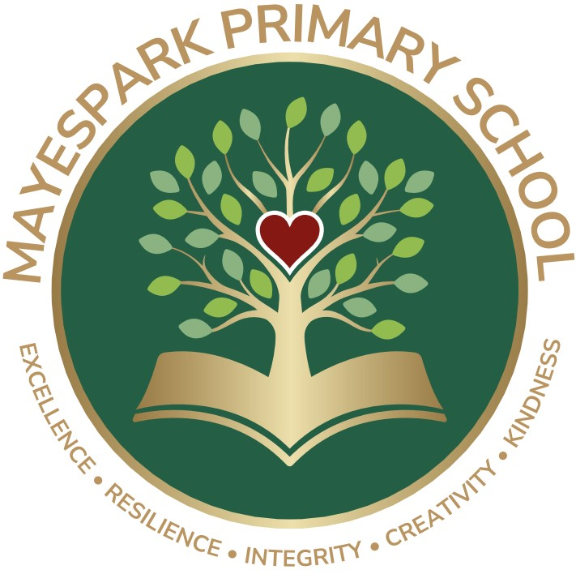

EARLY YEARS FOUNDATION

STAGE POLICY

September 2025

# Introduction to the Early Years Foundation Stage

The Early Years Foundation Stage (EYFS) applies to children from birth until the end of the Reception year. At Mayespark, the EYFS consists of Nursery (for 3-4 year olds) and Reception (for 4-5 year olds). Practitioners plan challenging learning experiences within a vibrant, engaging environment and assess the development and progress of each child.

The EYFS is based upon four themes and principles;

Themes

* A unique child
* Positive relationships
* Enabling environments
* Learning and development

Principles

* Every child is a unique learner who is constantly learning, capable, confident and self-assured
* Children learn to be strong and independent through developing positive relationships
* Children learn and develop well in enabling environments, in which their experiences respond to their individual needs and there is a strong partnership between practitioners and parents and carers
* Children develop and learn in different ways. The framework covers the education and care of all children in early years’ provision, including children with special educational needs

# Learning and Development

In the EYFS we acknowledge the potential for learning in every activity and situation that arises. Our aim is to provide a secure and stimulating environment in which children flourish and learn to make sense of the real world. We make the children feel valued and give them the confidence to become active learners.

Our activities provide first hand experiences through play and discussion where children are encouraged to interact with others, to move about and explore a wide variety of learning situations. Opportunities are provided for sustained activity and continuous provision, as well as spontaneous, self-chosen activities. It is important to us that children experience success, have fun and enjoy themselves whilst learning. At the heart of the EYFS curriculum are the three Characteristics of Effective Learning (CoEL);

* Playing and exploring
* Active learning
* Creating and thinking critically

CoEL are the different ways that children learn and these must be reflected in Early Years practice. Underpinning the CoEL is the understanding that during children’s earliest years, they form attitudes about learning that will last a lifetime. Children need to be encouraged to be creative and adventurous learners throughout their lives.

The EYFS curriculum is organised into seven areas of learning, consisting of three prime areas and four specific areas.

**Prime areas;**

* Personal, Social and Emotional Development (self-regulation, manging self and Building relationships)
* Communication and Language (listening and attention, understanding and speaking)
* Physical Development (gross Motor skills and fine Motor skills)

**Specific areas;**

* Literacy (comprehension, word reading and comprehension)
* Mathematics (number and numerical patterns)
* Understanding of the World (past and present, people, culture and communities and the natural world)
* Expressive Arts and Design (creating with materials and being imaginative and expressive)

All seven areas of the EYFS curriculum are equally important and depend upon each other. They are delivered through a balance of adult led and child-initiated activities. One learning experience may provide a child with opportunities to develop several competencies, skills and concepts across several areas of learning. Through play and practical experiences, children learn about the world and their place in it.

The Early Learning Goals (ELG) establish expectations for children to reach by the end of the EYFS. However, by the end of the EYFS some children may need to continue to work towards the ELGs.

In developing good Early Years practice, at Mayespark we recognise that children need;

* To know that they are valued as individuals
* To feel happy and secure in a stimulating and challenging environment
* Activities that are exciting, purposeful and relevant
* To be both physically and mentally active and involved in first hand experiences
* Opportunities to explore the environment both inside and outside
* Time to talk and share experiences with a variety of listeners
* Other children with whom to play and share
* Sensitive adults who are interested in them
* Opportunities to make mistakes without experiencing a sense of failure
* Encouragement to become independent, confident and sensitive to others’ needs
* To know that home and school are in harmony
* To feel positive about themselves

# Active Learning Through Play

Children’s play is extremely important. It is an essential and rich part of their learning process, supporting them in all areas of development.

Play is a powerful motivator encouraging children to be creative and to develop their ideas, understanding and language. Play is also flexible and able to suit the preferred learning style of the child. It can provide multiple ways for children to learn a variety of different skills and concepts.

We provide both structured and unstructured play opportunities inside and outside. These activities are designed to engage children in practical, first- hand experiences which will support children to discover, explore, investigate, and develop their personal interests and areas of curiosity. Such activities help children to make sense of the world around them as they begin to understand specific concepts. Play opportunities are also set up to provide children with opportunities to apply newly acquired knowledge, demonstrating their skills and level of understanding.

# Learning Garden

Outdoor learning is essential for all aspects of a child’s development. It can provide children with experiences which enable them to develop intellectually, emotionally, socially and physically. In doing so it provides a rich context for the development of their language and encourages positive attitudes towards a healthy lifestyle.

The learning gardens are accessed via free-flow which means children can move independently between the classrooms and the outdoor areas. Outdoors, children will have learning experiences that reflect the learning intentions, contexts and opportunities that are also provided indoors; together with additional learning opportunities that might be more easily accessed outdoors e.g. large physical play, mud kitchen, large scale sand and water play.

# Planning Indoor and Outdoor Learning

To ensure balance and breadth of provision, practitioners planning indoor and outdoor activities will think carefully about what it should include and why. They will have clear goals for children’s learning and at the same time be responsive to children’s enthusiasm and their interests. Within the planning there is flexibility to meet individual children’s needs as they arise during the session. Good quality resources are available to enhance and extend children’s play and the planning reflects the diversity and richness of the experience and developing interests of the children.

# Educational Visits and Experiences

At Mayespark we provide children with additional experiences such as an educational visit to embed the current topic and apply learning. We arrange for visitors to come into school and embrace other initiatives to include family members. We take part in whole school events such as World Book Day, festival celebrations, sports days and achievement assemblies. Involvement in these is always encouraged so children can receive a new experience in school.

# Organisation and planning

Mayespark Nursery has an intake of 52 children, in addition to offering one morning nursery class and one afternoon nursery class, with up to 26 children in each. We also offer all day session, subject to 30-hour code, which would be from 8.45am to 11.45am and 12.20pm to 3.20pm.

In Reception there are two classes, each with an intake of up to 30 children. All classes in the EYFS have a qualified teacher and nursery nurse, all classes also have additional LSAs according to children’s individual specific needs.

EYFS staff plan and work together to ensure continuity and progression, providing age and stage related activities to suit all our children. Children are also taught within their own class groups in a variety of ways; in whole class groups, small group work, pairs and individually.

Reception and Nursery classes have opportunities to move independently between their classroom and the outdoor area. In all classes, children are provided with an environment in which they are given opportunities to express themselves using a variety of mediums and suitable material to stimulate and extend imagination and understanding. Through planned play and talking, young children learn about themselves and the world around them, they are given opportunities to socialise, make friends and therefore develop personal, social and emotional skills and develop confidence.

# Transition

At the end of each academic year, handover meetings are held to discuss key facts about the children to ensure continuity in provision. Children spend time in their new learning environments with their future teachers to prepare them for the changes. For children starting Nursery, home visits take place at the beginning of the autumn term along with 2 play and stay sessions in which all parents are invited to come into the class room environment with the children to help with the settling in process.

# Assessment and Record Keeping

**Assessment in EYFS**

* On entry into Reception children undertake the RBA (Reception Baseline Assessment) to assess each child’s starting point.
* On-going assessment against the Early Learning Goals.
* Distant marking sheets to record children’s daily progress and to address misconceptions.
* Personalised next steps for each individual child.
* End of EYFS profile.

Ongoing assessment is an essential aspect of the effective running of the EYFS. Regular, planned and focused assessments are made of children’s learning and individual needs. The main EYFS assessment method is through practitioners’ observations of children in different teaching and learning contexts, including both adult focused activities and child-initiated play.

Other methods of assessing children in the EYFS setting include engaging alongside children in their play, annotation of children’s written work, talking with children about their task or play and in progress files. Progress files record children’s progress over the academic year in all areas of learning and development of the EYFS framework. Samples of children’s work are gathered, along with photographic evidence and observations.

Teacher observations are evaluated against the EYFS Development Matters statements and the ELGs, children’s learning priorities are identified and relevant learning opportunities are planned to support children to make the next steps and progress.

# Parent/Carer Partnerships

Education is a partnership between home and school. Parents/carers are children’s first educators. At Mayespark we strive to build on the learning experiences that are taking place at home. Children get the best out of their education when parents/carers and Early Years practitioners work together.

It is important that there is a good communication and flow of information between parents/carers, Early

Years practitioners and all those involved. There are several ways in which this can be achieved;

* Visits to Mayespark before admission – viewing the learning environments
* Welcome session – understanding the ethos of Mayespark
* Induction meetings – finding out all necessary information
* Open days – children and parents explore the new learning environments together
* Parents’ meetings – discuss child’s progress and next steps
* Progress files – evidence of work samples throughout the year
* Two school reports – achievements in the seven areas of learning and CEL, mid-year and at the end of the academic year
* Read together sessions – sharing books and promoting a love for reading
* My school App- to stay up to date with key information
* Daily accessibility of the staff to parents and carers

# Self-Help and Independence

Through the Early Years, our practitioners support the children’s growing independence and self-help skills. We support children’s independence as they do things for themselves, such as dressing and feeding themselves. We expect children to manage their own basic hygiene and personal needs successfully, including going to the toilet independently. We understand that toileting accidents may occur and we have the appropriate facilities for changing children, therefore all parents must read and sign the intimate care policy which is discussed when a child starts at Mayespark.

# Healthy Living

As a school that promotes good health and well-being, Mayespark is committed to encouraging and developing positive attitudes towards food and a healthy diet. Promoting a healthy life style is integral to our curriculum and we recognise the importance of offering children the opportunity to make informed choices about what, when, where and why they eat. As a school we know that food is fundamental to the quality of a child’s life, not just in providing essential nutrition but in communicating and sharing positive values, attitudes and experiences with each other. We believe that adults (staff, parents and carers) should be good role models and should support the children in understanding how balanced nutrition contributes to a person’s health, happiness and general well-being.

# Equal Opportunities

At Mayespark we provide all children regardless of ethnicity, culture, religion, home language, family background, learning difficulties, disabilities, gender or ability, equal access to all aspects of school life and work to ensure that every child is valued fully as an individual. Practitioners, as role models, are aware of the influence of adults in promoting positive attitudes and use that influence to challenge stereotypical ideas.

# Inclusion

Children with special educational needs will be given support as appropriate to enable them to benefit from the curriculum. This includes children that are more able, and those with specific learning difficulties and disabilities. Additional adult support may be provided for children with special medical needs. Individual Education Plans (IEPs) and provision maps identify targets in specific areas of learning for those children who require additional support, in line with the school's Special Educational Needs policy. The SENDCO and class teacher discuss these targets with the child and his/her parents/carers. Progress is monitored and reviewed regularly.

# Safeguarding

In our school and in our Early Years provision, safeguarding and promoting the welfare of children is everyone’s responsibility. Everyone who comes into contact with children and families has a role to play in safeguarding: identifying concerns, sharing information and taking prompt action. In order to fulfil this responsibility effectively, all professionals should make sure their approach is child-centred. This means that they should consider, at all times, what is in the best interest of the child. See School Safeguarding policy for further detail.