RWI (Read Write Inc) Homework Information

Every day your child attends a phonics lesson. The phonics scheme we teach from is called RWI. The children are assessed and put into groups so they are working at the correct level for them. This may mean that your child is not necessarily in a group with their class teacher. Each week, your child will bring home a spelling sheet which looks like this:

Front page
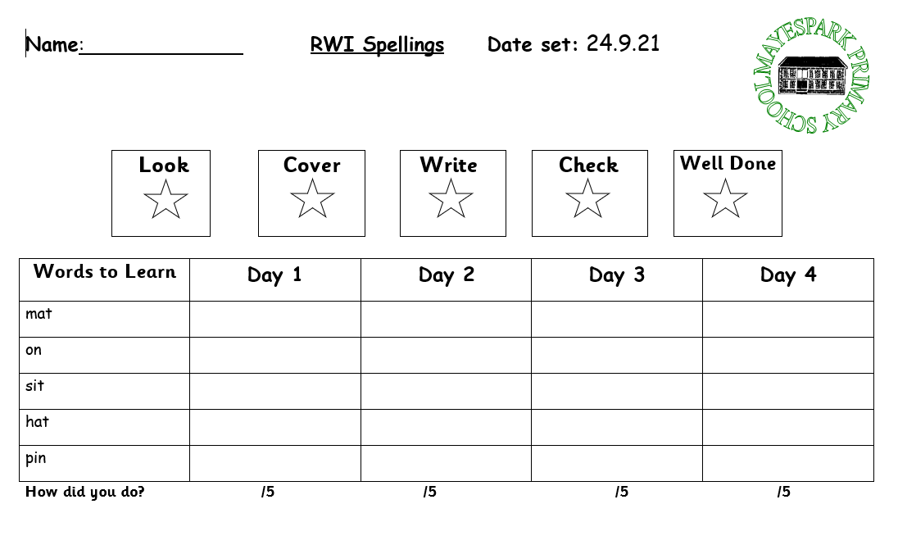
Back page
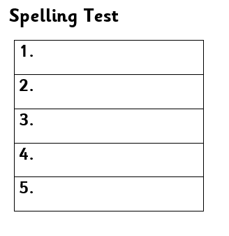

Some children have 5 spellings to learn and some have 10. This is dependent on the RWI group they are in. The front page which says ‘Day 1, Day 2’, etc is for your child to practise their spellings at home. This will not be collected in by the teacher. The back page is for the test which will be completed in school. This part will have been blank on the first set of spellings your child received. Once the spelling test has been completed in school, your child will bring home their new spellings with the test for the previous set of spellings on the back.

Your child will also receive a RWI book or sheet to read at home. Usually this will be on a Friday. They will have been reading this book in school with their RWI teacher. Please read this with your child a few times. The green words at the front of the book are words that your child should be able to sound out and blend and the red words are words that cannot be sounded out so need to be learnt.

The books and sheets look like this:

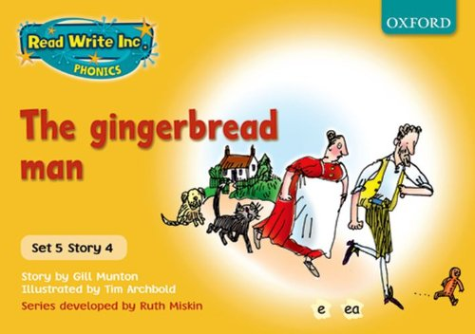
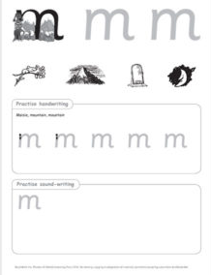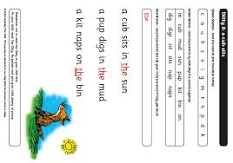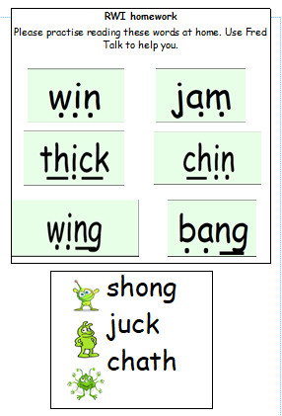

If your child is in a colour group and brings home a RWI book they will also bring a ‘BOOK BAG book’. See the example:
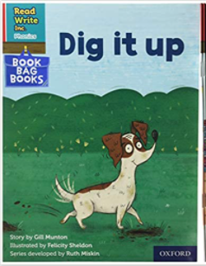
This is a book your child will not have read at school but is at the same level as the class book they have been reading. This gives them the opportunity to practise reading an unfamiliar book which includes sounds they have learnt at school. The books are set out like the books your child has read in class so they will be able to practise their green words, red words as well as answer questions about the story.

Free e-books
http://www.oxfordowl.co.uk/reading/
On the Oxford Owl website there are lots of free e-books for home reading. Your child will have log in details for the website and then they can choose books at the same colour stage to practise reading.

