Children who completed the pupil voice:
EYFS/ KS1 | KS2
20 | 50

Why is PE important?
PE makes you strong.

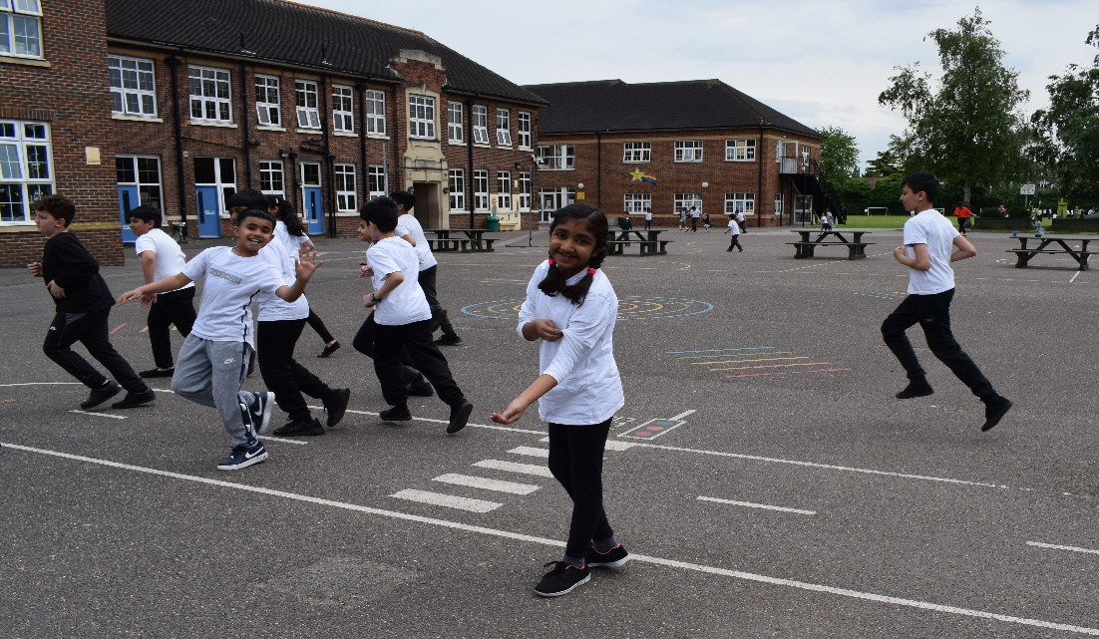
PE is important because it helps you burn calories.

PE makes me fit and healthy.

PE makes me sleep better at night.

EYFS and KS1 Pupil Voice

Statements –EYFS/ KS1 PE |  | Yes | No | Not sure
1 | Do you enjoy PE lessons? | 100%
2 | Do you get to try lots of different sports in PE? | 100%
3 | Do girls and boys get the same chances in PE? | 58% |  | 42%
4 | Do you practice skills in PE to get better? | 100%
5 | Does your teacher help you get better? | 86% |  | 14%
6 | Do you know how good you are at PE? | 71% |  | 29%
7 | Do you play lots of games in PE to help you get better? | 100%
8 | Do you know why it’s important to warm up in PE? | 86% |  | 14%
9 | Do you feel confident in PE? | 71% |  | 29%

It is evident that EYFS and KS1 children at Mayespark Primary School feel very positive about their PE lessons with all children asked agreeing that they have the opportunity to take part in a range of sports and enjoy lessons. We identified that we need to look at how we report to the children on how they can improve in PE. We also need to make sure that all children know the importance of warming up in PE, this can be done in each lesson. Further work needs to been done on understanding why 42% of the children asked were not sure if girls and boys receive the same chances in PE.

EYFS/ KS1 Questionnaire.
Why is PE important?
“because it helps you move,” Year 1 pupil. | “to keep yourself fit,” Year 2 pupil.
“to keep your bodies warm,” Year 2 pupil. | “so that you become strong,” Reception pupil.
“PE is important because you get fit,” Year 2 pupil. | “because it helps your body,” Year 1 pupil

Why is it important to warm up in PE?
“we have to warm up before we balance so that we don’t hurt ourselves,” Year 1 pupil | “if you don’t warm up you might get cold,” Reception pupil.  “so that you don’t hurt yourself,” Reception pupil.
“so, you can play better,” Reception pupil.  “calms your body down and gets your heart ready,” Year 1 pupil | “it is important to get your body warm so you are ready for the lesson,” Reception pupil.

What do you enjoy the most about PE?
“playing games,” Year 1 pupil | “you get to run around,” Year 2 pupil.
“I love doing warm ups,” Reception pupil. | “playing against other children,” Year 2 pupil.
“I enjoy doing lots of different sports,” Reception pupil. | “trying hard and learning new skills,” Year 1 pupil

Is there anything that you don’t like about PE?
“balancing games,” Reception pupil. | “losing,” Year 1 pupil
“stretching,” Year 2 pupil. | “I love everything about PE,” Reception pupil.

What activities do you like to do at playtime/lunchtimes?
Skipping, playing with my friends, run, cricket, football, playing tag

What sports clubs would you like to see at the school?
Cricket, football, basketball, kick boxing

Statements –EYFS/ KS1 PE |  | Strongly agree | Agree | Not sure | Disagree | Strongly disagree
1 | I enjoy PE lessons. | 50% | 45% |  | 5%
2 | I get to try lots of different sports and activities. | 30% | 55% | 10% | 5%
3 | Girls and boys get the same opportunities in PE. | 40% | 40% | 20%
4 | I get the chance to improve my skills in PE lessons. | 45% | 40% |  | 15%
5 | I know what we are expected to learn in each lesson. | 30% | 35% | 25% | 5% | 5%
6 | I know how well I am doing in PE and how I can improve. | 25% | 55% | 20%
7 | We play games to practice our skills in PE. | 65% | 25% | 5% | 5%
8 | I know why it’s important to warm up and cool down in PE. | 65% | 25% | 5% |  | 5%
9 | I feel confident in PE? | 30% | 60% | 5% | 5%
KS2 Pupil Voice

The graph paints a positive image of PE throughout KS2 with a high amount of strongly agree and agree statements regarding enjoying PE lessons. We would like to see that all children are clear on the objectives for each lesson and this is something to address. It is evident that we make the importance of warm ups and cool downs clear. We need to work on how we assess the children in PE and how they know how well they are doing as 20% of children asked were unsure. It’s great that 80% of the children either strongly agree or agree that girls and boys get the same opportunities in PE. We would like to continue to improve on this area as a school and work will continue next year in raising the profile of girls in sport.
KS2 Questionnaire.
Why is PE important?
“it gets your heart pumping and makes you feel awake” Year 6 pupil. | “you need exercise to stay healthy” Year 5 pupil.
“PE is not only great exercise but it exposes you to different sports” Year 4 pupil. | “because it’s good for you physical and mental health” Year 4 pupil.
“it is important to take care of your physical stamina. It makes you fit” Year 6 pupil. | “it keeps us at a healthy weight” Year 3 pupil.

What makes a really enjoyable and successful PE lesson?
“playing games” Year 3 pupil. | “when everybody plays fairly” Year 4 pupil.
“listening,” Year 3 pupil. | “learning new skills” Year 5 pupil.
“practising skills then playing games” Year 6 pupil. | “doing a warm up, skills and games” Year 4 pupil.

Why is it important to warm up in PE?
“it’s important to warm up so you don’t pull a muscle” Year 5 pupil. | “you can stretch more and so you don’t pull a muscle” Year 3 pupil.
“it’s important to warm up because your heart starts pumping bloody everywhere” Year 6 pupil. | “learning and practising new skills” Year 6 pupil.
“so your body is ready to start activity” Year 5 pupil.

What do you enjoy the most about PE?
“I enjoy all the activates my teacher sets up” Year 6 pupil. | “all the different games we play” Year 3 pupil.
“getting to play together and having competitions” Year 4 pupil. | “the matches” Year 5 pupil.
“everything, going outside” Year 3 pupil. | “I enjoy doing different sports” Year 6 pupil.

What activities do you like to do at playtime/lunchtimes?
Cricket, tag, football, netball, table tennis

What sports clubs would you like to see at the school?
Boxing, football, netball, table tennis, hockey

