Pupil premium strategy statement
This statement details our school’s use of pupil premium (and recovery premium) funding to help improve the attainment of our disadvantaged pupils.
It outlines our pupil premium strategy, how we intend to spend the funding in this academic year and the effect that last year’s spending of pupil premium had within our school.

School overview
Detail | Data
School name | Mayespark Primary School
Number of pupils in school | 609
Proportion (%) of pupil premium eligible pupils | 23%
Academic year/years that our current pupil premium strategy plan covers (3-year plans are recommended) | - – 2027
Date this statement was first published | December 2024
Date of first review | December 2025
Date on which it will be reviewed | December 2026
Statement authorised by | Headteacher
Pupil premium lead | Emiley Davies
Governor lead

Funding overview
Detail | Amount
Pupil premium funding allocation this academic year | £178,293 2023/24  (£162,330 in 2024/25)
Pupil premium funding carried forward from previous years (enter £0 if not applicable) | £0
Total budget for this academic year (2024/25) | £162,330

Part A: Pupil premium strategy plan

Statement of intent
Our ultimate objectives for our disadvantaged pupils are:
- To remove barriers to learning created by poverty
- To close the attainment gap between disadvantaged and non-disadvantaged pupils.
Our current Pupil Premium strategy plan will work to:
- Provide all teachers with high quality CPD to ensure all children receive effective quality first teaching.
- Identify barriers to learning created by disadvantage
- Provide targeted intervention, support and resources to address identified gaps in learning.
- Enhance children’s experience of school through enrichment and educational experiences.
- To close the word gap for ALL pupils so that they are able to read fluently with comprehension and can access the breadth of the curriculum.
- To improve the quality of writing in all year groups
- To improve attendance so that disadvantaged pupils attend as well as non-disadvantaged pupils
- Continue the nurturing environment while pushing for excellence for all children
Research from the Education Endowment Fund (EEF) claims that the most important and effective strategy to close the gap between disadvantaged and non-disadvantaged pupils is a focus on high-quality teaching. This, along with an emphasis on the teacher–pupil relationship is at the very heart of the strategies we have outlined in this report. Teacher’s knowledge of the pupil’s in their class and the gaps in learning along with opportunities to close them will be critical to closing the attainment gap between disadvantaged and non-disadvantaged pupils. Crucially, however, it is our intention that every pupil should make progress and attain as high as they are able no matter what their barriers to learning may be.
Our assessment processes in school are robust and allow us to identify the gaps in learning for all pupils. This formative approach is also used to identify the needs of pupil groups and individuals based on their answers in tests and teacher observation in lessons. We then use this information to respond strategically to the needs of the pupils ensuring that every child has opportunities to close the gaps in their understanding. Our policy, in line with research, is that live feedback has the biggest impact on learning.
The approaches we have suggested in this report are well researched and devised with the needs of our children at the centre. There has been input from the senior leadership team and class teachers. Some of the strategies are suggestions made by external advisors who have visited the school and understand the needs of our pupils.

Challenges
This details the key challenges to achievement that we have identified among our disadvantaged pupils.
Challenge number | Detail of challenge
1 | The gap between children in receipt of Pupil Premium (PP) and Non-Pupil Premium (NPP) is significantly lower than the National Average (NA) gap for Reading and Maths. However, in writing there is a significant gap which is also present in teacher assessment data. See Appendix 1 for data. We have introduced a new approach to teaching writing and this is having an impact already.
2 | Our data across the school shows the percentage of children attaining ARE or above in reading, writing and maths combined at end of KS2 over the last 4 years:  The gap between our disadvantaged pupils and all pupils is variable and we aim to narrow this gap with a combination of high-quality teaching and targeted interventions. Our disadvantaged pupils consistently out-perform disadvantaged pupils nationally.
  Year | MPS All | MPS Dis | Gap | NA Dis | Gap
  2021/22 | 65% | 59% | -9 | 43% | 16
  2022/23 | 57% | 48% | -9 | 44% | 4
  2023/24 | 66% | 57% | -9 | 46% | 11
  2024/25 | 65% | 63% | -2 | 47% | 16
3 | Assessments, monitoring, observations, and discussions with pupils indicate vocabulary gaps among many disadvantaged pupils. These are evident from Reception through to year 6 and in general, are more prevalent among our disadvantaged pupils than their peers.
4 | Assessments in EYFS along with monitoring and observations show that children begin their schooling with poor PSED and, more recently, communication and language skills.
5 | Discussions with children and observations demonstrate that children have limited life experiences leading to a lack of cultural capital and aspiration.
6 | We have a number of vulnerable families who have required further support in social and emotional development.

Intended outcomes
This explains the outcomes we are aiming for by the end of our current strategy plan, and how we will measure whether they have been achieved.
Intended outcome | Success criteria
To improve outcome for disadvantaged pupils in Writing. | SATs scores at the end of KS2 show a reduction in the gap between PP and Non-PP as measured by the ASR.
To improve the outcomes in reading. | Teacher assessment data will show an improvement in outcomes for reading.  Internal test data will show an upward trend in outcomes for reading.  Book band tracking will show that children’s reading ages are increasing.  Drop-ins and test data will show that ‘Destination Reader’ has had a positive impact on outcomes.  Reading Plus will be tracked and monitored to ensure it leads to accelerated progress.
Children will have wider vocabulary and knowledge of the meanings of subject specific vocabulary. This will have a positive impact on writing. | Discussions with children and lesson drop-ins will show that teachers are including a wide range of new vocabulary in the classroom.  Test analysis will demonstrate an improvement in the answering of vocabulary focused questions.  Monitoring of planning and books will show that vocabulary is being planned for and taught as part of each subject.
Children in EYFS will make improved attainment in all areas. | Teachers will complete the baseline assessments and use this as an opportunity to gain an understanding of the ‘on entry’ attainment levels of the children in receipt of PP.  Data drops throughout the year will show an improvement in attainment Monitoring of planning, drop ins and observation of the children will demonstrate that the needs of PP pupils are being met.
Children will have improved life experiences that positively impact their well-being and cultural capital. | Monitoring of planning and children’s books will show that there are opportunities in the curriculum to expand the children’s life experiences.  Extra-curricular experiences are varied and well attended.  Children will be attending a range of educational visits that allow them to build their cultural capital. Discussions with the children will demonstrate this.  Children will be nurtured leading to fewer behaviour incidents and improved attendance.
To improve outcomes in maths for children who are pupil premium and close the gap with those who are not pupil premium. | Teacher assessment data will show an improvement in outcomes for maths.  Internal test data will show an upward trend in outcomes for maths.  Drop-ins and test data will show that modelling in maths has had a positive impact on outcomes.  Mastering Mathematics is embedded and teachers are competent in planning with the scheme

Activity in this academic year
This details how we intend to spend our pupil premium (and recovery premium funding) this academic year to address the challenges listed above.

Teaching (for example, CPD, recruitment and retention)
Budgeted cost: £39,300
Activity | Evidence that supports this approach | Challenge number(s) addressed | Cost
Individual termly pupil progress meetings for all staff. Prior to progress meetings, data will be analysed and children will be identified who are not making adequate progress.  All class teachers will meet with a member of our senior leadership team to discuss barriers to learning and identify clear next steps. | ‘Once you have gauged the performance of your disadvantaged pupils against national benchmarks, for pupils whose attainment is below age-related expectations, you should examine what could be hindering their attainment.’  EEF https://educationendowmentfoundation. org.uk/guidance-for-teachers/usingpupil-premium?utm_source=/guidancefor-teachers/using-pupil-  premium&utm_medium=search&utm_c ampaign=site_searchh&search_term | 2,3,4 | £15,500
Tailored staff training to raise quality of teaching  and learning.  Teaching Walkthrus and incremental coaching to be implemented. | ‘Good teaching is the most important lever schools have to improve outcomes  for disadvantaged pupils.’  EEF https://educationendowmentfoundation. org.uk/public/files/Publications/Pupil_Pr  emium_Guidance_iPDF.pdf | 2,3,4 | £8,200
‘Destination Reader’ purchased as a recommended  approach to teaching reading. This needs to continue to be embedded and monitored. | ‘Destination Reader focuses on  developing learning behaviours that uplevel children’s discussions. Feedback from over 100 schools currently using Destination Reader has shown dramatic improvement in the quality of reading lessons at KS2. Children read with greater understanding, independence and, above all, enjoy reading more.’ https://www.hackneyservicesforschools. co.uk/product/destination-reader-school | 2,3 | £5,000
Leadership time in monitoring the planning, teaching and assessment of reading. This includes the monitoring of reading at home. | An instructional leader promotes common approaches to factors such as teaching and behaviour management in the school, monitors teaching, and makes sure that professional development focuses on teaching and learning. In many cases, instructional leaders start the process of school improvement by implementing a particular initiative promoting a particular curricular or pedagogical approach. Ofsted framework 2019. | 2,3,4 | £3,600
SEND support for those pupils eligible for PP in EYFS Nursery Nurses | Use of a structured-but-adaptive manualised intervention programme alongside  embedded professional development had a positive impact on children’s expressive  vocabulary and the quality of adult-child interactions during shared book-reading.  Nuffield Foundation https://www.nuffieldfoundation.org/wp-content/uploads/2019/11/Dockrell-Talking-Time-final-report.pdf | 2,3,4 | £7,000

Targeted academic support (for example, tutoring, one-to-one support structured interventions)
Budgeted cost: £56,630
Activity | Evidence that supports this approach | Challenge number(s) addressed | Cost
One to one conferencing carried out by class Teachers with children in Year R - 6 | 1-on-1 conferencing works during formative and summative stages of the educational process.  The Art of Education University  https://theartofeducation.edu/2016/08/2 9/bring-benefits-1-1-conferencing/ | 1,2,3 | £25,000
Individual reading practice. Children who do not read regularly at home will be identified by class teachers. A support member of staff will hear individual readers weekly, practising decoding and comprehension | Reading comprehensions strategies involve the teaching of explicit approaches and techniques a pupil can use to improve their comprehension of written text. Many learners will develop these approaches without teacher guidance, adopting the strategies through trial and error as they look to better understand texts that challenge them. However, we know that on average, disadvantaged children are less likely to own a book of their own and read at home with family members, and for these reasons may not acquire the necessary skills for reading and understanding challenging texts.  EEF https://educationendowmentfoundation. org.uk/education-evidence/teaching-  learning-toolkit/reading-comprehensionstrategies | 1,2 | £8,000
Targeted Interventions from HLTAs | Teaching assistants (also known as TAs, classroom support assistants or teachers’ aides) are adults who support teachers in the classroom. Teaching assistants’ duties can vary widely, but they are generally deployed in two ways; to support the teacher in the general classroom environment, or to provide targeted interventions, which are often delivered out-of-class. The role can also include administrative support.  https://educationendowmentfoundation.org.uk/education-evidence/teaching-learning-toolkit/teaching-assistant-interventions | 1,2 | £28,000  Not enough budget to provide this in 2024/25
Reading plus purchased as a method for assessment and intervention | The Reading Plus program is designed to help students of all abilities become the best readers they can be. The program is based on the latest reading research from leading experts as well as academic and research institutions https://f.hubspotusercontent00.net/hubf s/2086007/Theoretical-Framework-  Foundational-Research_16-  Pages_20210310.pdf | 1,2,3 | £5,630
Purchase of books to keep book banded system up to date | ‘Quality levelled reading schemes help to build the fluency, stamina, confidence and the important reading skills that children need before they move on to a wider range of books. Supporting notes and resources can help teachers with effective questioning and promote discussion. Linked resources are often provided to enable parents to work more effectively with their children at home.’  Oxford Reading Owl – Building an outstanding reading schoolhttps://cdn.oxfordowl.co.uk/2017/04/21/ 10/51/51/265/bp_osi_buildingoutstandin g.pdf | 1,2,3 | £7,000
Leadership focus time for robust assessment and gap analysis to ensure that interventions are focused for pupils entitled to pupil premium funding. | Teachers can use assessment to help them plan lessons, adapt lessons to measured gaps in knowledge and skills, and if necessary re-teach where problems persist. To do this effectively requires pupils to be assessed at the start of a unit of learning, so that instruction can be adapted to the level that pupils are starting from.  Ofsted framework 2019 | 2,3,4 | £8,000

Wider strategies (for example, related to attendance, behaviour, wellbeing)
Budgeted cost: £ 66,400
Activity | Evidence that supports this approach | Challenge number(s) addressed | Cost
Systematically track parents’ attendance at parents’ evening | ‘Parental engagement has a positive impact on average of 4 months’ additional progress. It is crucial to consider how to engage with all parents to avoid widening attainment gaps.’  EEF https://educationendowmentfoundation. org.uk/education-evidence/teachinglearning-toolkit/parental-engagement | 1 | £2,500
Pastoral care provided through Our Space provision. Learning mentors will be assigned to work with specific pupils in need of additional pastoral care | Teaching learning behaviours will reduce the need to manage misbehaviour.  EEF https://educationendowmentfoundation. org.uk/education-evidence/guidancereports/behaviour | 5,6 | £13,700
Subsidised before and after school childcare for working parents. | Pupils will be provided with a nutritious afternoon snack / breakfast and more parents will be able to  work, providing greater financial stability for their family  Before the coronavirus pandemic, as many as 1.7 million children in the UK were living with food insecurity, at risk of hunger in the morning, according to government figures.* Then, in the 6 months March-August 2020, the Food Foundation reported that 2.3 million  children were living in households that had experienced food insecurity.  https://www.magicbreakfast.com/whywe-are-needed | 5,6 | £14,600
Subsidise educational visits, residential visits to PGL and France. | Leaders adopt or construct a curriculum that is ambitious and designed to give learners, particularly the most disadvantaged, the knowledge and cultural capital they need to succeed in life.  Ofsted framework 2019 | 5 | £7,600
Peripatetic music tuition. All children have access to private instrumental tuition. | A steady routine can help provide stability in a child’s life, which can give children and young people a sense of security and help reduce stress. Here are some tips you can suggest to parents and carers you work with:  • plan regular weekly activities, such as seeing friends and relatives or taking part in a club or hobby  https://learning.nspcc.org.uk/childhealth-development/promoting-mentalhealth-wellbeing | 5 | £3,000
Parent Support Advisor (PSA) in place to help improve attendance through family support. | The importance of parent engagement in children’s learning is widely acknowledged (e.g. Goodall 2017), indeed the evidence suggests that it has many benefits, such as improvements in literacy and maths skills (Van Voorhis et al. 2013), better school attendance (McConnell and Kubina 2014) and closure of the achievement gap (Goodall 2017).  https://educationendowmentfoundation. org.uk/public/files/Publications/Parental Engagement/Parental_Engagement__Evidence_from_Research_and_Practi ce.pdf | 1,5,6 | £14,000
ELSA trained LSA’s are to work with identified children. | The ELSA programme is a targeted intervention aimed at developing the social and emotional skills of primary and secondary school aged children.  https://www.elsanetwork.org/elsanetwork/other-research/ | 6 | £11,000

Total budgeted cost: £162,330

Part B: Review of outcomes in the previous academic year

Pupil premium strategy outcomes
This details the impact that our pupil premium activity had on pupils in the 2024/5 academic year.
We have analysed the performance of our school’s disadvantaged pupils during the 2023/4 academic year using key stage 2 performance data, phonics check results and our own internal assessments.
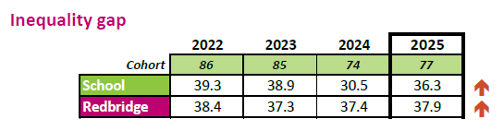
EYFS data

The Inequality gap in 2025 is in line with the local average.
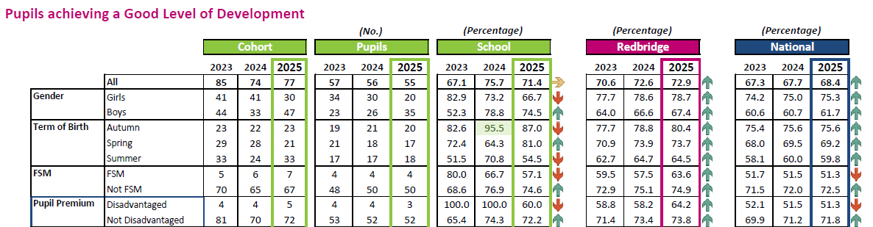
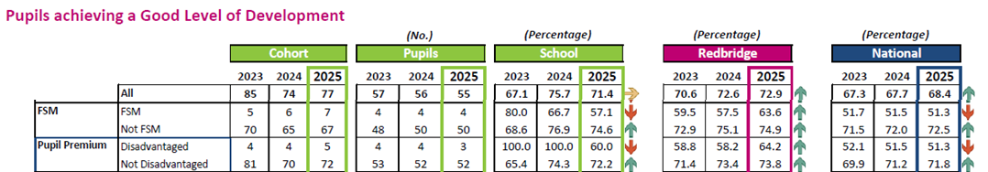

Total absence (Attendance)
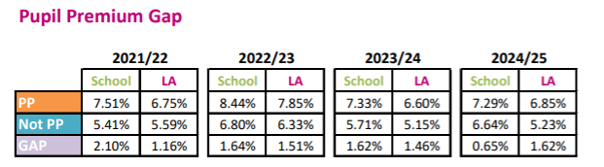

We have led a number of successful educational visits in 2024/5. Children from the school have had subsidised opportunities to attend theatre shows, pantomimes, museums and the beach, amongst other visits. This has helped in their understanding of cultural capital as well as giving them opportunities to experience new things.

The overall impact on wellbeing and behaviour has become evident throughout the year. There has been an increase in emotional support required for children and families as we have witnessed an increase in safeguarding issues. The nurture space has been full and targeted interventions for specific pupils have been utilised to support emotional regulation. We will continue to build and develop this approach with the use of the learning mentors.

Our Ofsted Visit in November 2023 was positive and gave a Good overall judgement.

Externally provided programmes
Please include the names of any non-DfE programmes that you purchased in the previous academic year. This will help the Department for Education identify which ones are popular in England
Programme | Provider
Reading Plus | Reading Plus Solutions
Destination Reader | Hackney Education
TTRS | Times Table Rock Stars

Further information (optional)
Use this space to provide any further information about your pupil premium strategy. For example, about your strategy planning, or other activity that you are implementing to support disadvantaged pupils, that is not dependent on pupil premium or recovery premium funding.

Appendix 1

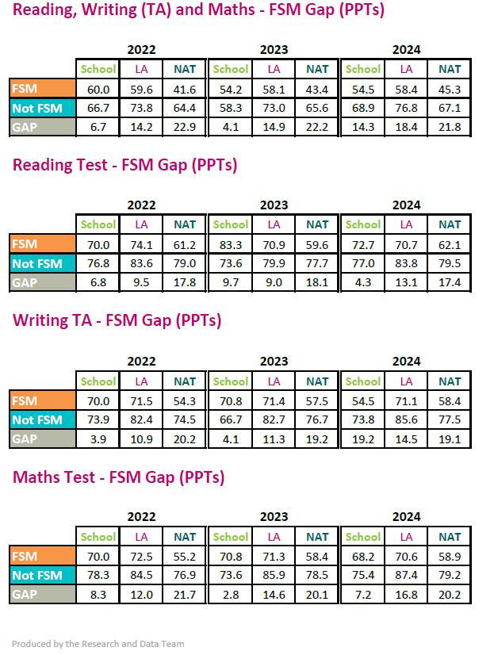
Source – LBR Annual Statistical Report 2024

Appendix 2
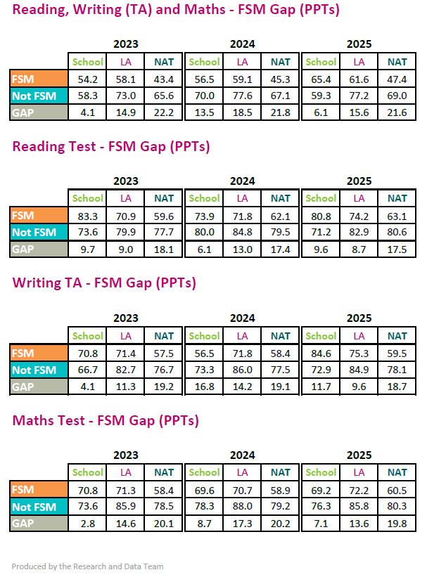

Source – LBR Annual Statistical Report 2025

