Metacognition Policy

Written by: Clare Roult
Date: January 2022
Review date: July 2023

What is Metacognition?
“If pupils don’t learn the way we teach…perhaps we should teach the way they learn.” (Eppig 1981)

Recent research from the Sutton Trust provides a detailed analysis of the most effective strategies to raise attainment and close the attainment gap. Amongst the top three is ‘meta-cognitive strategies’ defined by the Trust as:
“teaching approaches which make learners think about learning more explicitly. This is usually through teaching pupils to plan, monitor and evaluate their own learning. Self-regulation refers to managing one’s own motivation towards learning as well as the more cognitive aspects of thinking and reasoning. Overall these strategies involve being aware of one’s strengths and weaknesses as a learner, being able to set and monitor goals and having strategies to choose from or switch to during learning activities.” (Metacognition and Self-regulated learning Guidance Report, EEF, 2018)

School Vision/ Rationale
A key theme which underpins our teaching at Mayespark is a growth mindset. We believe that in order to support children’s learning and to make them more independent learners, we need to embrace challenges, be intrigued by mistakes, demonstrate resilience to overcome barriers and to thrive on feedback. Another important aspect is to be inspired by the success of others as well as supporting and encouraging each other.
Rather than simply praising success, we need to look deeper into learning and praise the effort, persistence and positive attitudes to learning. This includes the frequent difficulties we may face in the process of learning. There is strong evidence to suggest that, improving ‘learning to learn’ skills is a very powerful way of improving outcomes for disadvantaged pupils. Metacognitive approaches have consistently high levels of impact. This approach has the potential for narrowing the gap by improving the way disadvantage pupils think about their own learning.
Reflections
Celebration is one of the most common types of reflection, where a child might want to capture a great piece of learning. Another type of reflection is failure and this needs to be considered. Failure needs to be built into the ethos of the classroom and modelled by the teacher. The children need to feel comfortable with failure before they will be able to model the metacognitive skills required for more independent learning. Failure is important as it is where great learning can happen and is usually has a lot of emotion attached to it. Challenge and ‘doing something different next time’ are important in building resilient learners.
It is however, of paramount importance, to ensure that the level of challenge is set appropriately for individual children. If challenge is set correctly, the learner will be able to ask questions, either consciously or unconsciously and typically exhibit an awareness of the degree of challenge in what they are learning. If the challenge is not set at an appropriate level, the learner will either not accept the challenge or will suffer from cognitive overload.

Aims
- To aid students to become independent learners.
- To help students monitor their own progress.
- To help students take more responsibility/ownership of their learning.
- To aid students to identify what can impede their learning.
- To aid students to identify what moves their learning on.
- To support students to identify their strengths and their weaknesses in their learning.
- To develop pupil’s knowledge of themselves as a learner.
- To encourage pupils to understand how motivation can affect their learning.
- To develop classroom dialogue to support metacognitive strategies.
- To provide opportunities for students to reflect on their learning.

Definition
Self-regulated learning can be split into 3 categories:
Cognition –mental processes involved in knowing, understanding and learning. Cognitive strategies – skills like memorisation techniques or subject specific strategies.
Metacognition – the ways learners monitor and purposefully direct their learning. E.g. monitoring whether strategies have been successful and changing them if necessary.
Motivation – our willingness to engage our metacognitive and cognitive skills and apply them to learning.
Cognition, metacognition and motivation all interact in complex ways during the learning process.

We approach any learning task or opportunity with some metacognitive knowledge about:
- our own abilities and attitudes (knowledge of ourselves as a learner)
- what strategies are effective and available (knowledge of strategies)
- the particular type of activity (knowledge of the task)
When undertaking a learning task, we start with this knowledge and then apply and adapt it. This is metacognitive regulation. Planning how to undertake a task, working on it while monitoring the strategy to check progress, then evaluating overall success.
In an expert learner, these processes are unconscious and automatic. In novice learners, it can be valuable to make them explicit.
The strength of the evidence supporting the effectiveness of metacognition strategies is high, studies show that children make accelerated learning and that it is particularly effective for low achieving children.

Teaching/ Curriculum
Knowledge and strategies are at the core of metacognition. They encourage mastery in mathematics, reading and writing. Some strategies are subject specific and some are transferrable. Through our teaching and learning, we:
- Activate prior learning
- Explicitly encourage the use of metacognitive strategies
- Model learning
- Develop memorisation strategies
- Guide practice
- Promote independence
- Provide ample opportunities for reflection
As a result, we aim to develop habits that support children’s learning at Mayespark, in future academic settings and to provide vital skills for life-long learning.

Organisation

Children from Year 2 - 6 will be taught regular discreet metacognition lessons using the ReflectEd scheme of work from the beginning of the Autumn term. Year 1 will begin their lessons in Autumn 2 and Reception in the Summer term.
The lessons for all the year groups focus on children learning a different skills e.g growth mindset, learning how to reflect effectively, learning a new skill, being able to cope with making mistakes as well as developing memory skills.
Children will make their own folder for metacognition at the beginning of Year 2 and this will be passed up to the next year group each year and any work from the standalone lessons or written reflections will be filed in these folders.
Where teachers feel necessary, they can prepare metacognition lessons which support the individual children they are teaching. For example, it may become apparent that the children need more support with understanding how to edit their work and so a standalone lesson could be planned to account for this.
Throughout the rest of the curriculum, metacognitive strategies and language is underpinned to enable children the chance to make connections in their learning and to practice the skills they are learning from the discreet lessons.

Written reflections
Children from Reception to Year 3 aren’t expected to write written reflections (until the summer term of year 3), however it is expected that the teacher will model written reflections for the children to contribute to. It is expected that these adult-scribed written reflections will be displayed in the classes for children and teachers to refer back to.
These written reflections can take place during any part of the lesson, most commonly at the end of the lesson. Children in Year 3 will start to write written reflections during the summer term.
All reflections will be written on paper and filed in the children’s metacognition folders.
Teachers need to ensure that adequate time is allocated for these reflections to be completed in depth. This requires a period of time for modelling good written reflections, the opportunity to share reflections with a talk partner, discussing the language for the lesson as well as writing the reflections.
Appendix A provides sentence starters to prompt quality reflections.

Verbal reflections
Children from Reception to Year 3 are encouraged to make verbal reflections led by their class teacher in a way that is age appropriate. They may also wish to use the sentence starters in Appendix B, to help structure their reflections.

Performance Tags (See Appendix C)
As part of the reflection process, all children in KS1 and 2 will be asked to give themselves a coloured performance tag which relates to their feelings towards a certain task or lesson. The children could be asked to identify where they feel they are in their learning at different stages of the lesson/unit of work/etc.
The performance tags are as follows:
Red – I don’t know anything about it yet.
Yellow – I know a little but still need some help.
Green – I am confident.
Blue – I can coach. I can teach somebody else how to do it.

The purpose of these performance tags is for the child to assess their own achievements against the learning objective for that lesson. All adults within the class and across the school are to engage in conversation with the children about their performance tags and these can be challenged by the adult if it is deemed necessary. It is very important that children are able to explain why they have placed themselves on that tag and that they understand how they are going to move to the next colour.

Resources
All ReflectEd lesson plans to be used for Metacognition are saved on the server under the pathway: Staff shared area; Curriculum; Planning; Foundation Subjects; Metacognition.

Homework/ Parent Partnerships
Metacognition homework will be set to encourage children to use the metacognitive skills learnt in lessons.
Parents will receive a handout (Appendix D) at the beginning of the year explaining what Metacognition is and how we embed it into our curriculum at Mayespark. This information will all be available on the school website and added to the first piece of Metacognition homework set each year.
Information about the Metacognition skills taught in each half term will be detailed on the ‘Big Picture’ curriculum newsletter sent out to parents every half term.

Assessment
Verbal feedback will be provided as explained in our Teaching and Learning policy. The following details key approaches to teaching the ReflectEd lessons:
Talk
Talk is a key element of the ReflectEd approach. Children must have regular structured opportunities to share their reflections. Structuring is very important in ensuring that every child participates equally and is accountable to someone else for their ideas and responses.
When asking children to share their reflections, the teacher carries out the following steps:
The teacher gives the children some thinking time.
When working with a partner, the teacher gives each child an equal amount of time to share their reflections.
The listener is asked to paraphrase what their partner has said, in order to promote active listening.
Learning from others
Learning from and listening to others is a key element of reflecting on learning. To ensure that children have access to good language and behaviour models, children should sit in mixed ability pairings. Teachers will need to model these initially and conduct mini-plenaries throughout the lessons to ensure children’s understanding.
Reflective behaviour and language
Teachers should try to keep metacognition at the forefront of their minds in all of their teaching, not just the standalone metacognition lesson. This should also be evident in feedback provided to children. They should model reflective behaviour to the children through their own use of reflective language.
Valuing and using the children’s reflections
Children will spend time writing reflections in the ReflectEd approach. In order for children to get better at reflecting upon their learning and so that they know their reflections are valued, teachers must spend time reading them and giving constructive feedback to the children. Spending time reading the children’s reflections will also provide the teacher with an invaluable source of information about their children as learners.

Appendix A
Below are examples of sentence starters that are used to promote and structure quality reflections from the children. Children are encouraged to choose the sentence starter that best reflects their learning for that lesson, whilst being reminded to use a variety of sentence starters in their reflections.
I am blue because ….  I am able to coach because… Today I was successful because…  I am becoming an expert at …. because  …  The easiest part of the work was … | I am green because…  I found that … helped me because…  I am proud of myself today because …  Today I was able to make progress because …  The easiest part of the work was ….
I am yellow …  I need help with … so tomorrow I will… I felt confused when ….  Next time I need to remember… I need to use … to support me.  The hardest part of the work was / is  …  Next time I need to …. So that I can improve my work. | I am red …  I got stuck because…  Next time I need to remember… I need to use … to support me.  Today I was unsuccessful because … I’m having problems with …  The hardest part of the work was / is  …  Next time I need to …. So that I can  improve my work.

Appendix B: Sentence starters for EYFS & KS1

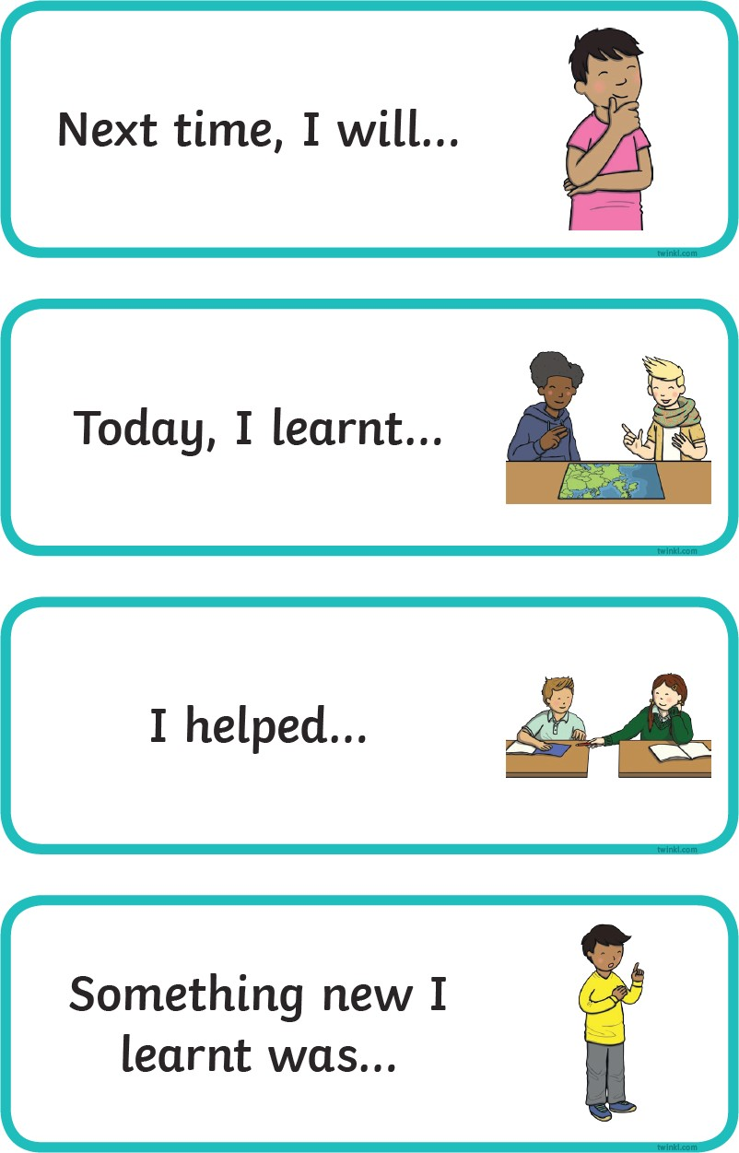
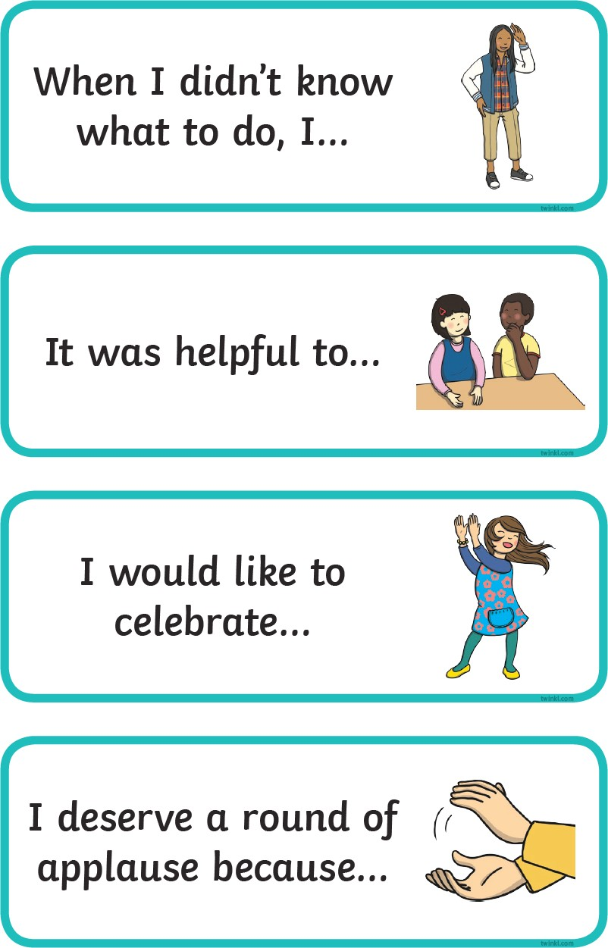
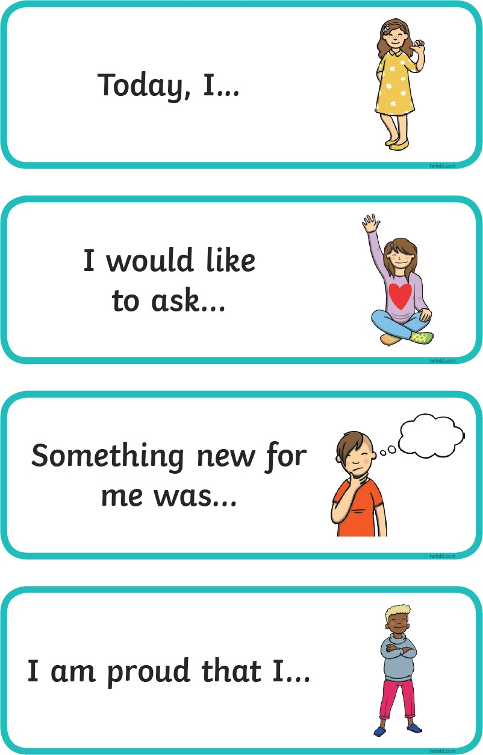
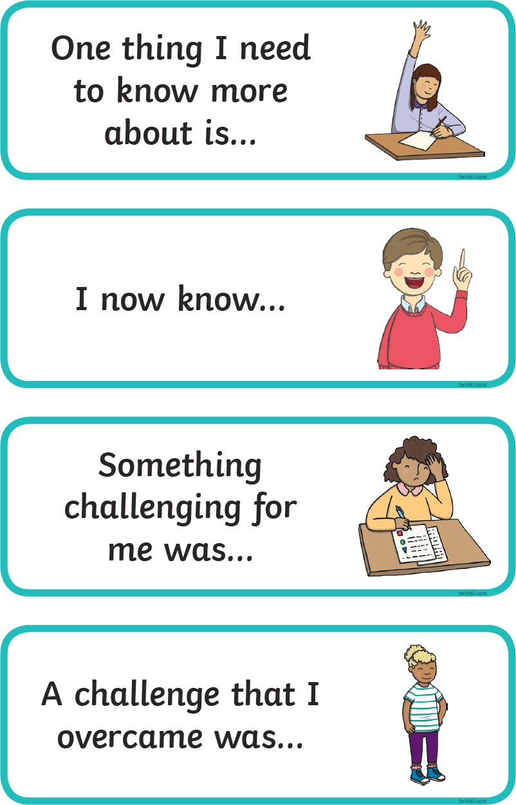

Appendix C: Performance tags

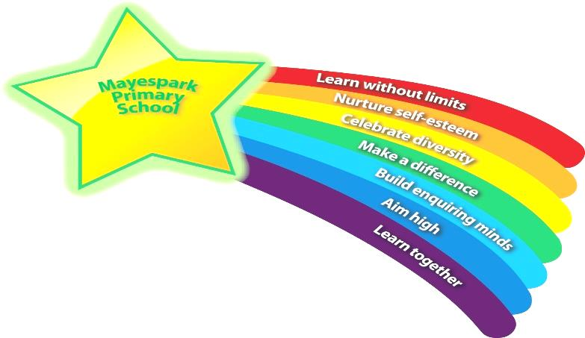
Appendix D: Handout to parents

Your child will continue to learn about metacognition this year.

This handout will inform you of what metacognition is, why we do it and

how you can best support your child at home.

Background to metacognition

Metacognition can be defined as ‘thinking about thinking’ or ‘learning to learn’. It encourages children to consider the ways in which they work best as learners and what might prevent them achieving their very best.

When we approach any task, we bring knowledge about:
- our own ability
- what strategies are effective
- ideas regarding the particular type of activity

Metacognitive strategies are all about acknowledging the planning, monitoring and evaluation stages of completing tasks. Firstly, we plan for how we will approach the task; then we monitor how it is going and finally we evaluate how we did.
Children who recognise this cycle are characterised as ‘self-regulated’ learners. They are able to note when they are planning, monitoring and evaluating, questioning themselves when needed.

‘Self-regulated learners are ‘learners who are proactive in their efforts to learn because they are aware of their strengths and limitations.’
Zimmerman, B J, 2010.

At Mayespark we use performance tags for the children to monitor how they feel when starting a task, whilst performing the task and as a part of their evaluation.

Modelling metacognitive strategies
When completing a task with your child such as homework, discuss the following questions:

Planning
- What is the goal of this task?
- Have I completed a task like this before and how did it go?
- Where is the best place to start?
- Do I need extra resources to help me?

Monitoring
- How am I doing here?
- Is there something I could change to help me reach the goal?
- What has gone well so far?
- How am I feeling about this task?
- Do I need to take a break and come back to this later?

Evaluating
- How did it go?
- How would I do this differently next time?
- Did I reach the goal set at the start?
- Is there a technique I would use differently next time?
- Did I start in the right place?

Going forward, the goal is for your child to start asking these questions of themselves. Such a mindset will help them navigate the many tasks they will come across in life. With practice, they will be able to plan, monitor and evaluate how they are getting on effectively, increasing the likelihood of success in reaching their goals.

We will continue to encourage this approach to thinking and learning throughout your child’s time at Mayespark, it would be amazing if you could also encourage them to think the same the same way with tasks at home.

