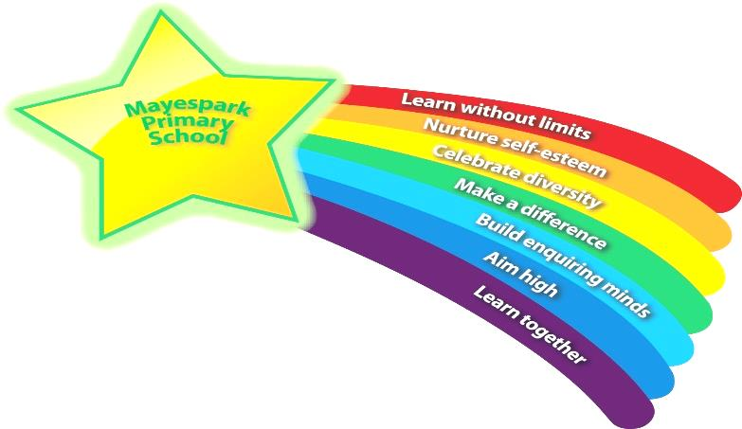

Metacognition

Your child will continue to learn about metacognition this year.

This handout will inform you of what metacognition is, why we do it and

how you can best support your child at home.

Background to metacognition

Metacognition can be defined as ‘thinking about thinking’ or ‘learning to learn’. It encourages children to consider the ways in which they work best as learners and what might prevent them achieving their very best.

When we approach any task, we bring knowledge about:
- our own ability
- what strategies are effective
- ideas regarding the particular type of activity

Metacognitive strategies are all about acknowledging the planning, monitoring and evaluation stages of completing tasks. Firstly, we plan for how we will approach the task; then we monitor how it is going and finally we evaluate how we did.
Children who recognise this cycle are characterised as ‘self-regulated’ learners. They are able to note when they are planning, monitoring and evaluating, questioning themselves when needed.

‘Self-regulated learners are ‘learners who are proactive in their efforts to learn because they are aware of their strengths and limitations.’
Zimmerman, B J, 2010.

At Mayespark we use performance tags for the children to monitor how they feel when starting a task, whilst performing the task and as a part of their evaluation.

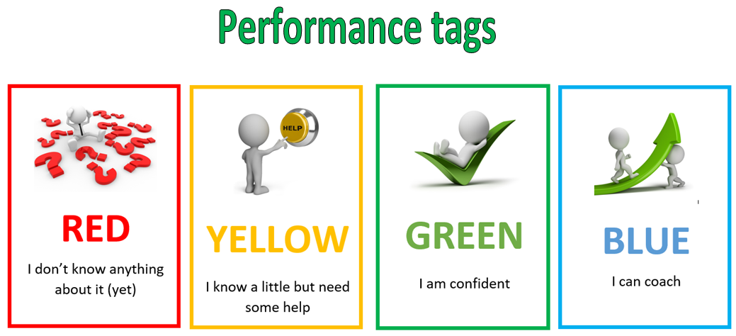

Modelling metacognitive strategies
When completing a task with your child such as homework, discuss the following questions:

Planning
- What is the goal of this task?
- Have I completed a task like this before and how did it go?
- Where is the best place to start?
- Do I need extra resources to help me?

Monitoring
- How am I doing here?
- Is there something I could change to help me reach the goal?
- What has gone well so far?
- How am I feeling about this task?
- Do I need to take a break and come back to this later?

Evaluating
- How did it go?
- How would I do this differently next time?
- Did I reach the goal set at the start?
- Is there a technique I would use differently next time?
- Did I start in the right place?

Going forward, the goal is for your child to start asking these questions of themselves. Such a mindset will help them navigate the many tasks they will come across in life. With practice, they will be able to plan, monitor and evaluate how they are getting on effectively, increasing the likelihood of success in reaching their goals.

We will continue to encourage this approach to thinking and learning throughout your child’s time at Mayespark, it would be amazing if you could also encourage them to think the same the same way with tasks at home.

