

Mathematics Policy

Written by: Sangeeta Sharma and Fatimah Zehra
Last Review date: May 2026
Next Review date: May 2028

MAYESPARK PRIMARY SCHOOL

Mathematics Policy

Introduction
This policy outlines the aims, organisation and management for the teaching and learning of mathematics at Mayespark Primary School. Mathematics is a life skill. It is an essential element of communication, widely used in society, both in everyday situations and in the world of work. “A high-quality mathematics education therefore provides a foundation for understanding the world, the ability to reason mathematically, an appreciation of the beauty and power of mathematics, and a sense of enjoyment and curiosity about the subject” (National Curriculum 2014).

Intent
The National Curriculum (2014) for mathematics aims to ensure that all pupils:
- become fluent in the fundamentals of mathematics, including through varied and frequent practice with increasingly complex problems over time, so that pupils have conceptual understanding and are able to recall and apply their knowledge rapidly and accurately to problems
- reason mathematically by following a line of enquiry, conjecturing relationships and generalisations, and developing an argument, justification or proof using mathematical language
- can solve problems by applying their mathematics to a variety of routine and non-routine problems with increasing sophistication, including breaking down problems into a series of simpler steps and persevering in seeking solutions.

The Maths Curriculum at Mayespark uses the Mathematics Mastery Approach. At the centre of our maths vision is the belief that all children have the potential to succeed. We believe that all children, where possible, should have access to the same curriculum content and should deepen their conceptual understanding by tackling challenging and varied problems.

What is ‘Mastery’?
The ‘Mastery Approach’ to teaching mathematics is the underlying principle of Mathematics Mastery. Instead of learning mathematical procedures by rote, we want our children to build a deep understanding of concepts which will enable them to apply their learning in different situations. To achieve this, we aim to develop pupils’ Conceptual Understanding, Mathematical Thinking and Language and Communication. (See diagram below).

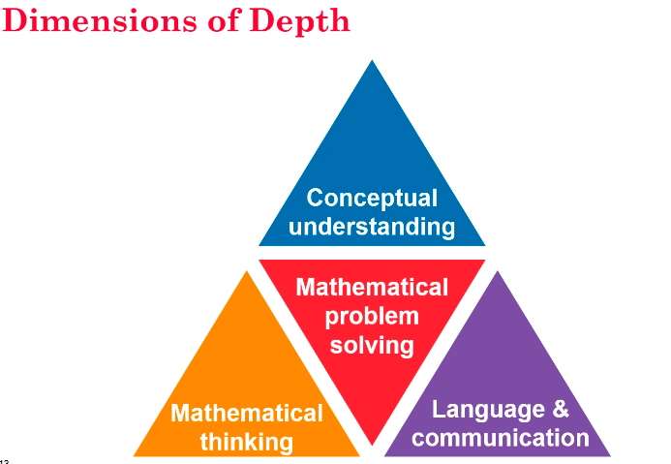

Our intent focuses on equipping all pupils with the mathematics they need to master the curriculum for each year group, which requires that all pupils:
- recall key number facts with speed and accuracy and use them to calculate and work out unknown facts
- develop their ability to apply mathematical skills with confidence and understanding when solving problems
- apply their mathematics to a variety of routine and non-routine problems with increasing sophistication, including breaking down problems into a series of simpler steps and persevering in seeking solutions
- express themselves and their ideas using the language of mathematics with assurance
- have sufficient depth of knowledge and understanding to reason and explain mathematical concepts and procedures and use them to solve a variety of problems
- develop positive attitudes to mathematics, recognising that mathematics can be both useful and enjoyable
- nurture a fascination and excitement of mathematics
- are able to use and apply the skills in other curricular areas

Our expectation is that the majority of pupils will move through the programmes of study at broadly the same pace. However, decisions about when to progress should always be based on the security of the pupil’s understanding and their readiness to progress to the next stage. Pupils who grasp concepts rapidly should be challenged through being offered rich and sophisticated problems. Those children who are not sufficiently fluent with earlier materials should consolidate their understanding, including through additional practice, before moving on.

Implementation

Organisation

- A daily mathematics lesson of 60 minutes is taught from Year 1-6.
- A daily maths meeting session of 15 minutes is taught from Reception - Year 6.
- In Year 2-6, maths meetings consist of 3 days consolidating their maths knowledge and 2 days focussing on arithmetic.
- In EYFS, pupils experience mathematics on a daily basis, through teacher directed tasks and child-initiated play. Opportunities for mathematics should be developed through daily routines and all areas of learning.

Six-part structure

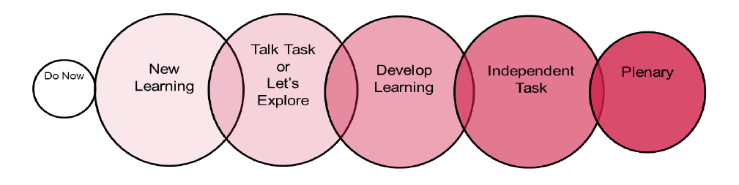
Within Mathematics Mastery, each lesson follows a six-part structure which is outlined below.

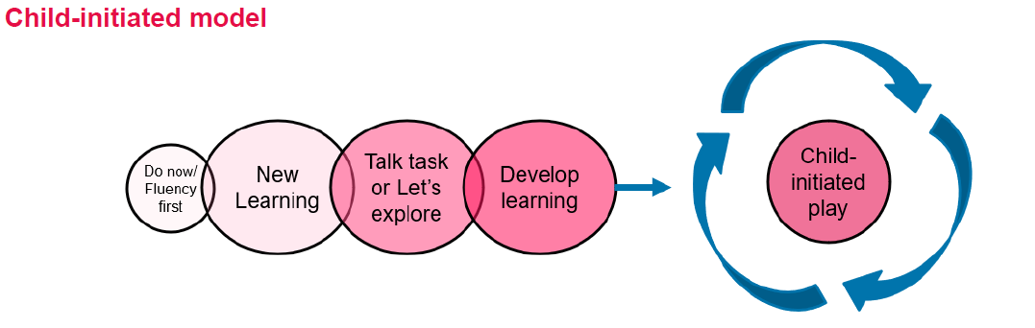

EYFS model

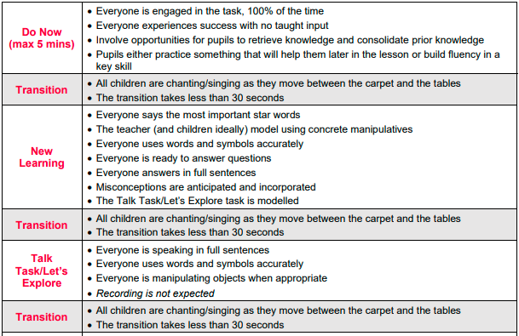

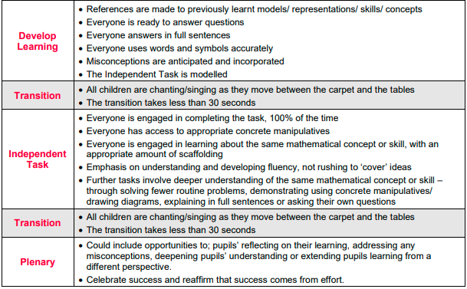

- Representations used in lessons expose the mathematical structure being taught.
- Stem sentences are used to allow learners to verbalise their mathematical thinking, using the correct mathematical vocabulary.
- Misconceptions are planned for and addressed within the main teaching.
- Although children are expected to use formal written methods, the teaching should allow children to select the most efficient method.
- The level of challenge should not move children onto the next year group’s curriculum in their learning; it should widen the breadth and depth of the knowledge to ensure mastery across different contexts in real life.

Teaching strategies
In order to provide the children with active and stimulating learning experiences, a variety of teaching and learning opportunities are adopted:
- Children may work individually on a task, in pairs or in a small group, depending on the nature of the activity.
- Wherever possible, practical ‘real’ activities are used to introduce concepts and reinforce learning objectives.
- Opportunities to transfer skills learnt, to real situations, are used whenever possible.
- Activities are planned to encourage the full and active participation of all pupils.
- Teachers use carefully planned questions throughout the lesson in order to meet the needs of all abilities.
- Teachers place a strong emphasis on correct use of mathematical language; this is supported by key vocabulary being displayed. Stem sentences are used and modelled during whole class input.
- Teachers value pupils’ oral contributions and create an ethos in which all children feel they can contribute.
- Throughout the school, children learn number facts and times tables using exciting videos and songs, alongside NumBots and TTRS.
- Classroom working walls are used to encourage children to learn and recall facts which will support their maths learning.
- Reasoning and problem-solving skills are taught throughout the six-part lesson structure in order to model the use of correct mathematical vocabulary and written reasoning.
- Children in EYFS use Numberblocks to support their knowledge of number.

Curriculum Planning

Long term planning
All mathematical topics will be taught in blocks so that children can master each mathematical concept and apply it across a range of contexts. These are outlined in the curriculum maps for each year group.

Medium term planning
Teachers will follow Unit Narratives and Programmes of Study to teach sequences that build learning over time which is in line with the National Curriculum.

Short term planning
- Planning Guides will be used by teachers daily following the six-part structure.
- All teachers will use PowerPoint or Flipcharts to teach their weekly planning.
- These will be amended and updated based on assessment for learning and the needs of the class.
- Teachers evaluate their PowerPoints daily, making any necessary changes to provide additional input and challenges.
- Planning may be monitored by SLT and maths subject leaders.

Assessment

Day-to-day assessments
As part of the ongoing teaching and learning process, teachers will assess children's understanding, achievement and progress in mathematics using the Distance Marking sheet. Daily annotations, which inform day to day teaching and learning, are based on observation, questioning, informal quizzing, and the marking and evaluation of work. This will also enable appropriate feedback to children for the following day. Teachers will make use of questioning at different stages of pupil’s learning, including prior to a unit to identify misconceptions, during a unit of work to check these have been addressed and also at the end. Stamps will be used to mark children’s work by the teacher. Any children who have not met the learning objective, will be identified on the Distance Marking sheet with a clear idea of how the child’s needs will be met in the following lesson.

At Mayespark, we also use pre-unit and post-unit quizzes as a formative assessment tool. Pre-unit quizzes are short quizzes used at the start of a unit to assess if children have the pre-requisite knowledge. Post-unit quizzes are conducted at the end of a unit to evaluate learning, track progress and identify misconceptions. These quizzes are often multiple choice and low-stake which will inform teacher preparation and planning.

Learners will also be taught to assess and evaluate their own achievements by recognising successes, learning from their own mistakes and identifying areas for improvement. In KS2, children will self-mark and self-edit their work to unpick misconceptions and this will be checked by teachers.

Summative assessments
Standardised assessments are carried out at the end of each term in Years 1 to 6. Termly assessments help identify which pupils are on track to meet end-of-year expectations and an analysis of these assessments are carried out to inform future planning and preparation.

Teachers are involved in moderation of mathematics in the following ways:
- With colleagues in school during year group meetings
- With colleagues in school during professional development meetings.

Environment
It is important that the whole school and classroom environment supports both the learning and teaching of mathematics. The school aims to provide a mathematically stimulating environment:
- through the use of maths working walls to support learning and teaching in a lesson or series of lessons
- through the use of a maths meeting display where pupils can practise and consolidate prior learning
- by providing each table with a maths toolkit containing a good range of resources and manipulatives for teacher and pupil use. In each toolkit, resources such as number lines, hundred squares, place value counters, place value charts and cuisinaire rods are available. Children are encouraged to access these independently.

Homework
We recognise the importance of making links between home and school and encourage parental involvement with the learning of mathematics. Homework provides opportunities for children:

• to practise and consolidate their skills and knowledge of mental arithmetic methods
• to share their mathematical work with their family
• to prepare for their future learning.

Children in Years 3-6 receive a piece of mathematics homework each week on MyMaths, which they will have a login for. This will be focused on what they have been learning that week. Children in Reception, Year 1 and 2 receive a piece of mathematics homework each week on Google Classroom. This will be focused on number fluency, including times tables and/or number bonds as well as consolidating learning from that week.

