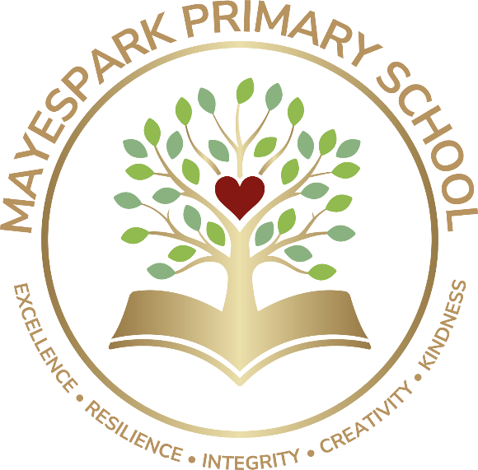

Food and Healthy Eating Policy

Written by: Emiley Davies
Date: Sept 2025
To be reviewed: Sept 2028

Food and Healthy Eating Policy

Introduction
Mayespark Primary School is dedicated to providing an environment that promotes healthy food and eating, enabling pupils to make informed choices about the food they eat. This will be achieved by the whole school approach to food and nutrition documented in this whole school food policy. This policy covers all aspects of food and drink at school.

The policy is communicated to the entire school community on the school website. It is adhered to by everyone involved with the teaching/serving/cooking of food/drink in school during the day and our partners who share our school premises. A named teacher has responsibility for Healthy schools and oversees the policy and healthy lunches.

The nutritional principles of this policy are based on current evidence-based findings; and the ’Eatwell Plate’ is the agreed model for ensuring a healthy balanced diet.

The Eatwell Guide - NHS www.gov.uk/government/publications/the-eatwell-plate-how-to-use-it-in-promotional-material

Curriculum

Rationale
Mayespark is a healthy school working towards renewing the Healthy School Award. We consider all elements of our work to ensure that we promote health awareness to all members of the school community. We provide valuable role models to pupils and their families with regard to food and healthy eating patterns.

Through effective leadership, the school ethos and the curriculum, all school staff can bring together all elements of the school day to create an environment which supports a healthy lifestyle.

Aims and Objectives
- To encourage all children to be responsible for their own health and choices.
- To contribute to the healthy physical development of all members of our school community.
- To give our pupils the information they need to make healthy choices
- To promote health awareness
- To ensure that we are giving consistent messages about food and health

Food Across the Curriculum
There are a number of opportunities for pupils to develop knowledge and understanding of health throughout EYFS, KS1 and KS2, including healthy eating patterns and practical skills that are needed to understand where food comes from such as preparing and cooking food.

It is essential that nutrition education is embedded in the curriculum and there is consistency across different subjects- Science, RSHE, PE, DT and that it remains consistent with the whole school food policy.

Every year, children will complete a cookery unit – which is part of the DT curriculum - which will always include aspects of health and nutrition. In RSHE children learn about a healthy diet. In PE the children look at how to stay healthy and the importance of a healthy life style. They move onto looking at how food plays an active part in this. In Science children look at the different food groups and the amounts of each we need to eat.

Children who attend our Life Skills group are taught how to find a recipe, buy ingredients and then prepare a meal or healthy snack as part of their curriculum.

School and food provision throughout the school day

Snacks
Children in EYFS and Key Stage 1 have milk daily which is free and the school participates in the Government initiative to provide all EYFS and Key Stage 1 children with free fruit and vegetables during the day. All children are encouraged to bring fruit to school – only healthy snacks are allowed.
Tuck Shop
Friends of Mayespark run a healthy tuck shop during some playtimes to give the children the opportunity to purchase healthy snacks and try new things.

School lunches and packed lunches
All our school meals are provided for by Stir Catering. Children are provided with a choice of meals including hot, cold, halal, non-halal, and vegetarian options, all of which pay regard to nutritional balance and healthy options. This includes the availability of fresh salad items each day as a choice for the children. Menus are displayed on the school website for parents and carers to view and choose their meals.

Many children bring packed lunch to school. Pupils’ lunch boxes should offer balanced nutrition. Across a week parents are encouraged to offer a variety of healthy foods in accordance with the lunchbox guidance leaflet which is available for parents at their admissions meeting and in the school foyer. This guidance recommends a balanced selection of foods which should be available to the children in their lunch box.

Because we recognise that there is no such thing as “bad food”, we teach the children to enjoy treats in moderation. Wednesday is the one day in the week where children can enjoy ‘treats’ as part of their packed lunch. These treats should relatively healthy and not excessive e.g. a couple of biscuits, a muffin, a scone or a small chocolate bar. On all other days, children’s lunch boxes should contain healthy snacks only such as plain popcorn, raisins, cheese or baked crackers. Sweets, chewing gum and fizzy drinks are not permitted on any day.

During lunchtime play leaders monitor the contents of children’s lunch boxes. Good news notes are distributed to those children who have a balanced packed lunch. The following procedure will be followed if a child has an item of food not in accordance with our healthy eating policy:
- the child will be reminded of our policy
- the child will be asked not to eat the item of food
- a sticker will be put on the item of food saying ‘Your child was not able to eat this item today as treats are only permitted on Wednesday.’
- if a child’s lunch box consists of unhealthy food only, they will either be allowed to eat part of their lunch or they will be offered a school dinner. In either case the child’s parent / carer will be contacted.
- members of staff will monitor packed lunches over a period of time and contact parents where there is a concern

Early Years Foundation Stage and Arch
Snack time in Early Years provides a range of different fruit, vegetables, crackers and other finger food. This also offers the opportunity for children to develop their communication skills in asking for more, saying please and thank you etc.

Use of food as a reward/birthdays and Special occasions
For birthdays children are able to bring in a small treat to be sent home with their classmates so that parents/carers can make the decision as to when or if they can be eaten. Parents are remined that we are a nut-free school and teachers cannot cut large cakes to be served to children.

There are other occasions like class parties where children are allowed a treat. These treats range from pizzas, cupcakes, sausage rolls, crisps, hot chocolate etc.

Monday Munch is a behaviour reward where selected children are able to join the headteacher for a healthy snack.

Special Dietary Requirements

The school is aware of the possibility of food allergies within the school population, particularly nut allergies. Mayespark is therefore a nut free school. Pupils are taught not to share packed lunches and parents are reminded about the need to avoid sending in packed lunches containing nuts.

Parents or carers of children who are on special diets for medical or religious reasons, or who have allergies, will be asked to provide as much information as possible about which foods are suitable or foods which must be avoided. This information will be displayed in the staff room and in the school kitchen. Individual care plans are created for pupils with special dietary needs/requirements. These document symptoms and adverse reactions, actions to be taken in an emergency, and emergency contact details, along with any particular food requirements. The school and school caterers (if appropriate) are made aware of any food allergies/food intolerance/medical diets and requests for these diets are submitted according to an agreed process. Further, advice from allergies’ websites suggest that it is in the interest of pupils’ longer-term safety, that they learn to be aware of the risks of cross contamination and that they learn to manage the risks themselves.

Food Safety

Appropriate food safety precautions are taken when food is prepared or stored. These vary depending on the food on offer and include: ensuring that adequate storage and washing facilities are available. Any food safety hazards are identified and controlled. Information is cascaded to everyone who is involved with food related activities in school. We have food safety information displayed in the appropriate areas.

The food and eating environment

The school will provide a clean, sociable environment for pupils to eat their lunch and has developed the healthy/welcoming aspects of the dining room environment.

Play leaders help to ensure a safe, enjoyable experience at lunchtime and are able to encourage healthy eating.

Leading by example and staff training

Teachers, caterers and play leaders have a key role in influencing pupils’ knowledge, skills and attitudes about food, so it is important that they are familiar with healthy eating guidelines. As a school, we ensure we model drinking water in front of children, we model healthy eating in front of the children and staff will sometimes eat their dinner with children to model good eating behaviour.

It is essential that staff are committed to setting an example with food in school.

Partnership with parents and carers

The partnership of home and school is important in shaping how children and young people behave, particularly where health is concerned. Each must reinforce the other.

We encourage parents to choose healthy options for packed lunches.

