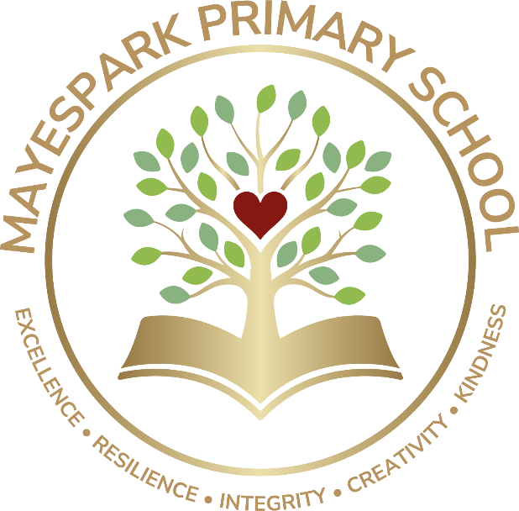

Equality, Diversity & Inclusion
Policy

Operational Date | September 2025
Frequency of Review | Every 3 Years
Date last Reviewed and Approved by Board of Governors | June 2025

- Introduction
Mayespark Primary School is committed to equality and inclusion.
We recognise the value of diverse environments and strive to promote a culture in which all pupils, staff and members of the school community are welcomed and supported to fulfil their potential, irrespective of their background or personal characteristics.
We are committed to an ethos and culture of inclusion in our school for all pupils, irrespective of race, religion/belief, political views, disability, SEN status, gender, gender identity (e.g. transgender) and/or sexual orientation (LGBTQ+).
Mayespark Primary School is an inclusive school where we focus on the well-being and progress of all our children and young people and where all members of our school community are of equal worth.
We recognise, respect and value difference and understand that diversity is a strength that enriches our lives. We take account of differences and strive to remove any barriers to learning and development.
We oppose all forms of unlawful and unfair discrimination and bullying and harassment. As a school community, we recognise the need to champion equality and ensure inclusion for all pupils in the full life of our school; where appropriate making necessary adjustments to enable everyone’s participation.

Mayespark Primary School believes that education (both formal and informal learning) is fundamental to equality of opportunity. It prepares young people for life and is a powerful influence on access to and advancement in employment. All young people should be able to learn and develop fully in a truly diverse and inclusive environment.
All our policies and practices are fully inclusive and supportive of a welcoming culture for all communities; this is evidenced in our practices and procedures.
- Mission and Values
Mayespark Primary School takes pride in celebrating the rich diversity of our families and value learning from each other.

Our Vision is that every pupil will be inspired to reach their full potential. We deliver academic excellence, whilst ensuring a holistic approach to education.
Our Values and Ethos
At Mayespark Primary School we believe that every child in our school is entitled to the very best education so that they develop a love of learning and an enquiring mind. We provide a hands-on, stimulating curriculum which challenges our children to aim high.
We believe that learning is more than acquiring knowledge, learning is developing the skills of resilience – persevering with challenges and taking risks where necessary; it is about working cooperatively and respectfully with others to achieve shared goals. These skills are key to empowering our children to become lifelong learners who believe in themselves.
In our school we provide a safe and inclusive environment where diversity is embraced and difference is respected. We believe that we are all role models for our children, and in providing support and showing how we care for others, we can encourage our children to become the responsible citizens of tomorrow.
We value the powerful contribution which parents and carers make to the learning journey of every child and aim to include and support them to achieve the best for their children.
The school community has decided on the following core values:
- Excellence
- Resilience
- Integrity
- Creativity
- Kindness
Mayespark Primary School recognises the wider value of education, beyond solely the achievement of qualifications, allowing individuals to develop an understanding and experience of the value and range of diverse cultures, identities and backgrounds. We recognise that Name of School is enriched by the diversity that each individual brings and are committed to creating a safe, welcoming environment for all, where each learner can flourish, knowing that differences are respected.
- Equality and Inclusion – School Policies
Through this policy, and the wider practices within Mayespark Primary School we seek to empower our young people to embrace diversity and challenge discrimination. We equip our Governors and staff to fulfil their legal responsibilities, ensure that our school’s safeguarding procedures are comprehensive and inclusive and enable robust monitoring of our progress as a school.

Inclusion underpins all our school policies.

As part of our overall school policy development there are a number of policies that we must have in place and regularly review to ensure our school is addressing its statutory responsibilities. These include Anti-bullying Policy, Safeguarding Policy, Curriculum Policy, Behaviour Policy, Uniform Policy and Admissions Policy. Any arising incident will be dealt with by the appropriate policy. There should never be any grey areas when it comes to young people’s safety and well-being.

This is supplemented by a range of other policies that as a school we feel are important to have for our whole school community. It is our belief that equality and inclusion is central to all of our policies and that we maintain an ethos that welcomes diversity and promotes equal opportunities for all, ensuring all our pupils and their families feel valued and supported and making sure that equality and inclusion is evident in everyday school life.

- Responsibilities
The Governors have overall responsibility to:

‘Promote equality, good relations and diversity and to comply with education and employment legislation and anti-discrimination, human rights and equality legislation that affect its statutory duties in relation to the school’ ‘Every school a good school – the governors role’ (Department of Education NI, August 2019)
The Governors have overall responsibility to manage the implementation of equality and diversity in our school.
The Headteacher is responsible for:
ensuring policies and procedures are in place to comply with equality legislation;
- ensuring the school implements policies and practices in line with the principles of equality and inclusion;
- following the relevant procedures and acting in cases of unfair discrimination, harassment or bullying;
- ensuring appropriate training and awareness raising is undertaken with staff;
- ensuring that appropriate records are kept of any cases of unfair discrimination, harassment or bullying.

The School Senior Management Team are responsible for:
- putting the school’s equality and inclusion policies and codes into practice;
- making sure that all staff know their responsibilities and receive the support and training necessary to carry them out;
- following the relevant procedures and taking action where necessary.

The School’s Pastoral Care and Safeguarding Team (led by the Designated Teacher) will manage the implementation of the policy in partnership with the Principal.

All School Staff (teaching and non-teaching) have a responsibility for the day to day operation of this policy and will contribute to an inclusive and welcoming environment within the school.

Pupils/students are responsible for:
- respecting others in their language and actions;
- following all of the relevant school policies and codes of conduct in line with the principles of equality and inclusion.

- How do we promote Equality and Inclusion?
[Referring to the Self Audit and accompanying guidance, please delete and add as appropriate]

Mayespark Primary School promotes equality and inclusion within our school through the following activities:

School /Centre Practices
- Use a range of resources and teaching approaches
- Use appropriate terminology and language
- Tackle stereotypes
- Challenge homophobic, transphobic or any other type of bullying
- Increase the visibility/ role modelling of minority groups
- Set clear expectations about acceptable behaviour
- Have Equality and Inclusion as a regular topic at Board of Governor meetings
- Have regular Diversity Training for all staff
- Discussing uniform preferences with pupils / students

Facilities/ Services
- Have allocated accessible parking
- Having all accessible toilets/changing facilities
- Having an accessible main entrance and building
- Having signage, displays and resources reflecting all languages and cultures throughout the school
- Considering flexible payment schemes when planning trips and extra-curricular activities
- Helping young people to access advice from support organisations including notice boards with clear and accessible information and contacts

Curriculum
- Examining where and when themes around equality and inclusion might be embedded into topics within each curriculum area
- Holding equality and inclusion themed events on a regular basis and following up on these
- Participating in Shared Education and other programmes such as Schools of Sanctuary
- Ensuring that staff with specific areas of responsibility consider the implications of Equality and Inclusion with their teams.

- Monitoring the Success of the Equality and Inclusion Policy
The policy will be monitored via a range of methods:
- Governors to report on the successes and challenges in relation to inclusion;
- Number of bullying incidents by equality characteristic to be monitored and appropriate action taken as necessary;
- Embedding of equality and inclusion across curriculum areas to be monitored
- Number of comments and complaints in relation to equality and inclusion to be monitored;
- Record of training / information presented to staff/ pupils to be kept
- Positive stories on equality and inclusion to be highlighted
- Feedback from pupils, staff, parents and the wider community to be sought regularly
- Complaint’s Procedures
The school has a robust and transparent Complaints procedure. If a complaint is made regarding equality or inclusion, the Complaints process will be fairly and systematically applied. Access to the Complaints procedure can be found on the schools website

- Review cycle of policy
The Equality and Inclusion Policy will be reviewed by all stakeholders (detail how) and, if required, updated every three years in line with our school policy review cycle.

