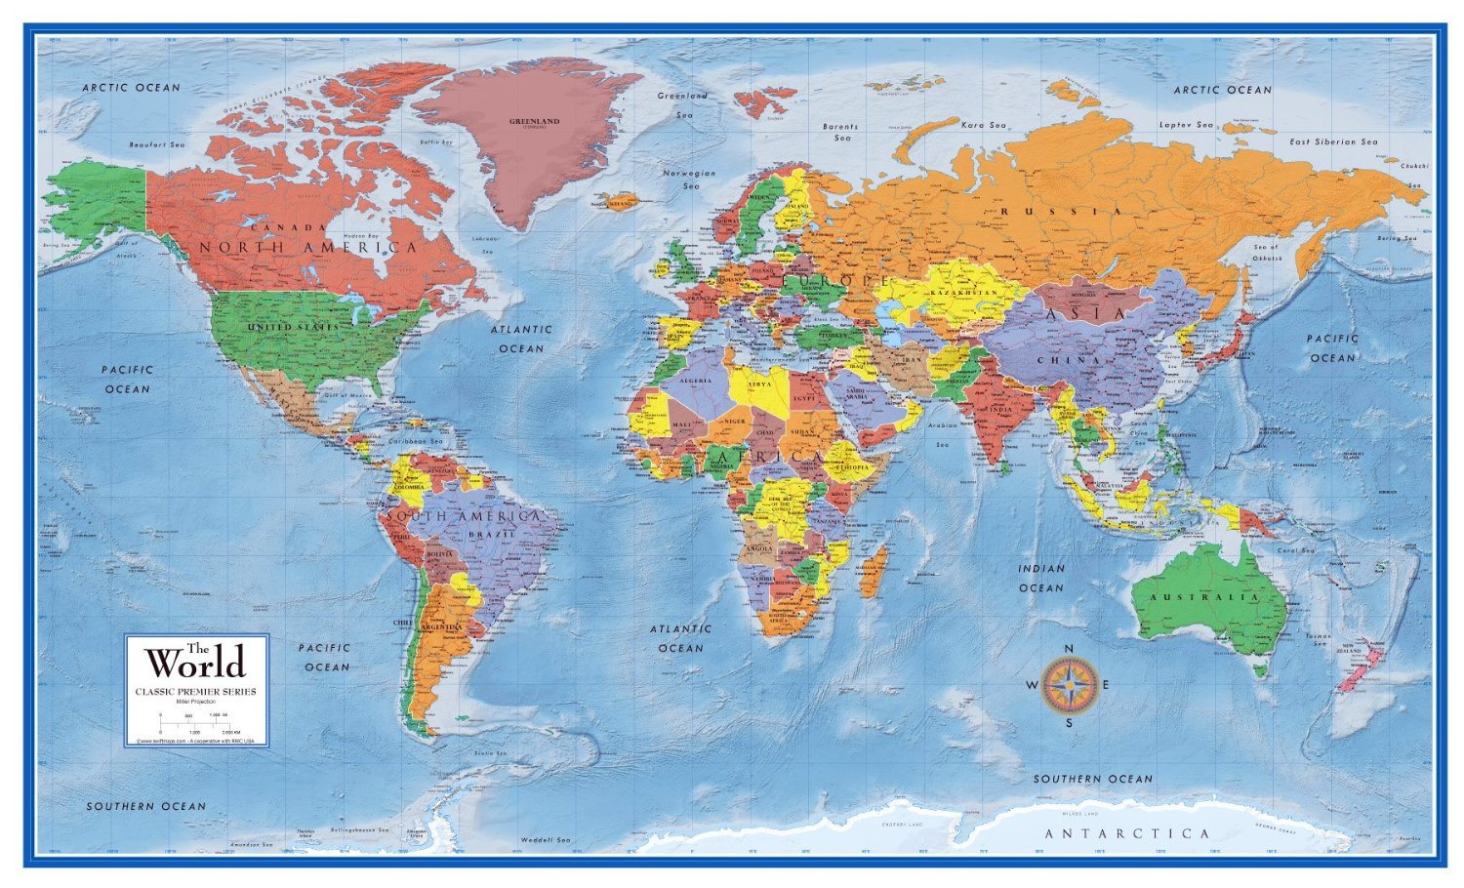

Year Group | Influential person | Country of origin
3
4 | Yotam Ottolenghi  Zaha Hadid | Israeli-British  Iraqi-British
5 | Warburtons  Anya Hindmarch  Nika Diamond-Krendal (Paradise Row Brand)  MicGalaw  Bethany Williams  Atomy studios | British  British  British (East London Textile industry)  South Africa  British  Polish
6

