

Behaviour Policy and Procedures

Updated: October 2025

Behaviour Policy

Principles
The Governing Body believes that in order for effective teaching and learning to take place, good behaviour in all aspects of school life is necessary. It seeks to ensure that children thrive in a caring learning environment by:

- Mayespark is an inclusive school; all members of the school community should be free from discrimination, harassment, victimisation and any other conduct that is prohibited by or under the Equality Act 2010
- Every child has the right to learn and this should happen with as little disruption as possible
- Everyone has a right to be listened to, to be valued, to feel and be safe. Everyone must be protected from abuse
- It is expected that all adults – staff, volunteers and governors – will set excellent examples to the children at all times
- We seek to give every child a sense of personal responsibility for his/her own actions
- The school’s Behaviour Policy will ensure there are measures to encourage good behaviour, self-discipline and respect, and prevent all forms of bullying amongst pupils; it also provides guidance on the use of reasonable force
- Where there are significant concerns over a pupil’s behaviour, the school will work with parents to strive for common strategies between home and school
- The school will seek advice and support from appropriate outside agencies where concerns arise over a child’s behaviour
- The school will fulfil its legal duties under the Equality Act 2010 in respect of safeguarding, children with special educational needs and all vulnerable children
- The school will keep abreast of current issues and initiatives with regard to Health and Safety at Work Act 1974 and related regulations.

Aim
All staff at Mayespark Primary School have high expectations of children’s behaviour in order that every child achieves their full potential. We believe that everybody in school has the right to:
- feel safe.
- learn and develop.
- be treated with respect and fairness.

Our children’s chances of success and happiness in school depend upon them having a clear understanding of what is appropriate behaviour. They need to develop the desire to make responsible choices and to behave in an acceptable manner towards all adults and other children.

Factors that influence pupils’ behaviour:
At Mayespark we recognise that the development and maintenance of good pupil behaviour depends upon a number of interlinked factors. The approach we have adopted is to encourage positive behaviour by progressively tackling all those factors that influence this development. It is the responsibility of all school staff to work actively on all of these key factors, both in their own classrooms and around the school as a whole.

These factors include:
- The provision of a relevant, motivating and challenging curriculum in every classroom
- A physical environment that is cheerful, uncluttered, clean, stimulating but calm
- A positive ethos throughout the school
- The involvement of pupils in reviewing their own learning and behaviour
- Strong, consistent routines
- A fair and consistently applied strategy for responding to inappropriate behaviour (see appendix G)
- A sense of belonging and community involving pupils, parents and the school, where all are treated with respect
- The provision of opportunities for children to develop social skills and to respond positively to each other, for example through ‘Circle Time’ and the teaching of the RSHE curriculum
- Teachers being thoroughly informed about their pupils, both academically and emotionally through handover meetings in July
- Provision in the school for discussions between staff about the difficult feelings and behaviours that children bring with them to school and teachers’ response to them – these discussions may sometimes involve external professionals who may work with the child or family.

Values Based Education
At Mayespark, a values-based education was introduced in October 2015 after consultation with the wider school community. The values were adapted in September 2024.
The chosen values are:
- Excellence
- Resilience
- Integrity
- Creativity
- Kindness

Each half-term a different value is focused on. All the values are discussed in Summer 2.

The values are referred to across the school during assemblies, lessons, playtimes and parents are encouraged to continue the reference to our values at home. Children are awarded badges and certificates relating to the values throughout the year. In addition there are values ambassadors, which are children in each class from years 2 – 6 who promote the values through creating posters, badges and providing feedback to their classes. This policy is therefore integrated into the values of the school and our teaching of the expectations of the conduct of our pupils at all times.

Management of Behaviour in The Classroom - Assertive Discipline

Why have a whole school approach?
Every member of staff working in the school must be consistent in their approach to children’s behaviour and follow the school’s behaviour policy for the following reasons:
- Consistency and security for the children;
- Consistency and security for parents;
- Elimination of ambiguity for staff;
- Support for ECTs, supply staff and non-teaching staff;
- Ease in establishing good behaviour.
It is the responsibility of all staff to enforce the school rules at all times, not only with the children they personally work with, but with every child in the school whatever their age. Staff have a collective responsibility to support each other in this task.

The basic structure of Assertive Discipline at Mayespark Primary School:
The whole school system for the positive management of classroom behaviour at Mayespark is our version of Assertive Discipline. This includes:
- A set of whole school rules; (Appendix A)
- A set of rewards and consequences; (Appendix B)

Principles of our Assertive Discipline policy:
- It is the positive feedback and encouragement above all else that makes Assertive Discipline work. All staff must recognise and encourage choices of good behaviour. (Teachers should aim for 10 names written on the smiley face white board before any warnings are given);
- Staff must clearly define the limits of acceptable and unacceptable behaviour;
- Children need boundaries for them to feel safe;
- All rules need be taught and then reinforced. Children can only really choose to do the right thing if we have been absolutely clear about what we expect;
- Children are responsible for their choice of behaviour;
- Most children can behave if they want to;
- We reject the children’s behaviour, not reject the children themselves;
- Children need to realise that there are rewards for choosing acceptable behaviour and consequences for choosing unacceptable behaviour;
- Behaviour is communication;
- Reconciliation is often helpful to prevent further incidents;
- Assertive discipline preserves children’s self-esteem.

Rules, Rewards and Consequences
The school rules (Appendix A) will be displayed in every room in the school. They will be taught in assembly and in every classroom and will be reinforced by all members of staff at all times.
Teachers must set expectations for their own classroom and specific activities such as PE, swimming, lining-up in class, creative activities etc.

The following rewards encourage good behaviour:
- Good news notes,
- Stickers,
- Stamps,
- Dojo points,
- Talking to parents/phoning home to share positive news,
- Monday munch
- It is the teacher’s responsibility to have some way of ensuring that no child is missed out from positive praise - try to have as fair and sensitive system as possible by keeping accurate records. Senior leaders also keep a record (appendix J).

In the first weeks of each autumn term all children must be taught the system of rewards and consequences – every academic year. This will also need to be re-enforced throughout the year and especially when a new child joins a class. They must understand the following points:

- Every new day is a fresh start in class. (Lunch time and playtime issues to be resolved in review may continue to the next day).
- A reward is given as a result of good behaviour;
- There is a hierarchical system of consequences (below), but it can be by-passed for very serious actions this is recorded on behaviour tracking sheets (appendix J);
- Consequences are not punishments - they are the result of unacceptable behaviour;
- Consequences are a choice - the responsibility is on the pupil to choose to behave appropriately;

Consequences:
Non-verbal / verbal reminders
Stage 1: Warning.
Stage 2: 5-minute time out in class
Stage 3: 15-minute Time Out in another class (complete think about sheet)
Stage 4: A ‘Blue Letter’ is sent home to parents/carers
Stage 5: SLT called
Stage 6: Internal exclusion for rest of lesson
Stage 7: Internal exclusion for the next day

What do we do if a child refuses a consequence?
- Avoid a confrontation, speak to the child quietly and calmly, acknowledge the child’s feelings and remind them of what will happen if they don’t follow your instructions. Remind them that the consequence cannot be avoided. A useful way to initiate this conversation is: ‘I appreciate that you are feeling unhappy, I still need you to…’
- Step back and remind the child that the consequence will still apply however long it takes them to respond so they must make the right choice. Continue teaching. If child does not respond still, move to the next step.
- Telephone the office if SLT support is needed.
- If the child is aggressive and/or not in control, remove the rest of class and any other hazards from the situation and seek assistance by calling the office.

Monitoring Assertive Discipline in Practice:
Whenever a child incurs a consequence as a result of choosing inappropriate behaviour in class, the teacher should record this on the Behaviour Tracking Sheet in the behaviour folder in class. This should not be displayed in the classroom; it is the teacher’s record. The tracking provides, for each class, a record of every child who has incurred a sanction and draws attention to the following:

- children whose behaviour needs to be discussed with their parents.
- children who are causing regular, low level disruption in class, and who may need to be spoken to about their behaviour by someone other than their class teacher (Learning Mentor and/or SLT member).
- children whose behaviour in class is becoming a cause for concern and who may therefore need some specific support such as an individual ‘Pastoral Support Plan’;
- children whose behaviour indicates that they may need to be assessed by an external agency (Educational Psychologist and other outreach services).

The records are monitored on a weekly basis by a member of SLT.

Suspensions and Permanent Exclusions
We follow statutory exclusions procedures to ensure that every child receives an education in a safe and caring environment. There are times where the Headteacher will have to apply the ‘Suspension and Exclusion Policy’ as a consequence to extreme behaviour (An accumulation of smaller incidents can lead to a permanent Exclusion). Please refer to this policy for more detail.

Lining up and movement around the school:
All children should line up (in a line up order) in the classroom before leaving and should be led by the teacher at all times. Staff need to stop and allow catch-up in order that all children are properly supervised.
- Children should walk on the left in quiet lines when using the corridor.
- Staff must ensure that children enter and leave assemblies in silence.
- Staff should be in the playground ready for the end of break times or in corridors if the year group have a ‘soft start’ to meet the class and ensure that all children stand still after the first bell and all walk quietly to their lines on the second. It is essential that staff are out in the playground on time as behaviour can quickly deteriorate if classes are kept waiting.
- Children are expected to follow these rules when moving around the school without an adult.

Keeping parents informed
It is essential that parents are kept informed of both positive and negative events (see REWARDS list). Parental support for our policy is vital. New parents are given a summary of this policy in the School Prospectus and it can also be accessed on the school website.
Examples of positive behaviour should be shared; either in person at the end of the day or a through a telephone call (in the case of SEND pupils through the home school communication book). Teachers should endeavour to do this at least once a year for every child in their class. Sometimes a quick chat regarding negative behaviour after school can be very effective. However, serious incidents or recurring misbehaviour requires parental involvement. Keeping good records is essential.

- Blue Letters (Appendix D and E) will be copied and filed. The senior leader who signs the letter must check that the reply slip is returned the following day. If no slip is returned the office will phone parents to check that they received the letter. These letters will be scanned and uploaded on to CPOMs by office staff.
- Teachers should keep a brief record of any discussion with parents on CPOMS as evidence.
- In some situations, home/school books may be set up to keep parents informed on a regular basis if it is thought that this would secure a positive outcome. These should record positive behaviour as well as problems.
- Serious incidents must be recorded on CPOMS. Documentation is essential to avoid misunderstanding and good records may in future assist us in gaining additional support from other agencies for some children.
- Serious incidents will generate contact with the parent/carer on the same day of the incident.
- Files of incidents, bullying accusations, racism and language of intolerance are kept on CPOMs.

Reasonable force

As documented in ‘Behaviour and Discipline in schools’ (DFE updated January 2016), schools may consider using reasonable force if the pupil is deemed as causing harm to themselves, others, staff and/or danger to property (see the school’s Protocols and procedures for the use of reasonable force). In these circumstances, actions will be recorded and documented. If this type of behaviour persists, external agencies will be notified and a professionals meeting may be convened to discuss avenues of support for the young person, and a risk assessment written with staff. It may be necessary to record patterns of behaviour, logging triggers and support strategies.

Zones of Regulation
The Zones of Regulation® is a framework for teaching children strategies for emotional and sensory self-management. The zones help children identify how they are feeling in the moment according to their emotions and level of alertness, as well as guide them to strategies to support regulation. There are four colours or ‘Zones’ blue, green, yellow and red.

Blue Zone - used to describe low states of alertness and down feelings such as when one feels sad, tired, sick, or bored.

Green Zone - used to describe a calm state of alertness. A pupil may be described as happy, focused, content or ready to learn when in the Green Zone. This is the zone where optimal learning occurs.

Yellow Zone - also used to describe a heightened state of alertness and elevated emotions; however, individuals have more control when they are in the Yellow Zone. A pupil may be experiencing stress, frustration, anxiety, excitement, silliness, the wiggles, or nervousness when in the Yellow Zone.

Red Zone - used to describe extremely heightened states of alertness and intense emotions. A pupil may be elated, euphoric, or experiencing anger, rage, explosive behaviour, devastation, or terror when in the Red Zone.

Management of Behaviour in the Playground
The expectation of the team and any staff on playground duty, at the time of an incident, is that they address the incident and ensure that the children are held accountable for their actions. We understand that children will have disputes with one another in the playground as part of growing up. We believe in helping them to develop those important life-skills which enable them to resolve conflicts appropriately and effectively. We aim to do this through discussion, modeling and where necessary consequences.

Reception and Y1
For our youngest children, in Reception and Y1, class teachers are the most effective at teaching the children about respect, tolerance and friendship, so these issues should be dealt with by them.

If a child misbehaves during the lunchtime and has made the wrong choices then the Play Leader should hold their hand and have them with them for the rest of the lunch period, pointing out and reinforcing the play behaviour by other children that we want. The issue is then passed to the class teacher who will have the bigger picture on how the child is behaving generally and will be able to give pastoral support.

The consequences for the following behaviour will result in 5 minutes timeout with the staff/teachers on duty.
- Play fighting
- Swearing
- Pushing and pulling
- Deliberately upsetting another child (name calling)
- Arguing with peers
- Threatening language without physical contact
- Pushing in line
- Insulting another child/family
- Forcefully taking playground equipment off another child
- All other minor incidents

If repeated or other incidents occur in the same play or lunchtime the child may be given 10 minutes time out. Or if unable to be resolved in the moment and includes one of the infringements outlined below, the children (Yrs 2-6) should be referred to Reflection. This should be uploaded on to CPOMs by the adult and class teachers should ensure that the children attend Reflection at the next opportunity.

What is REFLECTION for and when should it be given?
Reflection at lunchtime is a consequence of unacceptable behaviour during any playtime or lunchtime only.
Staff must not use these sanctions to respond to poor classroom behaviour, nor should they place children in double jeopardy by adding what happens in the playground to what happens in the classroom.

The consequence of the following infringements of the school rules by Y2-Y6 is to go to Reflection at lunchtime:
- fighting
- deliberately hurting another child
- rudeness to Play Team and supervisory staff
- refusing to follow the instructions
- Inappropriate behaviour whilst in Reflection
- racism or language of intolerance

Lunchtime Reflection includes a requirement for the child to reflect and review their behaviour through discussion with a learning mentor or member of SLT. Children may remain in Reflection for the whole duration of lunch, unless it is found that they were a victim and or witnesses to the incident. Children who are bought to Reflection towards the end of lunch may be required to attend Reflection again another day.

If a child is given Reflection during morning playtime and they remain angry or aggressive, they should be taken to a member of SLT.

All children should be taken to Reflection by the class teacher. Years 2 and 3 children should take the children to a member of the office staff who will ensure that the children eat their lunch whilst awaiting the learning mentor or SLT member. Teachers on duty during morning play should add any incidents to CPOMs when returning to class.

The adult in Reflection for the day will:
- Check CPOMS to find out to see who is on Reflection on CPOMs
- Remind teachers to bring children to the reflection room if necessary
- Supervise children to collect their school dinner or packed lunch and then take them back to the Reflection Room
- Add children to CPOMS if they are sent during lunch
- Support children to complete a ‘think about it’ sheet (KS1 and KS2 sheets appendix F)
- Discuss the incident with the child or children and resolve any issues
- Send a letter to parents of the child who was the perpetrator informing them of the incident (parents of children who have witnessed an incident will NOT be contacted)
- Contact the parents of any child who was injured as a result of an incident to give them an outline of the incident

Those children who are regularly in reflection (approximately 5 visits in a half term, or combined with incidents noted in class) will require a meeting with a member of SLT, teacher and their parents. The child’s behaviour will be closely monitored and tracked through CPOMS to identify any extra support that they may need. Persistent Reflection attenders could be withdrawn from the playground for a set period. If behaviour relating to one element of play (for example football) continues to be below expectations, the consequence may be that they are banned from this area of play for a period of time. This decision is to be made by the behaviour lead.

Management of behaviour on PPA days
It is important that children understand that the expectations of their behaviour are the same on PPA days. It is also important for the PPA teachers to maintain an approach to behaviour management that is both consistent with the policy and each other. This includes:

- Using the PPA behaviour tracking sheet (appendix H). This includes writing children’s names under the smiley face to be left for the class teacher who will reward the pupil using the class system. Children that have demonstrated poor choices in behaviour should be recorded on the warnings section of the sheet with reasons. This will then all be transferred onto the class behaviour tracking sheet at the end of the day.
- Teachers will take responsibility for recording the behaviour of the class they have at the end of the afternoon. This requires them to record any warnings on the class tracking sheet along with any good news notes sent home.
- In the event of a child receiving a 4th warning leading to a blue letter, the teacher with the class at the time should use the tracking sheet (appendix H) to write the reasons from previous lessons.
- Classes to be passed between teachers in a calm manner with children lining up silently in order that the new teacher can start the lesson with positive praise and writing children on the smiley face board.
- Extreme behaviour should be reported to SLT in line with the policy.

Appendices – Reviewed October 2025

A | School Rules
B | Rewards and Consequences
C | Blue Letter 1 box
D | Blue Letter staged
E | Reflection notice to parents
F | Reflection THINKABOUT sheets
G | Behaviour Steps;
H | PPA Behaviour Tracking Sheet
I | One page policy
J | Behaviour Tracking Sheet

Appendix A
Mayespark Primary School

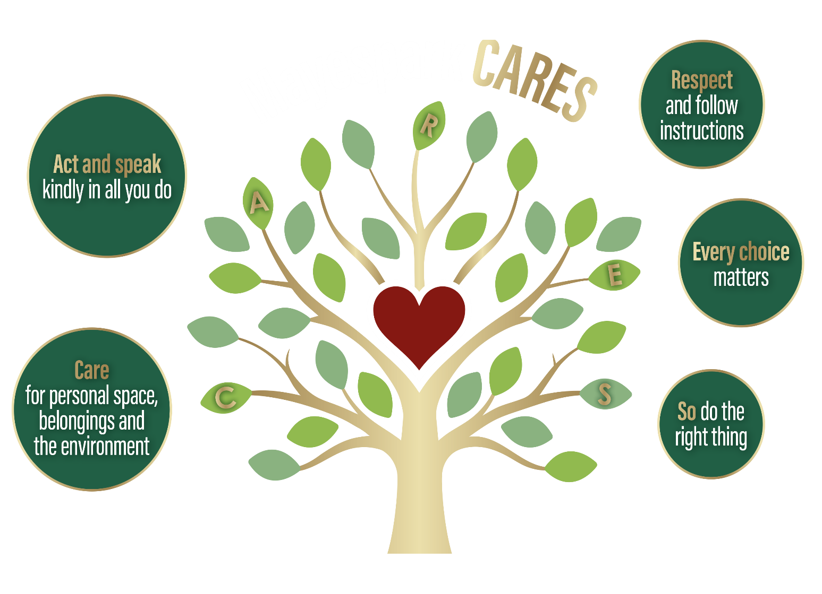
Rules

Appendix B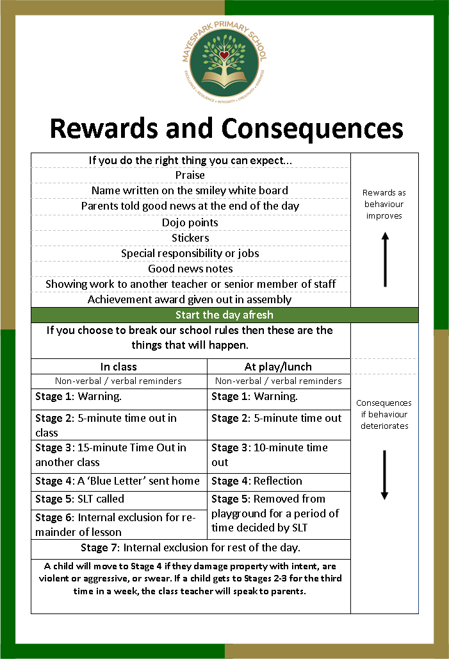

Appendix C

MAYESPARK PRIMARY SCHOOL


BLUE LETTER

To the parent / carer of: _________________________________________

Class ____________________________ Date: ________________________

Dear Parent/Carer,

We are very concerned about how your child behaved in school today and we think that you should know what happened.
What happened:
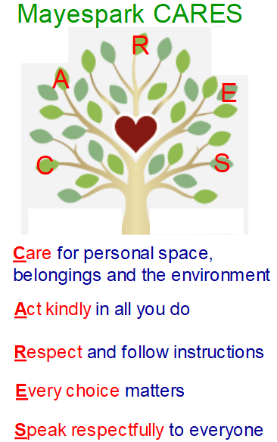

Please talk with your child about what happened and the importance of following our school rules. We need to make sure that everyone can work without interruption, and that staff and children alike are treated with respect.

So that we can be sure that you have received this letter would you please sign it and send it back to school tomorrow.

Yours sincerely,

Mrs E Davies Mrs E Jones Mr L Radmore Mrs C Ige
Headteacher Deputy Headteacher Assistant Headteacher Assistant Headteacher
_________________________________________________________________________________________

Please sign this slip to show that you have seen this letter and return it to me.

Name of child__________________________________________ Class_____________________

Signature: ______________________________________________________________________

Please print your name:______________________________________________________

Appendix D

MAYESPARK PRIMARY SCHOOL

BLUE LETTER

To the parent / carer of: _________________________________________

Class ____________________________ Date: ________________________

Dear Parent/Carer,

We are very concerned about how your child behaved in school today and we think that you should know what happened.

What happened:
Warning
5 minutes ‘time out’ in class
15 minutes ‘time out’ in
another class
Blue
letter

Please talk with your child about what happened and the importance of following our school rules. We need to make sure that everyone can work without interruption, and that staff and children alike are treated with respect.

So that we can be sure that you have received this letter would you please sign it and send it back to school tomorrow.

Yours sincerely,

Mrs E Davies Mrs E Jones Mr L Radmore Mrs C Ige
Headteacher Deputy Headteacher Assistant Headteacher Assistant Headteacher
_______________________________________________________________________________________________________
Please sign this slip to show that you have seen this letter and return it to me.

Name of child_______________________________________Class_____________________

Signature: ___________________________________________________________________

Please print your name:________________________________________________________

Appendix E

MAYESPARK PRIMARY SCHOOL

Lunch time reflection

Dear Parent / Carer, Date:_________________

We give children lunchtime ‘Reflection’ for unacceptable behaviour during break and lunch times. We use Reflection to try and make our playground as safe as possible and to ensure that our staff are treated with respect. Children in Reflection stay inside for the whole of the lunch break and eat inside, separate from the rest of the school. A learning mentor or member of SLT talks through their behaviour with them and about the choices that they have made.
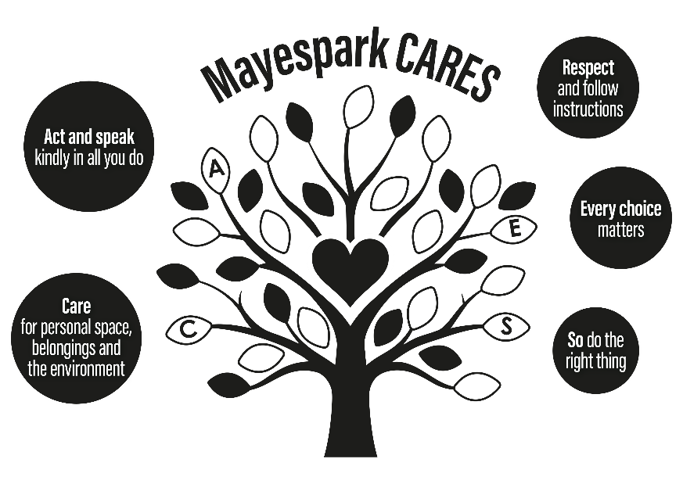
I regret to inform you that _____________________________ in class ________________, came to Reflection at lunchtime today for:

- Fighting

- Deliberately hurting another child

- Rudeness to playground supervisory staff

- Refusal to follow instructions

- Inappropriate behaviour while in reflection

- Prejudice related incident

If we feel your child is not learning from reflecting on his/her behaviour, then we shall contact you to arrange a meeting about their conduct.

Thank you for your support.

Mrs. E Davies, Headteacher

Please would you sign this note and return it to school so that we know you have received it.

__________________________________________________________________________________________
Reflection parent slip

Child’s name: ________________________ Parent’s signature: ____________________

Appendix F THINK ABOUT SHEET
Everyone deserves to feel safe
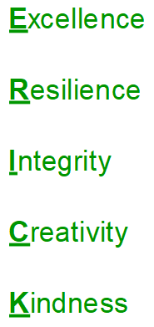

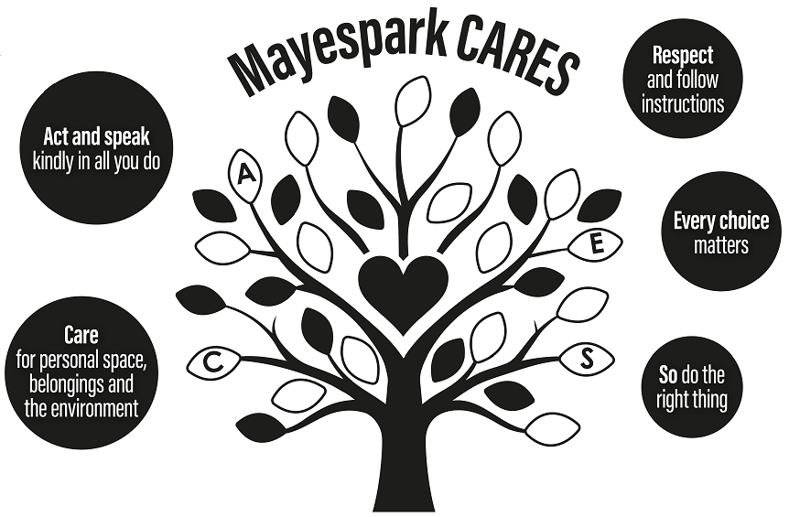
Name: __________________
Date: ___________________

Circle the rule that has
been broken: C A R E S
Which value have you forgotten?
What did you do? What was your role in the incident?

What will you do in the future? Suggest ways you can ensure this doesn’t happen again.

Pupil Sign _______________

Class: Date:
Name:
Pupil sign:
Next time I will

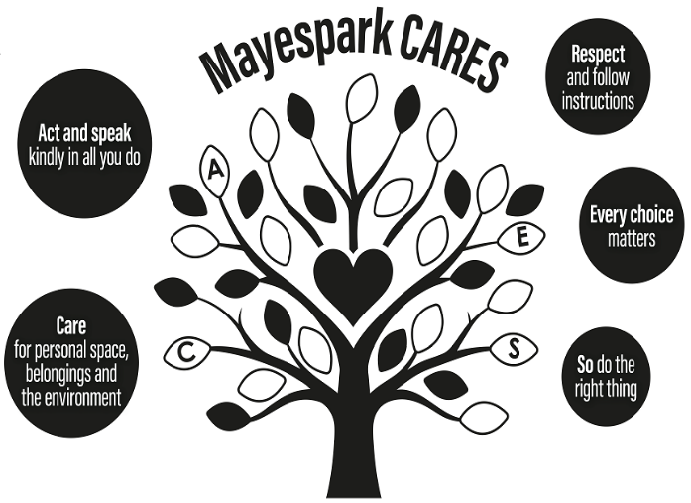

Appendix G
Behaviour Steps and examples

Warning (after non-verbal cues) | Five minutes time out | 15 minutes time out | Blue letter
- Throwing items across the room.  - Inappropriate/silly noises.  - Provoking peers.  - Running in school.  - Touching another person’s property.  - Calling out.  - Persistent tapping.  - Swinging on chairs.  - Refusal to follow instructions, including refusal to do work. | - Repeat of previous behaviour | - Repeat of previous behaviour after warning and five minutes time out given  - Disruptive during five minutes time out | - Ripping up work  - Swearing at others with intent to offend.  - Lying (dependent on the nature).  - Blocking up toilets.  - Spitting at someone.  - Punching/ hitting/ pinching/ pushing/ kicking with intent to hurt.  - Throwing wet tissues on ceiling or walls.  - Stealing.  - Leaving the classroom without permission (not time out).  - Prejudice related incident at scale 2 in class
Speaking to Parents | Phase Leader | AHT for Behaviour (Lee) | Review (play/lunch only)
If you are giving a blue letter – speak to the parents to explain the context and circumstances so that they understand.  Record anything significant on CPOMs | - Bullying – first incident (to investigate)  - Inappropriate sexualised behaviour – first occurrence (investigate)  All details recorded on CPOMs | - Prejudice related incident at scale 3/4 anywhere  - Use of phobic language.  - Graffiti (when it is insulting to someone).  - Using an object as a weapon.  - Intentionally throwing an object at someone.  - Persistent bullying  - Leaving the school premises without permission.  - Inappropriate sexualised behaviour – ongoing  - Physically abusive towards an adult (with intent).  - Throwing furniture | - Fighting  - Deliberately hurting another child  - Deliberately damaging equipment  - Refusing to follow the instructions of supervisory staff/teacher on duty  - Extreme rudeness to supervisory staff/teacher on duty  - Prejudice related incident at scale 2 in playground

Appendix H
Class ____________________________________ Date_____________________________________


Name | Warning | Five minutes time out | 15 minutes time out | Blue letter
Name | Warning | Five minutes time out | 15 minutes time out | Blue letter

Appendix I

Mayespark Behaviour policy
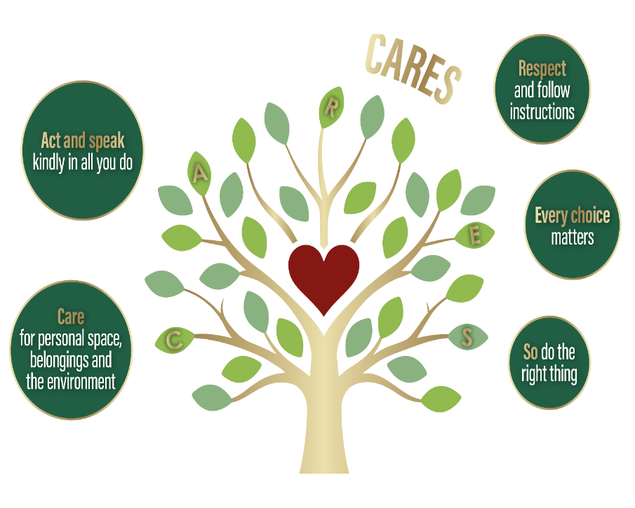

If you do the right thing you can expect… |  | Rewards as behaviour  improves
Praise | Good news notes | Rewards as behaviour  improves
Name written on the smiley board | Special responsibility or jobs | Rewards as behaviour  improves
Parents told good news | Showing work to SLT | Rewards as behaviour  improves
Dojo points/stickers/team points | Achievement award given out | Rewards as behaviour  improves
Start the day afresh
If you choose to break our school rules then these are the things that will happen.
In class | At play/lunch
Non-verbal / verbal reminders | Non-verbal / verbal reminders | Consequences if behaviour deteriorates
Stage 1: Warning. | Stage 1: Warning. | Consequences if behaviour deteriorates
Stage 2: 5-minute time out in class | Stage 2: 5-minute time out with adult | Consequences if behaviour deteriorates
Stage 3: 15-minute Time Out in another class (complete ‘Think About’ sheet) | Stage 3: 10-minute time out with adult | Consequences if behaviour deteriorates
Stage 4: A ‘Blue Letter’ is sent home to parents/carers | Stage 4: Reflection | Consequences if behaviour deteriorates
Stage 5: SLT called | Stage 5: Removed from playground for a period | Consequences if behaviour deteriorates
Stage 6: Internal exclusion for remainder of lesson | Stage 5: Removed from playground for a period | Consequences if behaviour deteriorates
Stage 7: Internal exclusion for rest of the day. |  | Consequences if behaviour deteriorates
A child will move to Stage 4 if they damage property with intent, are  violent or aggressive, or swearing at an adult. If a child gets to stage 2 or three for the third time in a week, the class teacher will speak to parents. |  | Consequences if behaviour deteriorates

APPENDIX J  Class__________________________ |  | Behaviour Tracking sheet |  | Week beginning ___________________
Date | Name | Warning | 5 minutes time out | 15 minutes time out | Blue letter | Rewards (List children who have received rewards this week)
 |  |  |  |  |  | Monday Munch
 |  |  |  |  |  | Certificate or HT stamp
 |  |  |  |  |  | Good news note (Continue on other side)
Date | Name | Warning | 5 minutes time out | 15 minutes time out | Blue letter | Good news note


Appendix K

Prejudice-Related Incident Procedure
A prejudice-related incident is any incident which is perceived to be prejudice-related by the victim or any other person.

Incidents amongst pupils
As soon as any member of staff becomes aware of a prejudice-related incident amongst pupils, which may relate to any of the following protected characteristics:
- sexual orientation
- disability
- gender reassignment
- race
- religion or belief
- sex

They must follow the following procedure:
- The incident should be logged by the member of staff who first becomes aware of it on CPOMs.
- Incidents should be ranked on the following scale:
- No offence was intended or taken.
- Hurt or distress was caused, but the offending behaviour is unlikely to be repeated.
- Hurt or distress was caused and the pupil(s) responsible had previously been warned that their behaviour was unacceptable.
- Substantial hurt or distress was caused, and/or the behaviour was based on substantial hostility and prejudice, and/or the behaviour may be repeated.
- The teacher (in class incidents) or Learning Mentors (playground incidents) will investigate incidents and decide on the scale. Scale 2 in class will get a blue letter, in the playground will go to review.
- Incidents at scale 3 will be dealt with by the AHT for behaviour.
- If the incident is at scale 4, it needs to be investigated immediately, the child should be taken to the Head Teacher or Assistant Head for behaviour straight away.
- It will be decided as to whether restorative justice or another form of education or punishment is best for the perpetrator. The response will be communicated to parents and carers of both perpetrator and target.
- The CPOMs record form will be updated by the person dealing with the incident.
- All incidents are to be reported to parents/carers, of both the perpetrator/s and the victim/s.

Pupils should be made aware of this procedure through circle time and class assemblies and encouraged to report all incidents, being reassured that they will be taken seriously. Worry boxes are available in classrooms for pupils who do not want to speak directly to a member of staff.

Termly meetings are held by the Equalities team to discuss incidents and children that may require behaviour contracts or other interventions.

Incidents perpetrated by staff members
All incidents should be reported to a member of the leadership team immediately. The incident will be logged and investigated by the Headteacher or Deputy Headteacher.
Incidents of discrimination, harassment or victimisation are deemed gross misconduct and will be treated in line with the school’s disciplinary procedure.
We will revisit the procedure termly to ensure that all elements are working positively and amend practices as necessary. If any part of this procedure needs further clarification, please see a member of the leadership team.

Last updated: 01 September 2025

