Mayespark Artist Study Overview
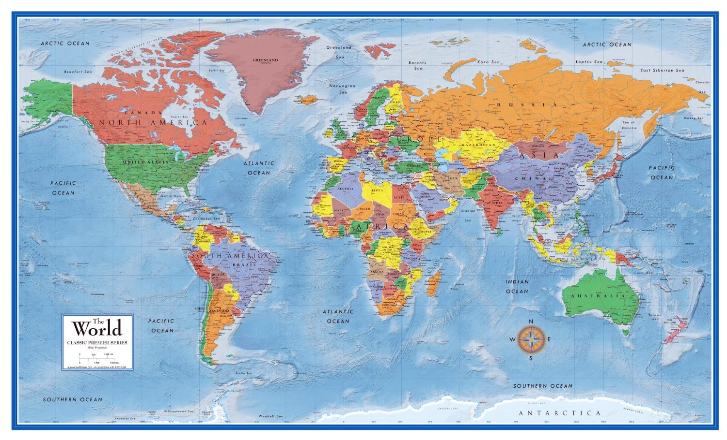

 | Artist | Country of Origin |  | Artist of the Month | Country of Origin |  |  | Art movements/period
N | Sonia Boyce | Caribbean- British (London) |  | Yinka Ilori | British Nigerian (London) |  | Year 3 | Cave art
 | Chris Ofili | British (Manchester) |  | Antony Gormley | British (London) |  | Year 3 | Ancient Greeks
R | Oliver Jeffers | Irish |  | Yayoi Kusama | Japanese |  | Year 4 | Ancient Romans
 | Vashti Harrison | Indian-African American (Virgina) |  | Wassily Kandinsky | Russian |  | Year 4 | Ancient Egyptians
 | Laura Hughes | British |  | Beatriz Milhaze | Brazilian |  | Year 5 | Ancient Islamic Civivlsations
1 | Wassily Kandinsky | Russian |  | Vashti Harrison | African American (Brooklyn)
 | Beatriz Milhaze | Brazilian |  | Ibrahim el-Salahi | Sudanese |  | Whole | Diwali
 | Bridget Riley | British (London) |  | Dina Chhan | Cambodian |  | school
 | Jasper Jones | American (South Carolina) |  | Joseph Herman | Polish- British
 | Vija Celmins | Latvian |  | Frida Kahlo | Mexican
 | David Hockney | British (Bradford)
 | Marcos Roman | American (Kansas)
2 | Henri Matisse | French
 | Pablo Picasso | Spanish
 | Max Ernst | German
 | L.S. Lowry | British (Saltford)
 | Richard Kimbo | African (Kenya)
 | Ben Osawe | African (Nigeria)
 | Andy Goldsworthy | British (Cheshire)
3 | Reggie Laurent | African American (Georgia)
 | Paul Klee | German
 | Winston Branch | British/ St. Lucia
 | Romero Britta | Brazillian
 | Rosie Sanders | British (Buckinghamshire)
 | Isabel le Roux | South African
4 | Alma Thomas | African American (Washington)
 | Molly McFee | American (Texas)
 | Caroline Jariwala | Guhrati-Indian-British(Birmingham)
5 | William Morris | British (Walthamstow)
 | Parviz Tanavoli | Polish
 | Yayoi Kusama | Japanese
 | Delta Martin | African American (Texas)
6 | Chila Kumari Burman | British (Punjabi-Livapudlian)
 | Kehinde Wiley | African American (New York)
 | Kathe Kollwitz | German
 | Banksy | British (Bristol) *possibly

